

**MARMARA UNIVERSITY**

**FACULTY OF ENGINEERING**

**DEPARTMENT OF INDUSTRIAL**

**ENGINEERING**

**Recycling Garbage Collector Application (RGCA)**

**DENİZ YAĞCI 150317504**

**GAYE KARA 150317028**

July,2019

**TABLE OF CONTENTS**

RECYCLING GARBAGE COLLECTOR APPLICATION 4

ENTITY NAMES 5

ENTITY (ER) DIAGRAM BY USING ORACLE NOTATION 6

ENTITY (ER) DIAGRAM BY USING ERWIN 7

MS SQL SERVER 10

DATA TYPES AND KEYS 11

RELATIONS 15

SQL DATA DEFINITION LANGUAGE-DDL STATEMENT 16

SQL EXPERIENCE TO THREE TABLE 62

A)DDL STATEMENTS 62

**A.1)CREATE/ALTER VIEW EXAMPLES** 62

**A.2)CREATE/ALTER INDEX EXAMPLES** 64

B)DML STATEMENTS-DATA MANIPULATION LANGUAGE 67

**B.1)INSERT INTO** 67

**B.2)UPDATE STATEMENTS** 68

**B.3)DELETE STATEMENTS** 69

**B.4)STORE PROCEDURE** 70

C)DQL STATEMENTS-DATA QUERY LANGUAGE 71

**C.1)SIMPLE JOINS-JOINING TWO TABLES** 71

**C.2)INNER/OUTER JOINS** 72

**C.3)NESTED QUERIES** 73

**C.4)SORTING** 74

**C.5)GROUP BY** 75

**C.6)USING SELECT STATEMENTS WITH STORED PROCEDURE** 76

D)DCL STATEMENTS-DATA CONTROL LANGUAGE 77

INTEGRETY TEST 78

1)TEST 1 78

2)TEST 2 79

4)TEST 4 81

5)TEST 5 82

7)TEST 7 84

8)TEST 8 85

9)TEST 9 86

RGC Application(Visual Studio/C#) 87

A)Photos of App 88

B)Codes of App 98

# **RECYCLING GARBAGE COLLECTOR APPLICATION**

This project is aimed at optimizing the collection of materials suitable for recycling in universities. This type of garbage types, the location of the garbage cans, the names of the employees involved in the waste bins and discharge points were optimized.

As a result of the social and economic activities of people, all kinds of substances that have expired and become harmful to nature are called waste. Materials such as cardboard, glass, metal, plastic can be classified as waste. Recycling of waste is only possible through recycling. Recycling is the recycling of these wastes, which have the possibility of re-use, to physical or chemical processes and converting them to a second raw material. The purpose of recycling is to prevent excessive use of resources, to ensure the separation of wastes in their sources, to reduce the amount of waste garbage.

Recycling of materials such as paper, cardboard, glass, plastic and metal will prevent the depletion of natural resources. Recycling, which contributes greatly to the economy of the country, will reduce the amount of foreign currency paid to imported scrap and will significantly save energy use. Recycling of used paper reduces air pollution by 74-94%, water pollution by 35% and water use by 45%. Adding 1 ton of waste paper to the pulp prevents 8 trees from being cut.

Recycling is a very efficient economic investment in the long run. Human beings are faced with many economic problems in the future as a result of the depletion of raw materials and natural resources. On the other hand, many recycled wastes will contribute to the prevention of environmental pollution.

Importance of Recycling;

* Prevents the reduction of natural resources.
* It provides energy saving.
* The amount of solid waste to be disposed of is reduced.
* Contributes to the economy.
* It provides a clean environment for future generations.
* It contributes to the reduction of greenhouse gas emissions.
* Recycling of domestic wastes by composting method increases the soil yield. Thus, both organic and high nutritional products are obtained.

In order for recycling to take place in our society, first of all, recycling should be provided at the highest level in universities.

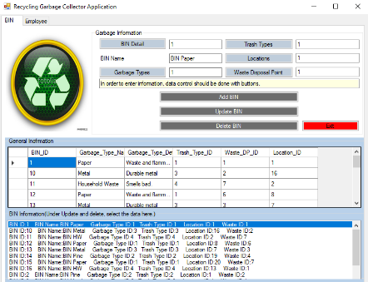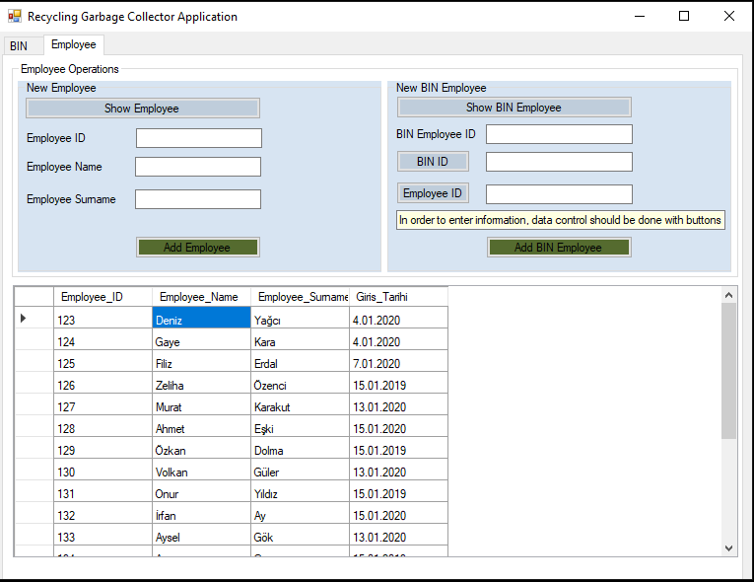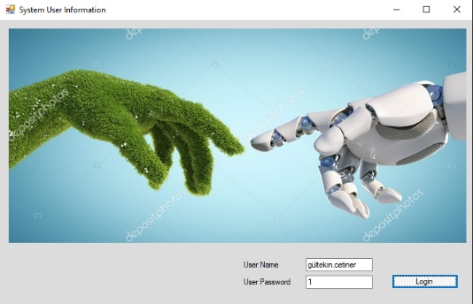This application has been created for the purposes of the above symptoms. The following pages provide information about the application.

# **ENTITY NAMES**

1. garbage_type
2. trash_type
3. trash_company
4. capacity
5. main_discharge_point
6. garbage_employee
7. garbage
8. employee
9. employee_info
10. districts
11. city
12. countries
13. main_discharge_point_record
14. record
15. region
16. location
17. building
18. storey
19. building info
20. building_date

# **ENTITY (ER) DIAGRAM BY USING ORACLE NOTATION**

# **ENTITY (ER) DIAGRAM BY USING ERWIN**

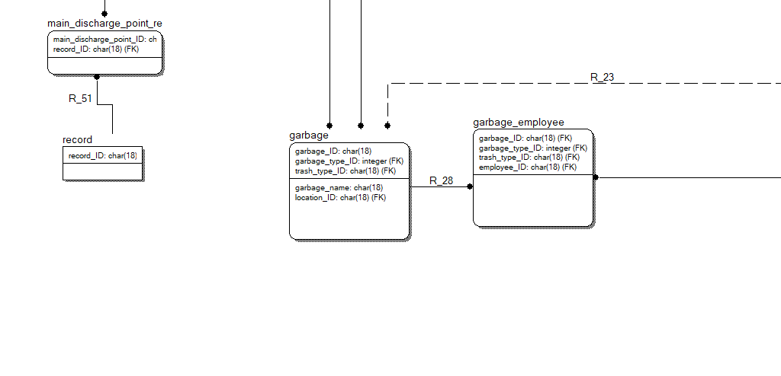

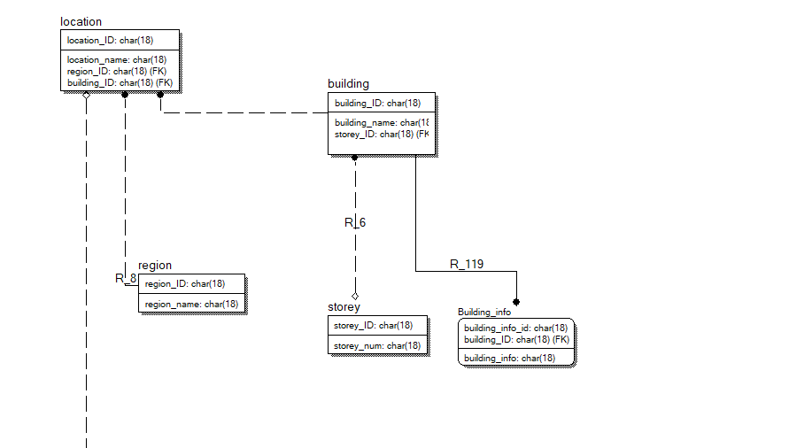

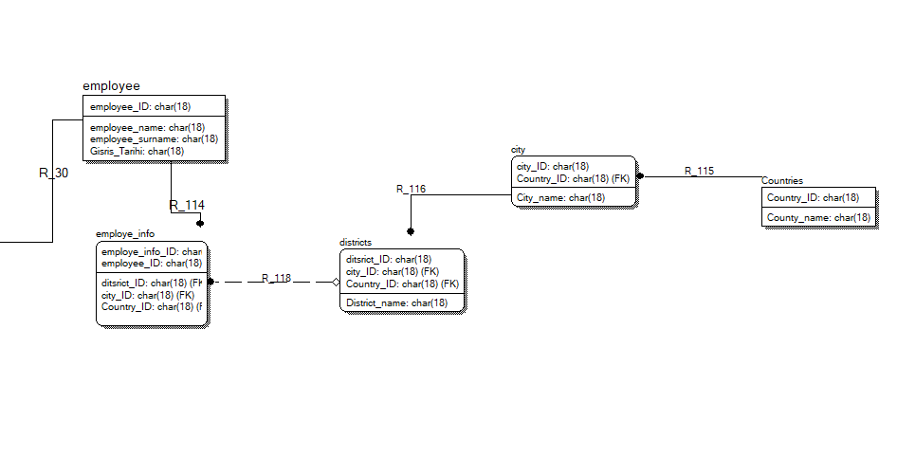

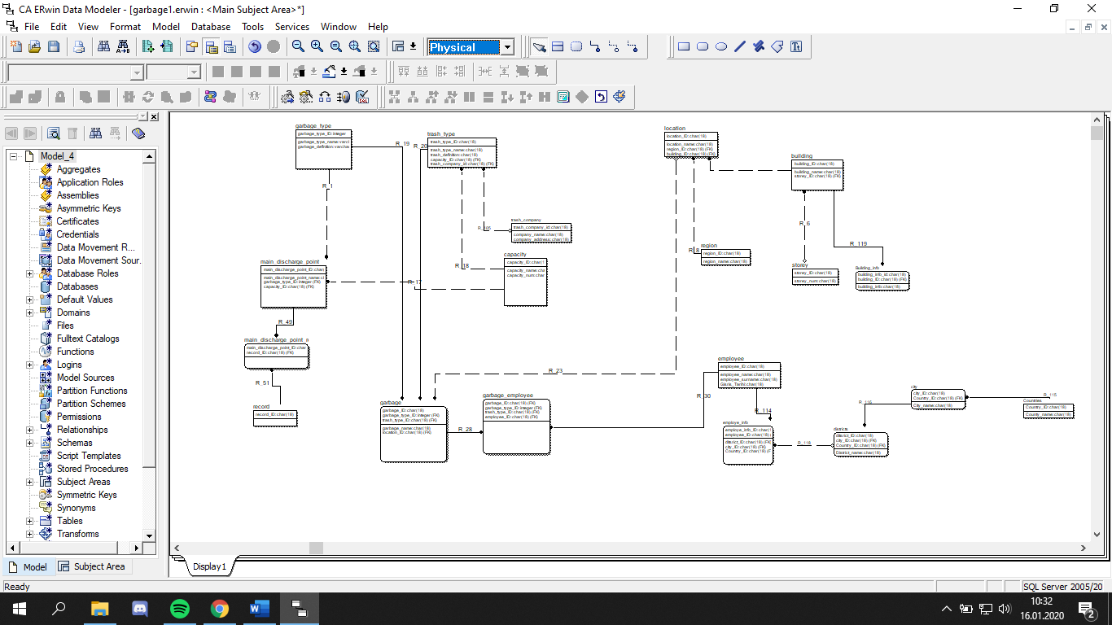

# **MS SQL SERVER**

The SQL Server is a relational database management system from Microsoft. The system is designed and built to manage and store information. The system supports various business intelligence operations, analytics operations, and transaction processing. The information is stored on the server. However, since the system is much more than a database, it also includes a management system. SQL stands for Structured Query Language, a computer language that manages and administers the server. There are many versions of the SQL server, each subsequent version being an improved model of its predecessor.

Microsoft SQL Server has numerous applications in the business world. The first and most obvious one is the database. However, businesses that hold sensitive customer information, such as personal details, credit card information, and other confidential information will benefit from increased security. The system also provides data sharing by computers in the same network, a factor that increases reliability. The SQL server is also used to increase the speed with which data is processed, allowing large operations to be executed with ease. With the information stored in the database, businesses will have a reliable backup system.

# **DATA TYPES AND KEYS**

|  |  |  |
| --- | --- | --- |
| **Building** |  |  |
| Column Name | Data Type | Allow Nulls |
| **Building_ID(PK)** | **nvarchar(10)** | **Unchecked** |
| **Building_Name** | **nvarchar(30)** | **Checked** |
| **Storey_ID(FK)** | **nvarchar(10)** | **Checked** |

|  |  |  |
| --- | --- | --- |
| **Garbage_Type** |  |  |
| Column Name | Data Type | Allow Nulls |
| **Garbage_Type_ID(PK)** | **nvarchar(10)** | **Unchecked** |
| **Garbage_Type_Name** | **nvarchar(30)** | **Checked** |
| **Garbage_Type_Definition** | **nvarchar(30)** | **Checked** |

|  |  |  |
| --- | --- | --- |
| **Building_info** |  |  |
| Column Name | Data Type | Allow Nulls |
| **building_info_id(PK)** | **nvarchar(10)** | **Checked** |
| **building_ID(FK)** | **nvarchar(10)** | **Checked** |
| **building_info** | **nvarchar(100)** | **Checked** |

|  |  |  |
| --- | --- | --- |
| **Location** |  |  |
| Column Name | Data Type | Allow Nulls |
| **Location_ID(PK)** | **nvarchar(10)** | **Unchecked** |
| **Location_name** | **nvarchar(30)** | **Checked** |
| **Region_ID(FK)** | **nvarchar(10)** | **Checked** |
| **Building_ID(FK)** | **nvarchar(10)** | **Checked** |

|  |  |  |
| --- | --- | --- |
| **Capacity_Type** |  |  |
| Column Name | Data Type | Allow Nulls |
| **Capacity_Type_ID(PK)** | **nvarchar(10)** | **Unchecked** |
| **Capacity_Type_Name** | **nvarchar(30)** | **Checked** |
| **Capacity_Amount** | **nvarchar(30)** | **Checked** |

|  |  |  |
| --- | --- | --- |
| **Main_Discharge_point_record** |  |  |
| Column Name | Data Type | Allow Nulls |
| **Main_Discharge_point_record_ID(PK)** | **nvarchar(10)** | **Checked** |

|  |  |  |
| --- | --- | --- |
| **City** |  |  |
| Column Name | Data Type | Allow Nulls |
| **City_ID(PK)** | **nvarchar(10)** | **Unchecked** |
| **country_ID(FK)** | **nvarchar(10)** | **Checked** |
| **City_name** | **nvarchar(30)** | **Checked** |

|  |  |  |
| --- | --- | --- |
| **Record** |  |  |
| Column Name | Data Type | Allow Nulls |
| **record_ID(PK)** | **nvarchar(10)** | **Checked** |

|  |  |  |
| --- | --- | --- |
| **Countries** |  |  |
| Column Name | Data Type | Allow Nulls |
| **Country_ID(PK)** | **nvarchar(10)** | **Checked** |
| **Country_name** | **nvarchar(30)** | **Checked** |

|  |  |  |
| --- | --- | --- |
| **district** |  |  |
| Column Name | Data Type | Allow Nulls |
| **District_ID(PK)** | **nvarchar(10)** | **Unchecked** |
| **City_ID(FK)** | **nvarchar(10)** | **Checked** |
| **District_name** | **nvarchar(30)** | **Checked** |

|  |  |  |
| --- | --- | --- |
| **Employee** |  |  |
| Column Name | Data Type | Allow Nulls |
| **Employee_ID(PK)** | **nvarchar(10)** | **Unchecked** |
| **Employee_Name** | **nvarchar(30)** | **Checked** |
| **Employee_Surname** | **nvarchar(30)** | **Checked** |
| **Giris_Tarihi** | **date** | **Checked** |

|  |  |  |
| --- | --- | --- |
| **Garbage** |  |  |
| Column Name | Data Type | Allow Nulls |
| **BIN_ID(PK)** | **nvarchar(10)** | **Unchecked** |
| **BIN_Name** | **nvarchar(30)** | **Checked** |
| **Garbage_Type_ID(FK)** | **nvarchar(10)** | **Checked** |
| **Trash_Type_ID(FK)** | **nvarchar(10)** | **Checked** |
| **Location_ID(FK)** | **nvarchar(10)** | **Checked** |
| **Waste_DP_ID(FK)** | **nvarchar(10)** | **Checked** |

|  |  |  |
| --- | --- | --- |
| **Garbage_Employee** |  |  |
| Column Name | Data Type | Allow Nulls |
| **Garbage_Employee_ID(PK)** | **nvarchar(10)** | **Unchecked** |
| **BIN_ID(FK)** | **nvarchar(10)** | **Checked** |
| **Employee_ID(FK)** | **nvarchar(10)** | **Checked** |

|  |  |  |
| --- | --- | --- |
| **Main_Discharge_point_record** |  |  |
| Column Name | Data Type | Allow Nulls |
| **Main_Discharge_point_record_ID(PK)** | **nvarchar(10)** | **Checked** |
|  |  |  |
|  |  |  |
|  |  |  |
| **Record** |  |  |
| Column Name | Data Type | Allow Nulls |
| **record_ID(PK)** | **nvarchar(10)** | **Checked** |
|  |  |  |
|  |  |  |
| **Region** |  |  |
| Column Name | Data Type | Allow Nulls |
| **Region_ID(PK)** | **nvarchar(10)** | **Unchecked** |
| **Region_Name** | **nvarchar(30)** | **Checked** |
|  |  |  |
|  |  |  |
| **Record_Garbage_Amount** |  |  |
| Column Name | Data Type | Allow Nulls |
| **Record_ID(PK)** | **nvarchar(10)** | **Unchecked** |
| **Record_Amount** | **nvarchar(30)** | **Checked** |
| **Record_Date** | **datetime** | **Checked** |
| **BIN_ID(FK)** | **nvarchar(10)** | **Checked** |
| **Waste_DP_ID(FK)** | **nvarchar(10)** | **Checked** |
|  |  |  |
| **Storey** |  |  |
| Column Name | Data Type | Allow Nulls |
| **Storey_ID(PK)** | **nvarchar(10)** | **Unchecked** |
| **Storey_Name** | **nvarchar(30)** | **Checked** |
|  |  |  |
|  |  |  |
| **System_Users** |  |  |
| Column Name | Data Type | Allow Nulls |
| **User_ID(PK)** | **nvarchar(10)** | **Unchecked** |
| **User_Name** | **nvarchar(30)** | **Checked** |
| **User_Sifre** | **nvarchar(30)** | **Checked** |
|  |  |  |
|  |  |  |
| **trash_Company** |  |  |
| Column Name | Data Type | Allow Nulls |
| **trash_company_ID(PK)** | **nvarchar(10)** | **Unchecked** |
| **company_name** | **nvarchar(30)** | **Checked** |
| **company_address** | **nvarchar(30)** | **Checked** |
|  |  |  |
|  |  |  |
|  |  |  |
| **Trash_Type** |  |  |
| Column Name | Data Type | Allow Nulls |
| **Trash_Type_ID(PK)** | **nvarchar(10)** | **Unchecked** |
| **Trash_Type_Name** | **nvarchar(30)** | **Checked** |
| **Trash_Type_Definition** | **nvarchar(30)** | **Checked** |
| **Capacity_Type_ID(FK)** | **nvarchar(10)** | **Checked** |
| **trash_company_ID(FK)** | **nvarchar(10)** | **Checked** |
|  |  |  |
| **Waste_Disposal_Point** |  |  |
| Column Name | Data Type | Allow Nulls |
| **Waste_DP_ID(PK)** | **nvarchar(10)** | **Unchecked** |
| **Waste_DP_Name** | **nvarchar(30)** | **Checked** |
| **Capacity_Type_ID(FK)** | **nvarchar(10)** | **Checked** |
| **Garbage_Type_ID(FK)** | **nvarchar(10)** | **Checked** |
| **Region_ID(FK)** | **nchar(10)** | **Checked** |

# **RELATIONS**

* Each Garbage must be defined one or only one Garbage Type.
* Each Garbage must be defined one or only one Trash Type.
* Each Garbage must be linked one or only one Garbage Employee.
* Each Garbage may be defined one or only one Location.
* Each Garbage Type must be connected one or more Garbage.
* Each Trash Type must be connected one or more Garbage.
* Each garbage Employee must be linked one or only one Garbage.
* Each Location may be connected one or more Garbage.
* Each Trash Type may be defined one or only one Trash Company.
* Each Trash Type may be defined one or only one Capacity.
* Each Trash Company may be connected one or more Trash Type.
* Each Capacity may be connected one or more Trash Type.
* Each Garbage Type may be defined one or more Main Discharge Point.
* Each Main Discharge Point may be connected one or only one Garbage Type.
* Each Main Discharge Point must be defined one or more Main Discharge Point Record.
* Each Main Discharge Point Record must be connected one or only one Main Discharge Point.
* Each Record must be connected one or more Main Discharge Point.
* Each Main Discharge Point must be defined one or only one Record.
* Each Building must be linked one or more Building Info.
* Each Location may be defined one or only one Region.
* Each Garbage Type must be connected one or more Garbage.
* Each Trash Type may be connected one or only one Trash Company.
* Each Trash Type may be connected one or only one Capacity.
* Each Garbage must be defined one or only one Garbage Employee.
* Each Garbage may be defined one or only one Location.
* Each Garbage Employee may be connected one or only one Employee.
* Each Region may be defined one or more Location.
* Each Main Discharge Point must be defined one or more Main Discharge Point Record.
* Each Main Discharge Point Record must be connected one or only one Main Discharge Point.
* Each Location may be defined one or only one Region.
* Each Garbage Type must be connected one or more Garbage.
* Each Region may be connected one or only one Trash Company.
* Each Trash Type may be connected one or only one Capacity.
* Each Capacity must be defined one or more Garbage.
* Each Garbage may be defined one or only one Location.

# **SQL DATA DEFINITION LANGUAGE-DDL STATEMENT**

CREATE TABLE building

(

building_ID char(18) NOT NULL ,

building_name char(18) NULL ,

storey_ID char(18) NULL

)

go

ALTER TABLE building

ADD CONSTRAINT XPKbuilding PRIMARY KEY CLUSTERED (building_ID ASC)

go

CREATE TABLE Building_info

(

building_info_id char(18) NOT NULL ,

building_info char(18) NULL ,

building_ID char(18) NOT NULL

)

go

ALTER TABLE Building_info

ADD CONSTRAINT XPKBuilding_info PRIMARY KEY CLUSTERED (building_info_id ASC,building_ID ASC)

go

CREATE TABLE capacity

(

capacity_ID char(18) NOT NULL ,

capacity_name char(18) NULL ,

capacity_num char(18) NULL

)

go

ALTER TABLE capacity

ADD CONSTRAINT XPKcapacity PRIMARY KEY CLUSTERED (capacity_ID ASC)

go

CREATE TABLE city

(

city_ID char(18) NOT NULL ,

City_name char(18) NULL ,

Country_ID char(18) NOT NULL

)

go

ALTER TABLE city

ADD CONSTRAINT XPKcity PRIMARY KEY CLUSTERED (city_ID ASC,Country_ID ASC)

go

CREATE TABLE Countries

(

Country_ID char(18) NOT NULL ,

County_name char(18) NULL

)

go

ALTER TABLE Countries

ADD CONSTRAINT XPKCountries PRIMARY KEY CLUSTERED (Country_ID ASC)

go

CREATE TABLE districts

(

ditsrict_ID char(18) NOT NULL ,

District_name char(18) NULL ,

city_ID char(18) NOT NULL ,

Country_ID char(18) NOT NULL

)

go

ALTER TABLE districts

ADD CONSTRAINT XPKdistricts PRIMARY KEY CLUSTERED (ditsrict_ID ASC,city_ID ASC,Country_ID ASC)

go

CREATE TABLE employe_info

(

employe_info_ID char(18) NOT NULL ,

employee_ID char(18) NOT NULL ,

ditsrict_ID char(18) NULL ,

city_ID char(18) NULL ,

Country_ID char(18) NULL

)

go

ALTER TABLE employe_info

ADD CONSTRAINT XPKemploye_info PRIMARY KEY CLUSTERED (employe_info_ID ASC,employee_ID ASC)

go

CREATE TABLE employee

(

employee_ID char(18) NOT NULL ,

employee_name char(18) NULL ,

employee_surname char(18) NULL ,

Gisris_Tarihi char(18) NULL

)

go

ALTER TABLE employee

ADD CONSTRAINT XPKemployee PRIMARY KEY CLUSTERED (employee_ID ASC)

go

CREATE TABLE garbage

(

garbage_ID char(18) NOT NULL ,

garbage_name char(18) NULL ,

garbage_type_ID integer NOT NULL ,

trash_type_ID char(18) NOT NULL ,

location_ID char(18) NULL

)

go

ALTER TABLE garbage

ADD CONSTRAINT XPKgarbage PRIMARY KEY CLUSTERED (garbage_ID ASC,garbage_type_ID ASC,trash_type_ID ASC)

go

CREATE TABLE garbage_employee

(

garbage_ID char(18) NOT NULL ,

garbage_type_ID integer NOT NULL ,

trash_type_ID char(18) NOT NULL ,

employee_ID char(18) NOT NULL

)

go

ALTER TABLE garbage_employee

ADD CONSTRAINT XPKgarbage_employee PRIMARY KEY CLUSTERED (garbage_ID ASC,garbage_type_ID ASC,trash_type_ID ASC,employee_ID ASC)

go

CREATE TABLE garbage_type

(

garbage_type_ID integer NOT NULL ,

garbage_type_name varchar(20) NULL ,

garbage_definition varchar(20) NULL

)

go

ALTER TABLE garbage_type

ADD CONSTRAINT XPKgarbage_type PRIMARY KEY CLUSTERED (garbage_type_ID ASC)

go

CREATE TABLE location

(

location_ID char(18) NOT NULL ,

location_name char(18) NULL ,

region_ID char(18) NOT NULL ,

building_ID char(18) NOT NULL

)

go

ALTER TABLE location

ADD CONSTRAINT XPKlocation PRIMARY KEY CLUSTERED (location_ID ASC)

go

CREATE TABLE main_discharge_point

(

main_discharge_point_ID char(18) NOT NULL ,

main_discharge_point_name char(18) NULL ,

garbage_type_ID integer NOT NULL ,

capacity_ID char(18) NOT NULL

)

go

ALTER TABLE main_discharge_point

ADD CONSTRAINT XPKmain_discharge_point PRIMARY KEY CLUSTERED (main_discharge_point_ID ASC)

go

CREATE TABLE main_discharge_point_record

(

main_discharge_point_ID char(18) NOT NULL ,

record_ID char(18) NOT NULL

)

go

ALTER TABLE main_discharge_point_record

ADD CONSTRAINT XPKmain_discharge_point_record PRIMARY KEY CLUSTERED (main_discharge_point_ID ASC,record_ID ASC)

go

CREATE TABLE record

(

record_ID char(18) NOT NULL

)

go

ALTER TABLE record

ADD CONSTRAINT XPKrecord PRIMARY KEY CLUSTERED (record_ID ASC)

go

CREATE TABLE region

(

region_ID char(18) NOT NULL ,

region_name char(18) NULL

)

go

ALTER TABLE region

ADD CONSTRAINT XPKregion PRIMARY KEY CLUSTERED (region_ID ASC)

go

CREATE TABLE storey

(

storey_ID char(18) NOT NULL ,

storey_num char(18) NULL

)

go

ALTER TABLE storey

ADD CONSTRAINT XPKstorey PRIMARY KEY CLUSTERED (storey_ID ASC)

go

CREATE TABLE trash_company

(

trash_company_id char(18) NOT NULL ,

company_name char(18) NULL ,

company_address char(18) NULL

)

go

ALTER TABLE trash_company

ADD CONSTRAINT XPKtrash_company PRIMARY KEY CLUSTERED (trash_company_id ASC)

go

CREATE TABLE trash_type

(

trash_type_ID char(18) NOT NULL ,

trash_type_name char(18) NULL ,

trash_definition char(18) NULL ,

capacity_ID char(18) NOT NULL ,

trash_company_id char(18) NULL

)

go

ALTER TABLE trash_type

ADD CONSTRAINT XPKtrash_type PRIMARY KEY CLUSTERED (trash_type_ID ASC)

go

ALTER TABLE building

ADD CONSTRAINT R_6 FOREIGN KEY (storey_ID) REFERENCES storey(storey_ID)

ON DELETE NO ACTION

ON UPDATE NO ACTION

go

ALTER TABLE Building_info

ADD CONSTRAINT R_119 FOREIGN KEY (building_ID) REFERENCES building(building_ID)

ON DELETE NO ACTION

ON UPDATE NO ACTION

go

ALTER TABLE city

ADD CONSTRAINT R_115 FOREIGN KEY (Country_ID) REFERENCES Countries(Country_ID)

ON DELETE NO ACTION

ON UPDATE NO ACTION

go

ALTER TABLE districts

ADD CONSTRAINT R_116 FOREIGN KEY (city_ID,Country_ID) REFERENCES city(city_ID,Country_ID)

ON DELETE NO ACTION

ON UPDATE NO ACTION

go

ALTER TABLE employe_info

ADD CONSTRAINT R_114 FOREIGN KEY (employee_ID) REFERENCES employee(employee_ID)

ON DELETE NO ACTION

ON UPDATE NO ACTION

go

ALTER TABLE employe_info

ADD CONSTRAINT R_118 FOREIGN KEY (ditsrict_ID,city_ID,Country_ID) REFERENCES districts(ditsrict_ID,city_ID,Country_ID)

ON DELETE NO ACTION

ON UPDATE NO ACTION

go

ALTER TABLE garbage

ADD CONSTRAINT R_19 FOREIGN KEY (garbage_type_ID) REFERENCES garbage_type(garbage_type_ID)

ON DELETE NO ACTION

ON UPDATE NO ACTION

go

ALTER TABLE garbage

ADD CONSTRAINT R_20 FOREIGN KEY (trash_type_ID) REFERENCES trash_type(trash_type_ID)

ON DELETE NO ACTION

ON UPDATE NO ACTION

go

ALTER TABLE garbage

ADD CONSTRAINT R_23 FOREIGN KEY (location_ID) REFERENCES location(location_ID)

ON DELETE NO ACTION

ON UPDATE NO ACTION

go

ALTER TABLE garbage_employee

ADD CONSTRAINT R_28 FOREIGN KEY (garbage_ID,garbage_type_ID,trash_type_ID) REFERENCES garbage(garbage_ID,garbage_type_ID,trash_type_ID)

ON DELETE NO ACTION

ON UPDATE NO ACTION

go

ALTER TABLE garbage_employee

ADD CONSTRAINT R_30 FOREIGN KEY (employee_ID) REFERENCES employee(employee_ID)

ON DELETE NO ACTION

ON UPDATE NO ACTION

go

ALTER TABLE location

ADD CONSTRAINT R_8 FOREIGN KEY (region_ID) REFERENCES region(region_ID)

ON DELETE NO ACTION

ON UPDATE NO ACTION

go

ALTER TABLE location

ADD CONSTRAINT R_9 FOREIGN KEY (building_ID) REFERENCES building(building_ID)

ON DELETE NO ACTION

ON UPDATE NO ACTION

go

ALTER TABLE main_discharge_point

ADD CONSTRAINT R_1 FOREIGN KEY (garbage_type_ID) REFERENCES garbage_type(garbage_type_ID)

ON DELETE NO ACTION

ON UPDATE NO ACTION

go

ALTER TABLE main_discharge_point

ADD CONSTRAINT R_17 FOREIGN KEY (capacity_ID) REFERENCES capacity(capacity_ID)

ON DELETE NO ACTION

ON UPDATE NO ACTION

go

ALTER TABLE main_discharge_point_record

ADD CONSTRAINT R_49 FOREIGN KEY (main_discharge_point_ID) REFERENCES main_discharge_point(main_discharge_point_ID)

ON DELETE NO ACTION

ON UPDATE NO ACTION

go

ALTER TABLE main_discharge_point_record

ADD CONSTRAINT R_51 FOREIGN KEY (record_ID) REFERENCES record(record_ID)

ON DELETE NO ACTION

ON UPDATE NO ACTION

go

ALTER TABLE trash_type

ADD CONSTRAINT R_18 FOREIGN KEY (capacity_ID) REFERENCES capacity(capacity_ID)

ON DELETE NO ACTION

ON UPDATE NO ACTION

go

ALTER TABLE trash_type

ADD CONSTRAINT R_105 FOREIGN KEY (trash_company_id) REFERENCES trash_company(trash_company_id)

ON DELETE NO ACTION

ON UPDATE NO ACTION

go

CREATE TRIGGER tD_building ON building FOR DELETE AS

/* ERwin Builtin Trigger */

/* DELETE trigger on building */

BEGIN

DECLARE @errno int,

@errmsg varchar(255)

/* ERwin Builtin Trigger */

/* building location on parent delete no action */

/* ERWIN_RELATION:CHECKSUM="00030cba", PARENT_OWNER="", PARENT_TABLE="building"

CHILD_OWNER="", CHILD_TABLE="location"

P2C_VERB_PHRASE="", C2P_VERB_PHRASE="",

FK_CONSTRAINT="R_9", FK_COLUMNS="building_ID" */

IF EXISTS (

SELECT * FROM deleted,location

WHERE

/* %JoinFKPK(location,deleted," = "," AND") */

location.building_ID = deleted.building_ID

)

BEGIN

SELECT @errno = 30001,

@errmsg = 'Cannot delete building because location exists.'

GOTO ERROR

END

/* ERwin Builtin Trigger */

/* building Building_info on parent delete no action */

/* ERWIN_RELATION:CHECKSUM="00000000", PARENT_OWNER="", PARENT_TABLE="building"

CHILD_OWNER="", CHILD_TABLE="Building_info"

P2C_VERB_PHRASE="", C2P_VERB_PHRASE="",

FK_CONSTRAINT="R_119", FK_COLUMNS="building_ID" */

IF EXISTS (

SELECT * FROM deleted,Building_info

WHERE

/* %JoinFKPK(Building_info,deleted," = "," AND") */

Building_info.building_ID = deleted.building_ID

)

BEGIN

SELECT @errno = 30001,

@errmsg = 'Cannot delete building because Building_info exists.'

GOTO ERROR

END

/* ERwin Builtin Trigger */

/* storey building on child delete no action */

/* ERWIN_RELATION:CHECKSUM="00000000", PARENT_OWNER="", PARENT_TABLE="storey"

CHILD_OWNER="", CHILD_TABLE="building"

P2C_VERB_PHRASE="", C2P_VERB_PHRASE="",

FK_CONSTRAINT="R_6", FK_COLUMNS="storey_ID" */

IF EXISTS (SELECT * FROM deleted,storey

WHERE

/* %JoinFKPK(deleted,storey," = "," AND") */

deleted.storey_ID = storey.storey_ID AND

NOT EXISTS (

SELECT * FROM building

WHERE

/* %JoinFKPK(building,storey," = "," AND") */

building.storey_ID = storey.storey_ID

)

)

BEGIN

SELECT @errno = 30010,

@errmsg = 'Cannot delete last building because storey exists.'

GOTO ERROR

END

/* ERwin Builtin Trigger */

RETURN

ERROR:

raiserror @errno @errmsg

rollback transaction

END

go

CREATE TRIGGER tU_building ON building FOR UPDATE AS

/* ERwin Builtin Trigger */

/* UPDATE trigger on building */

BEGIN

DECLARE @NUMROWS int,

@nullcnt int,

@validcnt int,

@insbuilding_ID char(18),

@errno int,

@errmsg varchar(255)

SELECT @NUMROWS = @@rowcount

/* ERwin Builtin Trigger */

/* building location on parent update no action */

/* ERWIN_RELATION:CHECKSUM="00037bcb", PARENT_OWNER="", PARENT_TABLE="building"

CHILD_OWNER="", CHILD_TABLE="location"

P2C_VERB_PHRASE="", C2P_VERB_PHRASE="",

FK_CONSTRAINT="R_9", FK_COLUMNS="building_ID" */

IF

/* %ParentPK(" OR",UPDATE) */

UPDATE(building_ID)

BEGIN

IF EXISTS (

SELECT * FROM deleted,location

WHERE

/* %JoinFKPK(location,deleted," = "," AND") */

location.building_ID = deleted.building_ID

)

BEGIN

SELECT @errno = 30005,

@errmsg = 'Cannot update building because location exists.'

GOTO ERROR

END

END

/* ERwin Builtin Trigger */

/* building Building_info on parent update no action */

/* ERWIN_RELATION:CHECKSUM="00000000", PARENT_OWNER="", PARENT_TABLE="building"

CHILD_OWNER="", CHILD_TABLE="Building_info"

P2C_VERB_PHRASE="", C2P_VERB_PHRASE="",

FK_CONSTRAINT="R_119", FK_COLUMNS="building_ID" */

IF

/* %ParentPK(" OR",UPDATE) */

UPDATE(building_ID)

BEGIN

IF EXISTS (

SELECT * FROM deleted,Building_info

WHERE

/* %JoinFKPK(Building_info,deleted," = "," AND") */

Building_info.building_ID = deleted.building_ID

)

BEGIN

SELECT @errno = 30005,

@errmsg = 'Cannot update building because Building_info exists.'

GOTO ERROR

END

END

/* ERwin Builtin Trigger */

/* storey building on child update no action */

/* ERWIN_RELATION:CHECKSUM="00000000", PARENT_OWNER="", PARENT_TABLE="storey"

CHILD_OWNER="", CHILD_TABLE="building"

P2C_VERB_PHRASE="", C2P_VERB_PHRASE="",

FK_CONSTRAINT="R_6", FK_COLUMNS="storey_ID" */

IF

/* %ChildFK(" OR",UPDATE) */

UPDATE(storey_ID)

BEGIN

SELECT @nullcnt = 0

SELECT @validcnt = count(*)

FROM inserted,storey

WHERE

/* %JoinFKPK(inserted,storey) */

inserted.storey_ID = storey.storey_ID

/* %NotnullFK(inserted," IS NULL","select @nullcnt = count(*) from inserted where"," AND") */

select @nullcnt = count(*) from inserted where

inserted.storey_ID IS NULL

IF @validcnt + @nullcnt != @NUMROWS

BEGIN

SELECT @errno = 30007,

@errmsg = 'Cannot update building because storey does not exist.'

GOTO ERROR

END

END

/* ERwin Builtin Trigger */

RETURN

ERROR:

raiserror @errno @errmsg

rollback transaction

END

go

CREATE TRIGGER tD_Building_info ON Building_info FOR DELETE AS

/* ERwin Builtin Trigger */

/* DELETE trigger on Building_info */

BEGIN

DECLARE @errno int,

@errmsg varchar(255)

/* ERwin Builtin Trigger */

/* building Building_info on child delete no action */

/* ERWIN_RELATION:CHECKSUM="00013de0", PARENT_OWNER="", PARENT_TABLE="building"

CHILD_OWNER="", CHILD_TABLE="Building_info"

P2C_VERB_PHRASE="", C2P_VERB_PHRASE="",

FK_CONSTRAINT="R_119", FK_COLUMNS="building_ID" */

IF EXISTS (SELECT * FROM deleted,building

WHERE

/* %JoinFKPK(deleted,building," = "," AND") */

deleted.building_ID = building.building_ID AND

NOT EXISTS (

SELECT * FROM Building_info

WHERE

/* %JoinFKPK(Building_info,building," = "," AND") */

Building_info.building_ID = building.building_ID

)

)

BEGIN

SELECT @errno = 30010,

@errmsg = 'Cannot delete last Building_info because building exists.'

GOTO ERROR

END

/* ERwin Builtin Trigger */

RETURN

ERROR:

raiserror @errno @errmsg

rollback transaction

END

go

CREATE TRIGGER tU_Building_info ON Building_info FOR UPDATE AS

/* ERwin Builtin Trigger */

/* UPDATE trigger on Building_info */

BEGIN

DECLARE @NUMROWS int,

@nullcnt int,

@validcnt int,

@insbuilding_info_id char(18),

@insbuilding_ID char(18),

@errno int,

@errmsg varchar(255)

SELECT @NUMROWS = @@rowcount

/* ERwin Builtin Trigger */

/* building Building_info on child update no action */

/* ERWIN_RELATION:CHECKSUM="0001517e", PARENT_OWNER="", PARENT_TABLE="building"

CHILD_OWNER="", CHILD_TABLE="Building_info"

P2C_VERB_PHRASE="", C2P_VERB_PHRASE="",

FK_CONSTRAINT="R_119", FK_COLUMNS="building_ID" */

IF

/* %ChildFK(" OR",UPDATE) */

UPDATE(building_ID)

BEGIN

SELECT @nullcnt = 0

SELECT @validcnt = count(*)

FROM inserted,building

WHERE

/* %JoinFKPK(inserted,building) */

inserted.building_ID = building.building_ID

/* %NotnullFK(inserted," IS NULL","select @nullcnt = count(*) from inserted where"," AND") */

IF @validcnt + @nullcnt != @NUMROWS

BEGIN

SELECT @errno = 30007,

@errmsg = 'Cannot update Building_info because building does not exist.'

GOTO ERROR

END

END

/* ERwin Builtin Trigger */

RETURN

ERROR:

raiserror @errno @errmsg

rollback transaction

END

go

CREATE TRIGGER tD_capacity ON capacity FOR DELETE AS

/* ERwin Builtin Trigger */

/* DELETE trigger on capacity */

BEGIN

DECLARE @errno int,

@errmsg varchar(255)

/* ERwin Builtin Trigger */

/* capacity main_discharge_point on parent delete no action */

/* ERWIN_RELATION:CHECKSUM="0001f7c4", PARENT_OWNER="", PARENT_TABLE="capacity"

CHILD_OWNER="", CHILD_TABLE="main_discharge_point"

P2C_VERB_PHRASE="", C2P_VERB_PHRASE="",

FK_CONSTRAINT="R_17", FK_COLUMNS="capacity_ID" */

IF EXISTS (

SELECT * FROM deleted,main_discharge_point

WHERE

/* %JoinFKPK(main_discharge_point,deleted," = "," AND") */

main_discharge_point.capacity_ID = deleted.capacity_ID

)

BEGIN

SELECT @errno = 30001,

@errmsg = 'Cannot delete capacity because main_discharge_point exists.'

GOTO ERROR

END

/* ERwin Builtin Trigger */

/* capacity trash_type on parent delete no action */

/* ERWIN_RELATION:CHECKSUM="00000000", PARENT_OWNER="", PARENT_TABLE="capacity"

CHILD_OWNER="", CHILD_TABLE="trash_type"

P2C_VERB_PHRASE="", C2P_VERB_PHRASE="",

FK_CONSTRAINT="R_18", FK_COLUMNS="capacity_ID" */

IF EXISTS (

SELECT * FROM deleted,trash_type

WHERE

/* %JoinFKPK(trash_type,deleted," = "," AND") */

trash_type.capacity_ID = deleted.capacity_ID

)

BEGIN

SELECT @errno = 30001,

@errmsg = 'Cannot delete capacity because trash_type exists.'

GOTO ERROR

END

/* ERwin Builtin Trigger */

RETURN

ERROR:

raiserror @errno @errmsg

rollback transaction

END

go

CREATE TRIGGER tU_capacity ON capacity FOR UPDATE AS

/* ERwin Builtin Trigger */

/* UPDATE trigger on capacity */

BEGIN

DECLARE @NUMROWS int,

@nullcnt int,

@validcnt int,

@inscapacity_ID char(18),

@errno int,

@errmsg varchar(255)

SELECT @NUMROWS = @@rowcount

/* ERwin Builtin Trigger */

/* capacity main_discharge_point on parent update no action */

/* ERWIN_RELATION:CHECKSUM="00023b93", PARENT_OWNER="", PARENT_TABLE="capacity"

CHILD_OWNER="", CHILD_TABLE="main_discharge_point"

P2C_VERB_PHRASE="", C2P_VERB_PHRASE="",

FK_CONSTRAINT="R_17", FK_COLUMNS="capacity_ID" */

IF

/* %ParentPK(" OR",UPDATE) */

UPDATE(capacity_ID)

BEGIN

IF EXISTS (

SELECT * FROM deleted,main_discharge_point

WHERE

/* %JoinFKPK(main_discharge_point,deleted," = "," AND") */

main_discharge_point.capacity_ID = deleted.capacity_ID

)

BEGIN

SELECT @errno = 30005,

@errmsg = 'Cannot update capacity because main_discharge_point exists.'

GOTO ERROR

END

END

/* ERwin Builtin Trigger */

/* capacity trash_type on parent update no action */

/* ERWIN_RELATION:CHECKSUM="00000000", PARENT_OWNER="", PARENT_TABLE="capacity"

CHILD_OWNER="", CHILD_TABLE="trash_type"

P2C_VERB_PHRASE="", C2P_VERB_PHRASE="",

FK_CONSTRAINT="R_18", FK_COLUMNS="capacity_ID" */

IF

/* %ParentPK(" OR",UPDATE) */

UPDATE(capacity_ID)

BEGIN

IF EXISTS (

SELECT * FROM deleted,trash_type

WHERE

/* %JoinFKPK(trash_type,deleted," = "," AND") */

trash_type.capacity_ID = deleted.capacity_ID

)

BEGIN

SELECT @errno = 30005,

@errmsg = 'Cannot update capacity because trash_type exists.'

GOTO ERROR

END

END

/* ERwin Builtin Trigger */

RETURN

ERROR:

raiserror @errno @errmsg

rollback transaction

END

go

CREATE TRIGGER tD_city ON city FOR DELETE AS

/* ERwin Builtin Trigger */

/* DELETE trigger on city */

BEGIN

DECLARE @errno int,

@errmsg varchar(255)

/* ERwin Builtin Trigger */

/* city districts on parent delete no action */

/* ERWIN_RELATION:CHECKSUM="0002232b", PARENT_OWNER="", PARENT_TABLE="city"

CHILD_OWNER="", CHILD_TABLE="districts"

P2C_VERB_PHRASE="", C2P_VERB_PHRASE="",

FK_CONSTRAINT="R_116", FK_COLUMNS="city_ID""Country_ID" */

IF EXISTS (

SELECT * FROM deleted,districts

WHERE

/* %JoinFKPK(districts,deleted," = "," AND") */

districts.city_ID = deleted.city_ID AND

districts.Country_ID = deleted.Country_ID

)

BEGIN

SELECT @errno = 30001,

@errmsg = 'Cannot delete city because districts exists.'

GOTO ERROR

END

/* ERwin Builtin Trigger */

/* Countries city on child delete no action */

/* ERWIN_RELATION:CHECKSUM="00000000", PARENT_OWNER="", PARENT_TABLE="Countries"

CHILD_OWNER="", CHILD_TABLE="city"

P2C_VERB_PHRASE="", C2P_VERB_PHRASE="",

FK_CONSTRAINT="R_115", FK_COLUMNS="Country_ID" */

IF EXISTS (SELECT * FROM deleted,Countries

WHERE

/* %JoinFKPK(deleted,Countries," = "," AND") */

deleted.Country_ID = Countries.Country_ID AND

NOT EXISTS (

SELECT * FROM city

WHERE

/* %JoinFKPK(city,Countries," = "," AND") */

city.Country_ID = Countries.Country_ID

)

)

BEGIN

SELECT @errno = 30010,

@errmsg = 'Cannot delete last city because Countries exists.'

GOTO ERROR

END

/* ERwin Builtin Trigger */

RETURN

ERROR:

raiserror @errno @errmsg

rollback transaction

END

go

CREATE TRIGGER tU_city ON city FOR UPDATE AS

/* ERwin Builtin Trigger */

/* UPDATE trigger on city */

BEGIN

DECLARE @NUMROWS int,

@nullcnt int,

@validcnt int,

@inscity_ID char(18),

@insCountry_ID char(18),

@errno int,

@errmsg varchar(255)

SELECT @NUMROWS = @@rowcount

/* ERwin Builtin Trigger */

/* city districts on parent update no action */

/* ERWIN_RELATION:CHECKSUM="000271be", PARENT_OWNER="", PARENT_TABLE="city"

CHILD_OWNER="", CHILD_TABLE="districts"

P2C_VERB_PHRASE="", C2P_VERB_PHRASE="",

FK_CONSTRAINT="R_116", FK_COLUMNS="city_ID""Country_ID" */

IF

/* %ParentPK(" OR",UPDATE) */

UPDATE(city_ID) OR

UPDATE(Country_ID)

BEGIN

IF EXISTS (

SELECT * FROM deleted,districts

WHERE

/* %JoinFKPK(districts,deleted," = "," AND") */

districts.city_ID = deleted.city_ID AND

districts.Country_ID = deleted.Country_ID

)

BEGIN

SELECT @errno = 30005,

@errmsg = 'Cannot update city because districts exists.'

GOTO ERROR

END

END

/* ERwin Builtin Trigger */

/* Countries city on child update no action */

/* ERWIN_RELATION:CHECKSUM="00000000", PARENT_OWNER="", PARENT_TABLE="Countries"

CHILD_OWNER="", CHILD_TABLE="city"

P2C_VERB_PHRASE="", C2P_VERB_PHRASE="",

FK_CONSTRAINT="R_115", FK_COLUMNS="Country_ID" */

IF

/* %ChildFK(" OR",UPDATE) */

UPDATE(Country_ID)

BEGIN

SELECT @nullcnt = 0

SELECT @validcnt = count(*)

FROM inserted,Countries

WHERE

/* %JoinFKPK(inserted,Countries) */

inserted.Country_ID = Countries.Country_ID

/* %NotnullFK(inserted," IS NULL","select @nullcnt = count(*) from inserted where"," AND") */

IF @validcnt + @nullcnt != @NUMROWS

BEGIN

SELECT @errno = 30007,

@errmsg = 'Cannot update city because Countries does not exist.'

GOTO ERROR

END

END

/* ERwin Builtin Trigger */

RETURN

ERROR:

raiserror @errno @errmsg

rollback transaction

END

go

CREATE TRIGGER tD_Countries ON Countries FOR DELETE AS

/* ERwin Builtin Trigger */

/* DELETE trigger on Countries */

BEGIN

DECLARE @errno int,

@errmsg varchar(255)

/* ERwin Builtin Trigger */

/* Countries city on parent delete no action */

/* ERWIN_RELATION:CHECKSUM="0000e55d", PARENT_OWNER="", PARENT_TABLE="Countries"

CHILD_OWNER="", CHILD_TABLE="city"

P2C_VERB_PHRASE="", C2P_VERB_PHRASE="",

FK_CONSTRAINT="R_115", FK_COLUMNS="Country_ID" */

IF EXISTS (

SELECT * FROM deleted,city

WHERE

/* %JoinFKPK(city,deleted," = "," AND") */

city.Country_ID = deleted.Country_ID

)

BEGIN

SELECT @errno = 30001,

@errmsg = 'Cannot delete Countries because city exists.'

GOTO ERROR

END

/* ERwin Builtin Trigger */

RETURN

ERROR:

raiserror @errno @errmsg

rollback transaction

END

go

CREATE TRIGGER tU_Countries ON Countries FOR UPDATE AS

/* ERwin Builtin Trigger */

/* UPDATE trigger on Countries */

BEGIN

DECLARE @NUMROWS int,

@nullcnt int,

@validcnt int,

@insCountry_ID char(18),

@errno int,

@errmsg varchar(255)

SELECT @NUMROWS = @@rowcount

/* ERwin Builtin Trigger */

/* Countries city on parent update no action */

/* ERWIN_RELATION:CHECKSUM="00010087", PARENT_OWNER="", PARENT_TABLE="Countries"

CHILD_OWNER="", CHILD_TABLE="city"

P2C_VERB_PHRASE="", C2P_VERB_PHRASE="",

FK_CONSTRAINT="R_115", FK_COLUMNS="Country_ID" */

IF

/* %ParentPK(" OR",UPDATE) */

UPDATE(Country_ID)

BEGIN

IF EXISTS (

SELECT * FROM deleted,city

WHERE

/* %JoinFKPK(city,deleted," = "," AND") */

city.Country_ID = deleted.Country_ID

)

BEGIN

SELECT @errno = 30005,

@errmsg = 'Cannot update Countries because city exists.'

GOTO ERROR

END

END

/* ERwin Builtin Trigger */

RETURN

ERROR:

raiserror @errno @errmsg

rollback transaction

END

go

CREATE TRIGGER tD_districts ON districts FOR DELETE AS

/* ERwin Builtin Trigger */

/* DELETE trigger on districts */

BEGIN

DECLARE @errno int,

@errmsg varchar(255)

/* ERwin Builtin Trigger */

/* districts employe_info on parent delete no action */

/* ERWIN_RELATION:CHECKSUM="00027ef4", PARENT_OWNER="", PARENT_TABLE="districts"

CHILD_OWNER="", CHILD_TABLE="employe_info"

P2C_VERB_PHRASE="", C2P_VERB_PHRASE="",

FK_CONSTRAINT="R_118", FK_COLUMNS="ditsrict_ID""city_ID""Country_ID" */

IF EXISTS (

SELECT * FROM deleted,employe_info

WHERE

/* %JoinFKPK(employe_info,deleted," = "," AND") */

employe_info.ditsrict_ID = deleted.ditsrict_ID AND

employe_info.city_ID = deleted.city_ID AND

employe_info.Country_ID = deleted.Country_ID

)

BEGIN

SELECT @errno = 30001,

@errmsg = 'Cannot delete districts because employe_info exists.'

GOTO ERROR

END

/* ERwin Builtin Trigger */

/* city districts on child delete no action */

/* ERWIN_RELATION:CHECKSUM="00000000", PARENT_OWNER="", PARENT_TABLE="city"

CHILD_OWNER="", CHILD_TABLE="districts"

P2C_VERB_PHRASE="", C2P_VERB_PHRASE="",

FK_CONSTRAINT="R_116", FK_COLUMNS="city_ID""Country_ID" */

IF EXISTS (SELECT * FROM deleted,city

WHERE

/* %JoinFKPK(deleted,city," = "," AND") */

deleted.city_ID = city.city_ID AND

deleted.Country_ID = city.Country_ID AND

NOT EXISTS (

SELECT * FROM districts

WHERE

/* %JoinFKPK(districts,city," = "," AND") */

districts.city_ID = city.city_ID AND

districts.Country_ID = city.Country_ID

)

)

BEGIN

SELECT @errno = 30010,

@errmsg = 'Cannot delete last districts because city exists.'

GOTO ERROR

END

/* ERwin Builtin Trigger */

RETURN

ERROR:

raiserror @errno @errmsg

rollback transaction

END

go

CREATE TRIGGER tU_districts ON districts FOR UPDATE AS

/* ERwin Builtin Trigger */

/* UPDATE trigger on districts */

BEGIN

DECLARE @NUMROWS int,

@nullcnt int,

@validcnt int,

@insditsrict_ID char(18),

@inscity_ID char(18),

@insCountry_ID char(18),

@errno int,

@errmsg varchar(255)

SELECT @NUMROWS = @@rowcount

/* ERwin Builtin Trigger */

/* districts employe_info on parent update no action */

/* ERWIN_RELATION:CHECKSUM="0002bb90", PARENT_OWNER="", PARENT_TABLE="districts"

CHILD_OWNER="", CHILD_TABLE="employe_info"

P2C_VERB_PHRASE="", C2P_VERB_PHRASE="",

FK_CONSTRAINT="R_118", FK_COLUMNS="ditsrict_ID""city_ID""Country_ID" */

IF

/* %ParentPK(" OR",UPDATE) */

UPDATE(ditsrict_ID) OR

UPDATE(city_ID) OR

UPDATE(Country_ID)

BEGIN

IF EXISTS (

SELECT * FROM deleted,employe_info

WHERE

/* %JoinFKPK(employe_info,deleted," = "," AND") */

employe_info.ditsrict_ID = deleted.ditsrict_ID AND

employe_info.city_ID = deleted.city_ID AND

employe_info.Country_ID = deleted.Country_ID

)

BEGIN

SELECT @errno = 30005,

@errmsg = 'Cannot update districts because employe_info exists.'

GOTO ERROR

END

END

/* ERwin Builtin Trigger */

/* city districts on child update no action */

/* ERWIN_RELATION:CHECKSUM="00000000", PARENT_OWNER="", PARENT_TABLE="city"

CHILD_OWNER="", CHILD_TABLE="districts"

P2C_VERB_PHRASE="", C2P_VERB_PHRASE="",

FK_CONSTRAINT="R_116", FK_COLUMNS="city_ID""Country_ID" */

IF

/* %ChildFK(" OR",UPDATE) */

UPDATE(city_ID) OR

UPDATE(Country_ID)

BEGIN

SELECT @nullcnt = 0

SELECT @validcnt = count(*)

FROM inserted,city

WHERE

/* %JoinFKPK(inserted,city) */

inserted.city_ID = city.city_ID and

inserted.Country_ID = city.Country_ID

/* %NotnullFK(inserted," IS NULL","select @nullcnt = count(*) from inserted where"," AND") */

IF @validcnt + @nullcnt != @NUMROWS

BEGIN

SELECT @errno = 30007,

@errmsg = 'Cannot update districts because city does not exist.'

GOTO ERROR

END

END

/* ERwin Builtin Trigger */

RETURN

ERROR:

raiserror @errno @errmsg

rollback transaction

END

go

CREATE TRIGGER tD_employe_info ON employe_info FOR DELETE AS

/* ERwin Builtin Trigger */

/* DELETE trigger on employe_info */

BEGIN

DECLARE @errno int,

@errmsg varchar(255)

/* ERwin Builtin Trigger */

/* employee employe_info on child delete no action */

/* ERWIN_RELATION:CHECKSUM="0002d09f", PARENT_OWNER="", PARENT_TABLE="employee"

CHILD_OWNER="", CHILD_TABLE="employe_info"

P2C_VERB_PHRASE="", C2P_VERB_PHRASE="",

FK_CONSTRAINT="R_114", FK_COLUMNS="employee_ID" */

IF EXISTS (SELECT * FROM deleted,employee

WHERE

/* %JoinFKPK(deleted,employee," = "," AND") */

deleted.employee_ID = employee.employee_ID AND

NOT EXISTS (

SELECT * FROM employe_info

WHERE

/* %JoinFKPK(employe_info,employee," = "," AND") */

employe_info.employee_ID = employee.employee_ID

)

)

BEGIN

SELECT @errno = 30010,

@errmsg = 'Cannot delete last employe_info because employee exists.'

GOTO ERROR

END

/* ERwin Builtin Trigger */

/* districts employe_info on child delete no action */

/* ERWIN_RELATION:CHECKSUM="00000000", PARENT_OWNER="", PARENT_TABLE="districts"

CHILD_OWNER="", CHILD_TABLE="employe_info"

P2C_VERB_PHRASE="", C2P_VERB_PHRASE="",

FK_CONSTRAINT="R_118", FK_COLUMNS="ditsrict_ID""city_ID""Country_ID" */

IF EXISTS (SELECT * FROM deleted,districts

WHERE

/* %JoinFKPK(deleted,districts," = "," AND") */

deleted.ditsrict_ID = districts.ditsrict_ID AND

deleted.city_ID = districts.city_ID AND

deleted.Country_ID = districts.Country_ID AND

NOT EXISTS (

SELECT * FROM employe_info

WHERE

/* %JoinFKPK(employe_info,districts," = "," AND") */

employe_info.ditsrict_ID = districts.ditsrict_ID AND

employe_info.city_ID = districts.city_ID AND

employe_info.Country_ID = districts.Country_ID

)

)

BEGIN

SELECT @errno = 30010,

@errmsg = 'Cannot delete last employe_info because districts exists.'

GOTO ERROR

END

/* ERwin Builtin Trigger */

RETURN

ERROR:

raiserror @errno @errmsg

rollback transaction

END

go

CREATE TRIGGER tU_employe_info ON employe_info FOR UPDATE AS

/* ERwin Builtin Trigger */

/* UPDATE trigger on employe_info */

BEGIN

DECLARE @NUMROWS int,

@nullcnt int,

@validcnt int,

@insemploye_info_ID char(18),

@insemployee_ID char(18),

@errno int,

@errmsg varchar(255)

SELECT @NUMROWS = @@rowcount

/* ERwin Builtin Trigger */

/* employee employe_info on child update no action */

/* ERWIN_RELATION:CHECKSUM="0003147a", PARENT_OWNER="", PARENT_TABLE="employee"

CHILD_OWNER="", CHILD_TABLE="employe_info"

P2C_VERB_PHRASE="", C2P_VERB_PHRASE="",

FK_CONSTRAINT="R_114", FK_COLUMNS="employee_ID" */

IF

/* %ChildFK(" OR",UPDATE) */

UPDATE(employee_ID)

BEGIN

SELECT @nullcnt = 0

SELECT @validcnt = count(*)

FROM inserted,employee

WHERE

/* %JoinFKPK(inserted,employee) */

inserted.employee_ID = employee.employee_ID

/* %NotnullFK(inserted," IS NULL","select @nullcnt = count(*) from inserted where"," AND") */

IF @validcnt + @nullcnt != @NUMROWS

BEGIN

SELECT @errno = 30007,

@errmsg = 'Cannot update employe_info because employee does not exist.'

GOTO ERROR

END

END

/* ERwin Builtin Trigger */

/* districts employe_info on child update no action */

/* ERWIN_RELATION:CHECKSUM="00000000", PARENT_OWNER="", PARENT_TABLE="districts"

CHILD_OWNER="", CHILD_TABLE="employe_info"

P2C_VERB_PHRASE="", C2P_VERB_PHRASE="",

FK_CONSTRAINT="R_118", FK_COLUMNS="ditsrict_ID""city_ID""Country_ID" */

IF

/* %ChildFK(" OR",UPDATE) */

UPDATE(ditsrict_ID) OR

UPDATE(city_ID) OR

UPDATE(Country_ID)

BEGIN

SELECT @nullcnt = 0

SELECT @validcnt = count(*)

FROM inserted,districts

WHERE

/* %JoinFKPK(inserted,districts) */

inserted.ditsrict_ID = districts.ditsrict_ID and

inserted.city_ID = districts.city_ID and

inserted.Country_ID = districts.Country_ID

/* %NotnullFK(inserted," IS NULL","select @nullcnt = count(*) from inserted where"," AND") */

select @nullcnt = count(*) from inserted where

inserted.ditsrict_ID IS NULL AND

inserted.city_ID IS NULL AND

inserted.Country_ID IS NULL

IF @validcnt + @nullcnt != @NUMROWS

BEGIN

SELECT @errno = 30007,

@errmsg = 'Cannot update employe_info because districts does not exist.'

GOTO ERROR

END

END

/* ERwin Builtin Trigger */

RETURN

ERROR:

raiserror @errno @errmsg

rollback transaction

END

go

CREATE TRIGGER tD_employee ON employee FOR DELETE AS

/* ERwin Builtin Trigger */

/* DELETE trigger on employee */

BEGIN

DECLARE @errno int,

@errmsg varchar(255)

/* ERwin Builtin Trigger */

/* employee employe_info on parent delete no action */

/* ERWIN_RELATION:CHECKSUM="0001ee48", PARENT_OWNER="", PARENT_TABLE="employee"

CHILD_OWNER="", CHILD_TABLE="employe_info"

P2C_VERB_PHRASE="", C2P_VERB_PHRASE="",

FK_CONSTRAINT="R_114", FK_COLUMNS="employee_ID" */

IF EXISTS (

SELECT * FROM deleted,employe_info

WHERE

/* %JoinFKPK(employe_info,deleted," = "," AND") */

employe_info.employee_ID = deleted.employee_ID

)

BEGIN

SELECT @errno = 30001,

@errmsg = 'Cannot delete employee because employe_info exists.'

GOTO ERROR

END

/* ERwin Builtin Trigger */

/* employee garbage_employee on parent delete no action */

/* ERWIN_RELATION:CHECKSUM="00000000", PARENT_OWNER="", PARENT_TABLE="employee"

CHILD_OWNER="", CHILD_TABLE="garbage_employee"

P2C_VERB_PHRASE="", C2P_VERB_PHRASE="",

FK_CONSTRAINT="R_30", FK_COLUMNS="employee_ID" */

IF EXISTS (

SELECT * FROM deleted,garbage_employee

WHERE

/* %JoinFKPK(garbage_employee,deleted," = "," AND") */

garbage_employee.employee_ID = deleted.employee_ID

)

BEGIN

SELECT @errno = 30001,

@errmsg = 'Cannot delete employee because garbage_employee exists.'

GOTO ERROR

END

/* ERwin Builtin Trigger */

RETURN

ERROR:

raiserror @errno @errmsg

rollback transaction

END

go

CREATE TRIGGER tU_employee ON employee FOR UPDATE AS

/* ERwin Builtin Trigger */

/* UPDATE trigger on employee */

BEGIN

DECLARE @NUMROWS int,

@nullcnt int,

@validcnt int,

@insemployee_ID char(18),

@errno int,

@errmsg varchar(255)

SELECT @NUMROWS = @@rowcount

/* ERwin Builtin Trigger */

/* employee employe_info on parent update no action */

/* ERWIN_RELATION:CHECKSUM="000241d9", PARENT_OWNER="", PARENT_TABLE="employee"

CHILD_OWNER="", CHILD_TABLE="employe_info"

P2C_VERB_PHRASE="", C2P_VERB_PHRASE="",

FK_CONSTRAINT="R_114", FK_COLUMNS="employee_ID" */

IF

/* %ParentPK(" OR",UPDATE) */

UPDATE(employee_ID)

BEGIN

IF EXISTS (

SELECT * FROM deleted,employe_info

WHERE

/* %JoinFKPK(employe_info,deleted," = "," AND") */

employe_info.employee_ID = deleted.employee_ID

)

BEGIN

SELECT @errno = 30005,

@errmsg = 'Cannot update employee because employe_info exists.'

GOTO ERROR

END

END

/* ERwin Builtin Trigger */

/* employee garbage_employee on parent update no action */

/* ERWIN_RELATION:CHECKSUM="00000000", PARENT_OWNER="", PARENT_TABLE="employee"

CHILD_OWNER="", CHILD_TABLE="garbage_employee"

P2C_VERB_PHRASE="", C2P_VERB_PHRASE="",

FK_CONSTRAINT="R_30", FK_COLUMNS="employee_ID" */

IF

/* %ParentPK(" OR",UPDATE) */

UPDATE(employee_ID)

BEGIN

IF EXISTS (

SELECT * FROM deleted,garbage_employee

WHERE

/* %JoinFKPK(garbage_employee,deleted," = "," AND") */

garbage_employee.employee_ID = deleted.employee_ID

)

BEGIN

SELECT @errno = 30005,

@errmsg = 'Cannot update employee because garbage_employee exists.'

GOTO ERROR

END

END

/* ERwin Builtin Trigger */

RETURN

ERROR:

raiserror @errno @errmsg

rollback transaction

END

go

CREATE TRIGGER tD_garbage ON garbage FOR DELETE AS

/* ERwin Builtin Trigger */

/* DELETE trigger on garbage */

BEGIN

DECLARE @errno int,

@errmsg varchar(255)

/* ERwin Builtin Trigger */

/* garbage garbage_employee on parent delete no action */

/* ERWIN_RELATION:CHECKSUM="0004d303", PARENT_OWNER="", PARENT_TABLE="garbage"

CHILD_OWNER="", CHILD_TABLE="garbage_employee"

P2C_VERB_PHRASE="", C2P_VERB_PHRASE="",

FK_CONSTRAINT="R_28", FK_COLUMNS="garbage_ID""garbage_type_ID""trash_type_ID" */

IF EXISTS (

SELECT * FROM deleted,garbage_employee

WHERE

/* %JoinFKPK(garbage_employee,deleted," = "," AND") */

garbage_employee.garbage_ID = deleted.garbage_ID AND

garbage_employee.garbage_type_ID = deleted.garbage_type_ID AND

garbage_employee.trash_type_ID = deleted.trash_type_ID

)

BEGIN

SELECT @errno = 30001,

@errmsg = 'Cannot delete garbage because garbage_employee exists.'

GOTO ERROR

END

/* ERwin Builtin Trigger */

/* garbage_type garbage on child delete no action */

/* ERWIN_RELATION:CHECKSUM="00000000", PARENT_OWNER="", PARENT_TABLE="garbage_type"

CHILD_OWNER="", CHILD_TABLE="garbage"

P2C_VERB_PHRASE="", C2P_VERB_PHRASE="",

FK_CONSTRAINT="R_19", FK_COLUMNS="garbage_type_ID" */

IF EXISTS (SELECT * FROM deleted,garbage_type

WHERE

/* %JoinFKPK(deleted,garbage_type," = "," AND") */

deleted.garbage_type_ID = garbage_type.garbage_type_ID AND

NOT EXISTS (

SELECT * FROM garbage

WHERE

/* %JoinFKPK(garbage,garbage_type," = "," AND") */

garbage.garbage_type_ID = garbage_type.garbage_type_ID

)

)

BEGIN

SELECT @errno = 30010,

@errmsg = 'Cannot delete last garbage because garbage_type exists.'

GOTO ERROR

END

/* ERwin Builtin Trigger */

/* trash_type garbage on child delete no action */

/* ERWIN_RELATION:CHECKSUM="00000000", PARENT_OWNER="", PARENT_TABLE="trash_type"

CHILD_OWNER="", CHILD_TABLE="garbage"

P2C_VERB_PHRASE="", C2P_VERB_PHRASE="",

FK_CONSTRAINT="R_20", FK_COLUMNS="trash_type_ID" */

IF EXISTS (SELECT * FROM deleted,trash_type

WHERE

/* %JoinFKPK(deleted,trash_type," = "," AND") */

deleted.trash_type_ID = trash_type.trash_type_ID AND

NOT EXISTS (

SELECT * FROM garbage

WHERE

/* %JoinFKPK(garbage,trash_type," = "," AND") */

garbage.trash_type_ID = trash_type.trash_type_ID

)

)

BEGIN

SELECT @errno = 30010,

@errmsg = 'Cannot delete last garbage because trash_type exists.'

GOTO ERROR

END

/* ERwin Builtin Trigger */

/* location garbage on child delete no action */

/* ERWIN_RELATION:CHECKSUM="00000000", PARENT_OWNER="", PARENT_TABLE="location"

CHILD_OWNER="", CHILD_TABLE="garbage"

P2C_VERB_PHRASE="", C2P_VERB_PHRASE="",

FK_CONSTRAINT="R_23", FK_COLUMNS="location_ID" */

IF EXISTS (SELECT * FROM deleted,location

WHERE

/* %JoinFKPK(deleted,location," = "," AND") */

deleted.location_ID = location.location_ID AND

NOT EXISTS (

SELECT * FROM garbage

WHERE

/* %JoinFKPK(garbage,location," = "," AND") */

garbage.location_ID = location.location_ID

)

)

BEGIN

SELECT @errno = 30010,

@errmsg = 'Cannot delete last garbage because location exists.'

GOTO ERROR

END

/* ERwin Builtin Trigger */

RETURN

ERROR:

raiserror @errno @errmsg

rollback transaction

END

go

CREATE TRIGGER tU_garbage ON garbage FOR UPDATE AS

/* ERwin Builtin Trigger */

/* UPDATE trigger on garbage */

BEGIN

DECLARE @NUMROWS int,

@nullcnt int,

@validcnt int,

@insgarbage_ID char(18),

@insgarbage_type_ID integer,

@instrash_type_ID char(18),

@errno int,

@errmsg varchar(255)

SELECT @NUMROWS = @@rowcount

/* ERwin Builtin Trigger */

/* garbage garbage_employee on parent update no action */

/* ERWIN_RELATION:CHECKSUM="00058a1b", PARENT_OWNER="", PARENT_TABLE="garbage"

CHILD_OWNER="", CHILD_TABLE="garbage_employee"

P2C_VERB_PHRASE="", C2P_VERB_PHRASE="",

FK_CONSTRAINT="R_28", FK_COLUMNS="garbage_ID""garbage_type_ID""trash_type_ID" */

IF

/* %ParentPK(" OR",UPDATE) */

UPDATE(garbage_ID) OR

UPDATE(garbage_type_ID) OR

UPDATE(trash_type_ID)

BEGIN

IF EXISTS (

SELECT * FROM deleted,garbage_employee

WHERE

/* %JoinFKPK(garbage_employee,deleted," = "," AND") */

garbage_employee.garbage_ID = deleted.garbage_ID AND

garbage_employee.garbage_type_ID = deleted.garbage_type_ID AND

garbage_employee.trash_type_ID = deleted.trash_type_ID

)

BEGIN

SELECT @errno = 30005,

@errmsg = 'Cannot update garbage because garbage_employee exists.'

GOTO ERROR

END

END

/* ERwin Builtin Trigger */

/* garbage_type garbage on child update no action */

/* ERWIN_RELATION:CHECKSUM="00000000", PARENT_OWNER="", PARENT_TABLE="garbage_type"

CHILD_OWNER="", CHILD_TABLE="garbage"

P2C_VERB_PHRASE="", C2P_VERB_PHRASE="",

FK_CONSTRAINT="R_19", FK_COLUMNS="garbage_type_ID" */

IF

/* %ChildFK(" OR",UPDATE) */

UPDATE(garbage_type_ID)

BEGIN

SELECT @nullcnt = 0

SELECT @validcnt = count(*)

FROM inserted,garbage_type

WHERE

/* %JoinFKPK(inserted,garbage_type) */

inserted.garbage_type_ID = garbage_type.garbage_type_ID

/* %NotnullFK(inserted," IS NULL","select @nullcnt = count(*) from inserted where"," AND") */

IF @validcnt + @nullcnt != @NUMROWS

BEGIN

SELECT @errno = 30007,

@errmsg = 'Cannot update garbage because garbage_type does not exist.'

GOTO ERROR

END

END

/* ERwin Builtin Trigger */

/* trash_type garbage on child update no action */

/* ERWIN_RELATION:CHECKSUM="00000000", PARENT_OWNER="", PARENT_TABLE="trash_type"

CHILD_OWNER="", CHILD_TABLE="garbage"

P2C_VERB_PHRASE="", C2P_VERB_PHRASE="",

FK_CONSTRAINT="R_20", FK_COLUMNS="trash_type_ID" */

IF

/* %ChildFK(" OR",UPDATE) */

UPDATE(trash_type_ID)

BEGIN

SELECT @nullcnt = 0

SELECT @validcnt = count(*)

FROM inserted,trash_type

WHERE

/* %JoinFKPK(inserted,trash_type) */

inserted.trash_type_ID = trash_type.trash_type_ID

/* %NotnullFK(inserted," IS NULL","select @nullcnt = count(*) from inserted where"," AND") */

IF @validcnt + @nullcnt != @NUMROWS

BEGIN

SELECT @errno = 30007,

@errmsg = 'Cannot update garbage because trash_type does not exist.'

GOTO ERROR

END

END

/* ERwin Builtin Trigger */

/* location garbage on child update no action */

/* ERWIN_RELATION:CHECKSUM="00000000", PARENT_OWNER="", PARENT_TABLE="location"

CHILD_OWNER="", CHILD_TABLE="garbage"

P2C_VERB_PHRASE="", C2P_VERB_PHRASE="",

FK_CONSTRAINT="R_23", FK_COLUMNS="location_ID" */

IF

/* %ChildFK(" OR",UPDATE) */

UPDATE(location_ID)

BEGIN

SELECT @nullcnt = 0

SELECT @validcnt = count(*)

FROM inserted,location

WHERE

/* %JoinFKPK(inserted,location) */

inserted.location_ID = location.location_ID

/* %NotnullFK(inserted," IS NULL","select @nullcnt = count(*) from inserted where"," AND") */

select @nullcnt = count(*) from inserted where

inserted.location_ID IS NULL

IF @validcnt + @nullcnt != @NUMROWS

BEGIN

SELECT @errno = 30007,

@errmsg = 'Cannot update garbage because location does not exist.'

GOTO ERROR

END

END

/* ERwin Builtin Trigger */

RETURN

ERROR:

raiserror @errno @errmsg

rollback transaction

END

go

CREATE TRIGGER tD_garbage_employee ON garbage_employee FOR DELETE AS

/* ERwin Builtin Trigger */

/* DELETE trigger on garbage_employee */

BEGIN

DECLARE @errno int,

@errmsg varchar(255)

/* ERwin Builtin Trigger */

/* garbage garbage_employee on child delete no action */

/* ERWIN_RELATION:CHECKSUM="0002e540", PARENT_OWNER="", PARENT_TABLE="garbage"

CHILD_OWNER="", CHILD_TABLE="garbage_employee"

P2C_VERB_PHRASE="", C2P_VERB_PHRASE="",

FK_CONSTRAINT="R_28", FK_COLUMNS="garbage_ID""garbage_type_ID""trash_type_ID" */

IF EXISTS (SELECT * FROM deleted,garbage

WHERE

/* %JoinFKPK(deleted,garbage," = "," AND") */

deleted.garbage_ID = garbage.garbage_ID AND

deleted.garbage_type_ID = garbage.garbage_type_ID AND

deleted.trash_type_ID = garbage.trash_type_ID AND

NOT EXISTS (

SELECT * FROM garbage_employee

WHERE

/* %JoinFKPK(garbage_employee,garbage," = "," AND") */

garbage_employee.garbage_ID = garbage.garbage_ID AND

garbage_employee.garbage_type_ID = garbage.garbage_type_ID AND

garbage_employee.trash_type_ID = garbage.trash_type_ID

)

)

BEGIN

SELECT @errno = 30010,

@errmsg = 'Cannot delete last garbage_employee because garbage exists.'

GOTO ERROR

END

/* ERwin Builtin Trigger */

/* employee garbage_employee on child delete no action */

/* ERWIN_RELATION:CHECKSUM="00000000", PARENT_OWNER="", PARENT_TABLE="employee"

CHILD_OWNER="", CHILD_TABLE="garbage_employee"

P2C_VERB_PHRASE="", C2P_VERB_PHRASE="",

FK_CONSTRAINT="R_30", FK_COLUMNS="employee_ID" */

IF EXISTS (SELECT * FROM deleted,employee

WHERE

/* %JoinFKPK(deleted,employee," = "," AND") */

deleted.employee_ID = employee.employee_ID AND

NOT EXISTS (

SELECT * FROM garbage_employee

WHERE

/* %JoinFKPK(garbage_employee,employee," = "," AND") */

garbage_employee.employee_ID = employee.employee_ID

)

)

BEGIN

SELECT @errno = 30010,

@errmsg = 'Cannot delete last garbage_employee because employee exists.'

GOTO ERROR

END

/* ERwin Builtin Trigger */

RETURN

ERROR:

raiserror @errno @errmsg

rollback transaction

END

go

CREATE TRIGGER tU_garbage_employee ON garbage_employee FOR UPDATE AS

/* ERwin Builtin Trigger */

/* UPDATE trigger on garbage_employee */

BEGIN

DECLARE @NUMROWS int,

@nullcnt int,

@validcnt int,

@insgarbage_ID char(18),

@insgarbage_type_ID integer,

@instrash_type_ID char(18),

@insemployee_ID char(18),

@errno int,

@errmsg varchar(255)

SELECT @NUMROWS = @@rowcount

/* ERwin Builtin Trigger */

/* garbage garbage_employee on child update no action */

/* ERWIN_RELATION:CHECKSUM="0002f95d", PARENT_OWNER="", PARENT_TABLE="garbage"

CHILD_OWNER="", CHILD_TABLE="garbage_employee"

P2C_VERB_PHRASE="", C2P_VERB_PHRASE="",

FK_CONSTRAINT="R_28", FK_COLUMNS="garbage_ID""garbage_type_ID""trash_type_ID" */

IF

/* %ChildFK(" OR",UPDATE) */

UPDATE(garbage_ID) OR

UPDATE(garbage_type_ID) OR

UPDATE(trash_type_ID)

BEGIN

SELECT @nullcnt = 0

SELECT @validcnt = count(*)

FROM inserted,garbage

WHERE

/* %JoinFKPK(inserted,garbage) */

inserted.garbage_ID = garbage.garbage_ID and

inserted.garbage_type_ID = garbage.garbage_type_ID and

inserted.trash_type_ID = garbage.trash_type_ID

/* %NotnullFK(inserted," IS NULL","select @nullcnt = count(*) from inserted where"," AND") */

IF @validcnt + @nullcnt != @NUMROWS

BEGIN

SELECT @errno = 30007,

@errmsg = 'Cannot update garbage_employee because garbage does not exist.'

GOTO ERROR

END

END

/* ERwin Builtin Trigger */

/* employee garbage_employee on child update no action */

/* ERWIN_RELATION:CHECKSUM="00000000", PARENT_OWNER="", PARENT_TABLE="employee"

CHILD_OWNER="", CHILD_TABLE="garbage_employee"

P2C_VERB_PHRASE="", C2P_VERB_PHRASE="",

FK_CONSTRAINT="R_30", FK_COLUMNS="employee_ID" */

IF

/* %ChildFK(" OR",UPDATE) */

UPDATE(employee_ID)

BEGIN

SELECT @nullcnt = 0

SELECT @validcnt = count(*)

FROM inserted,employee

WHERE

/* %JoinFKPK(inserted,employee) */

inserted.employee_ID = employee.employee_ID

/* %NotnullFK(inserted," IS NULL","select @nullcnt = count(*) from inserted where"," AND") */

IF @validcnt + @nullcnt != @NUMROWS

BEGIN

SELECT @errno = 30007,

@errmsg = 'Cannot update garbage_employee because employee does not exist.'

GOTO ERROR

END

END

/* ERwin Builtin Trigger */

RETURN

ERROR:

raiserror @errno @errmsg

rollback transaction

END

go

CREATE TRIGGER tD_garbage_type ON garbage_type FOR DELETE AS

/* ERwin Builtin Trigger */

/* DELETE trigger on garbage_type */

BEGIN

DECLARE @errno int,

@errmsg varchar(255)

/* ERwin Builtin Trigger */

/* garbage_type main_discharge_point on parent delete no action */

/* ERWIN_RELATION:CHECKSUM="000216fa", PARENT_OWNER="", PARENT_TABLE="garbage_type"

CHILD_OWNER="", CHILD_TABLE="main_discharge_point"

P2C_VERB_PHRASE="", C2P_VERB_PHRASE="",

FK_CONSTRAINT="R_1", FK_COLUMNS="garbage_type_ID" */

IF EXISTS (

SELECT * FROM deleted,main_discharge_point

WHERE

/* %JoinFKPK(main_discharge_point,deleted," = "," AND") */

main_discharge_point.garbage_type_ID = deleted.garbage_type_ID

)

BEGIN

SELECT @errno = 30001,

@errmsg = 'Cannot delete garbage_type because main_discharge_point exists.'

GOTO ERROR

END

/* ERwin Builtin Trigger */

/* garbage_type garbage on parent delete no action */

/* ERWIN_RELATION:CHECKSUM="00000000", PARENT_OWNER="", PARENT_TABLE="garbage_type"

CHILD_OWNER="", CHILD_TABLE="garbage"

P2C_VERB_PHRASE="", C2P_VERB_PHRASE="",

FK_CONSTRAINT="R_19", FK_COLUMNS="garbage_type_ID" */

IF EXISTS (

SELECT * FROM deleted,garbage

WHERE

/* %JoinFKPK(garbage,deleted," = "," AND") */

garbage.garbage_type_ID = deleted.garbage_type_ID

)

BEGIN

SELECT @errno = 30001,

@errmsg = 'Cannot delete garbage_type because garbage exists.'

GOTO ERROR

END

/* ERwin Builtin Trigger */

RETURN

ERROR:

raiserror @errno @errmsg

rollback transaction

END

go

CREATE TRIGGER tU_garbage_type ON garbage_type FOR UPDATE AS

/* ERwin Builtin Trigger */

/* UPDATE trigger on garbage_type */

BEGIN

DECLARE @NUMROWS int,

@nullcnt int,

@validcnt int,

@insgarbage_type_ID integer,

@errno int,

@errmsg varchar(255)

SELECT @NUMROWS = @@rowcount

/* ERwin Builtin Trigger */

/* garbage_type main_discharge_point on parent update no action */

/* ERWIN_RELATION:CHECKSUM="00024799", PARENT_OWNER="", PARENT_TABLE="garbage_type"

CHILD_OWNER="", CHILD_TABLE="main_discharge_point"

P2C_VERB_PHRASE="", C2P_VERB_PHRASE="",

FK_CONSTRAINT="R_1", FK_COLUMNS="garbage_type_ID" */

IF

/* %ParentPK(" OR",UPDATE) */

UPDATE(garbage_type_ID)

BEGIN

IF EXISTS (

SELECT * FROM deleted,main_discharge_point

WHERE

/* %JoinFKPK(main_discharge_point,deleted," = "," AND") */

main_discharge_point.garbage_type_ID = deleted.garbage_type_ID

)

BEGIN

SELECT @errno = 30005,

@errmsg = 'Cannot update garbage_type because main_discharge_point exists.'

GOTO ERROR

END

END

/* ERwin Builtin Trigger */

/* garbage_type garbage on parent update no action */

/* ERWIN_RELATION:CHECKSUM="00000000", PARENT_OWNER="", PARENT_TABLE="garbage_type"

CHILD_OWNER="", CHILD_TABLE="garbage"

P2C_VERB_PHRASE="", C2P_VERB_PHRASE="",

FK_CONSTRAINT="R_19", FK_COLUMNS="garbage_type_ID" */

IF

/* %ParentPK(" OR",UPDATE) */

UPDATE(garbage_type_ID)

BEGIN

IF EXISTS (

SELECT * FROM deleted,garbage

WHERE

/* %JoinFKPK(garbage,deleted," = "," AND") */

garbage.garbage_type_ID = deleted.garbage_type_ID

)

BEGIN

SELECT @errno = 30005,

@errmsg = 'Cannot update garbage_type because garbage exists.'

GOTO ERROR

END

END

/* ERwin Builtin Trigger */

RETURN

ERROR:

raiserror @errno @errmsg

rollback transaction

END

go

CREATE TRIGGER tD_location ON location FOR DELETE AS

/* ERwin Builtin Trigger */

/* DELETE trigger on location */

BEGIN

DECLARE @errno int,

@errmsg varchar(255)

/* ERwin Builtin Trigger */

/* location garbage on parent delete no action */

/* ERWIN_RELATION:CHECKSUM="0003295d", PARENT_OWNER="", PARENT_TABLE="location"

CHILD_OWNER="", CHILD_TABLE="garbage"

P2C_VERB_PHRASE="", C2P_VERB_PHRASE="",

FK_CONSTRAINT="R_23", FK_COLUMNS="location_ID" */

IF EXISTS (

SELECT * FROM deleted,garbage

WHERE

/* %JoinFKPK(garbage,deleted," = "," AND") */

garbage.location_ID = deleted.location_ID

)

BEGIN

SELECT @errno = 30001,

@errmsg = 'Cannot delete location because garbage exists.'

GOTO ERROR

END

/* ERwin Builtin Trigger */

/* region location on child delete no action */

/* ERWIN_RELATION:CHECKSUM="00000000", PARENT_OWNER="", PARENT_TABLE="region"

CHILD_OWNER="", CHILD_TABLE="location"

P2C_VERB_PHRASE="", C2P_VERB_PHRASE="",

FK_CONSTRAINT="R_8", FK_COLUMNS="region_ID" */

IF EXISTS (SELECT * FROM deleted,region

WHERE

/* %JoinFKPK(deleted,region," = "," AND") */

deleted.region_ID = region.region_ID AND

NOT EXISTS (

SELECT * FROM location

WHERE

/* %JoinFKPK(location,region," = "," AND") */

location.region_ID = region.region_ID

)

)

BEGIN

SELECT @errno = 30010,

@errmsg = 'Cannot delete last location because region exists.'

GOTO ERROR

END

/* ERwin Builtin Trigger */

/* building location on child delete no action */

/* ERWIN_RELATION:CHECKSUM="00000000", PARENT_OWNER="", PARENT_TABLE="building"

CHILD_OWNER="", CHILD_TABLE="location"

P2C_VERB_PHRASE="", C2P_VERB_PHRASE="",

FK_CONSTRAINT="R_9", FK_COLUMNS="building_ID" */

IF EXISTS (SELECT * FROM deleted,building

WHERE

/* %JoinFKPK(deleted,building," = "," AND") */

deleted.building_ID = building.building_ID AND

NOT EXISTS (

SELECT * FROM location

WHERE

/* %JoinFKPK(location,building," = "," AND") */

location.building_ID = building.building_ID

)

)

BEGIN

SELECT @errno = 30010,

@errmsg = 'Cannot delete last location because building exists.'

GOTO ERROR

END

/* ERwin Builtin Trigger */

RETURN

ERROR:

raiserror @errno @errmsg

rollback transaction

END

go

CREATE TRIGGER tU_location ON location FOR UPDATE AS

/* ERwin Builtin Trigger */

/* UPDATE trigger on location */

BEGIN

DECLARE @NUMROWS int,

@nullcnt int,

@validcnt int,

@inslocation_ID char(18),

@errno int,

@errmsg varchar(255)

SELECT @NUMROWS = @@rowcount

/* ERwin Builtin Trigger */

/* location garbage on parent update no action */

/* ERWIN_RELATION:CHECKSUM="0003908d", PARENT_OWNER="", PARENT_TABLE="location"

CHILD_OWNER="", CHILD_TABLE="garbage"

P2C_VERB_PHRASE="", C2P_VERB_PHRASE="",

FK_CONSTRAINT="R_23", FK_COLUMNS="location_ID" */

IF

/* %ParentPK(" OR",UPDATE) */

UPDATE(location_ID)

BEGIN

IF EXISTS (

SELECT * FROM deleted,garbage

WHERE

/* %JoinFKPK(garbage,deleted," = "," AND") */

garbage.location_ID = deleted.location_ID

)

BEGIN

SELECT @errno = 30005,

@errmsg = 'Cannot update location because garbage exists.'

GOTO ERROR

END

END

/* ERwin Builtin Trigger */

/* region location on child update no action */

/* ERWIN_RELATION:CHECKSUM="00000000", PARENT_OWNER="", PARENT_TABLE="region"

CHILD_OWNER="", CHILD_TABLE="location"

P2C_VERB_PHRASE="", C2P_VERB_PHRASE="",

FK_CONSTRAINT="R_8", FK_COLUMNS="region_ID" */

IF

/* %ChildFK(" OR",UPDATE) */

UPDATE(region_ID)

BEGIN

SELECT @nullcnt = 0

SELECT @validcnt = count(*)

FROM inserted,region

WHERE

/* %JoinFKPK(inserted,region) */

inserted.region_ID = region.region_ID

/* %NotnullFK(inserted," IS NULL","select @nullcnt = count(*) from inserted where"," AND") */

IF @validcnt + @nullcnt != @NUMROWS

BEGIN

SELECT @errno = 30007,

@errmsg = 'Cannot update location because region does not exist.'

GOTO ERROR

END

END

/* ERwin Builtin Trigger */

/* building location on child update no action */

/* ERWIN_RELATION:CHECKSUM="00000000", PARENT_OWNER="", PARENT_TABLE="building"

CHILD_OWNER="", CHILD_TABLE="location"

P2C_VERB_PHRASE="", C2P_VERB_PHRASE="",

FK_CONSTRAINT="R_9", FK_COLUMNS="building_ID" */

IF

/* %ChildFK(" OR",UPDATE) */

UPDATE(building_ID)

BEGIN

SELECT @nullcnt = 0

SELECT @validcnt = count(*)

FROM inserted,building

WHERE

/* %JoinFKPK(inserted,building) */

inserted.building_ID = building.building_ID

/* %NotnullFK(inserted," IS NULL","select @nullcnt = count(*) from inserted where"," AND") */

IF @validcnt + @nullcnt != @NUMROWS

BEGIN

SELECT @errno = 30007,

@errmsg = 'Cannot update location because building does not exist.'

GOTO ERROR

END

END

/* ERwin Builtin Trigger */

RETURN

ERROR:

raiserror @errno @errmsg

rollback transaction

END

go

CREATE TRIGGER tD_main_discharge_point ON main_discharge_point FOR DELETE AS

/* ERwin Builtin Trigger */

/* DELETE trigger on main_discharge_point */

BEGIN

DECLARE @errno int,

@errmsg varchar(255)

/* ERwin Builtin Trigger */

/* main_discharge_point main_discharge_point_record on parent delete no action */

/* ERWIN_RELATION:CHECKSUM="0003e57e", PARENT_OWNER="", PARENT_TABLE="main_discharge_point"

CHILD_OWNER="", CHILD_TABLE="main_discharge_point_record"

P2C_VERB_PHRASE="", C2P_VERB_PHRASE="",

FK_CONSTRAINT="R_49", FK_COLUMNS="main_discharge_point_ID" */

IF EXISTS (

SELECT * FROM deleted,main_discharge_point_record

WHERE

/* %JoinFKPK(main_discharge_point_record,deleted," = "," AND") */

main_discharge_point_record.main_discharge_point_ID = deleted.main_discharge_point_ID

)

BEGIN

SELECT @errno = 30001,

@errmsg = 'Cannot delete main_discharge_point because main_discharge_point_record exists.'

GOTO ERROR

END

/* ERwin Builtin Trigger */

/* garbage_type main_discharge_point on child delete no action */

/* ERWIN_RELATION:CHECKSUM="00000000", PARENT_OWNER="", PARENT_TABLE="garbage_type"

CHILD_OWNER="", CHILD_TABLE="main_discharge_point"

P2C_VERB_PHRASE="", C2P_VERB_PHRASE="",

FK_CONSTRAINT="R_1", FK_COLUMNS="garbage_type_ID" */

IF EXISTS (SELECT * FROM deleted,garbage_type

WHERE

/* %JoinFKPK(deleted,garbage_type," = "," AND") */

deleted.garbage_type_ID = garbage_type.garbage_type_ID AND

NOT EXISTS (

SELECT * FROM main_discharge_point

WHERE

/* %JoinFKPK(main_discharge_point,garbage_type," = "," AND") */

main_discharge_point.garbage_type_ID = garbage_type.garbage_type_ID

)

)

BEGIN

SELECT @errno = 30010,

@errmsg = 'Cannot delete last main_discharge_point because garbage_type exists.'

GOTO ERROR

END

/* ERwin Builtin Trigger */

/* capacity main_discharge_point on child delete no action */

/* ERWIN_RELATION:CHECKSUM="00000000", PARENT_OWNER="", PARENT_TABLE="capacity"

CHILD_OWNER="", CHILD_TABLE="main_discharge_point"

P2C_VERB_PHRASE="", C2P_VERB_PHRASE="",

FK_CONSTRAINT="R_17", FK_COLUMNS="capacity_ID" */

IF EXISTS (SELECT * FROM deleted,capacity

WHERE

/* %JoinFKPK(deleted,capacity," = "," AND") */

deleted.capacity_ID = capacity.capacity_ID AND

NOT EXISTS (

SELECT * FROM main_discharge_point

WHERE

/* %JoinFKPK(main_discharge_point,capacity," = "," AND") */

main_discharge_point.capacity_ID = capacity.capacity_ID

)

)

BEGIN

SELECT @errno = 30010,

@errmsg = 'Cannot delete last main_discharge_point because capacity exists.'

GOTO ERROR

END

/* ERwin Builtin Trigger */

RETURN

ERROR:

raiserror @errno @errmsg

rollback transaction

END

go

CREATE TRIGGER tU_main_discharge_point ON main_discharge_point FOR UPDATE AS

/* ERwin Builtin Trigger */

/* UPDATE trigger on main_discharge_point */

BEGIN

DECLARE @NUMROWS int,

@nullcnt int,

@validcnt int,

@insmain_discharge_point_ID char(18),

@errno int,

@errmsg varchar(255)

SELECT @NUMROWS = @@rowcount

/* ERwin Builtin Trigger */

/* main_discharge_point main_discharge_point_record on parent update no action */

/* ERWIN_RELATION:CHECKSUM="000437bb", PARENT_OWNER="", PARENT_TABLE="main_discharge_point"

CHILD_OWNER="", CHILD_TABLE="main_discharge_point_record"

P2C_VERB_PHRASE="", C2P_VERB_PHRASE="",

FK_CONSTRAINT="R_49", FK_COLUMNS="main_discharge_point_ID" */

IF

/* %ParentPK(" OR",UPDATE) */

UPDATE(main_discharge_point_ID)

BEGIN

IF EXISTS (

SELECT * FROM deleted,main_discharge_point_record

WHERE

/* %JoinFKPK(main_discharge_point_record,deleted," = "," AND") */

main_discharge_point_record.main_discharge_point_ID = deleted.main_discharge_point_ID

)

BEGIN

SELECT @errno = 30005,

@errmsg = 'Cannot update main_discharge_point because main_discharge_point_record exists.'

GOTO ERROR

END

END

/* ERwin Builtin Trigger */

/* garbage_type main_discharge_point on child update no action */

/* ERWIN_RELATION:CHECKSUM="00000000", PARENT_OWNER="", PARENT_TABLE="garbage_type"

CHILD_OWNER="", CHILD_TABLE="main_discharge_point"

P2C_VERB_PHRASE="", C2P_VERB_PHRASE="",

FK_CONSTRAINT="R_1", FK_COLUMNS="garbage_type_ID" */

IF

/* %ChildFK(" OR",UPDATE) */

UPDATE(garbage_type_ID)

BEGIN

SELECT @nullcnt = 0

SELECT @validcnt = count(*)

FROM inserted,garbage_type

WHERE

/* %JoinFKPK(inserted,garbage_type) */

inserted.garbage_type_ID = garbage_type.garbage_type_ID

/* %NotnullFK(inserted," IS NULL","select @nullcnt = count(*) from inserted where"," AND") */

IF @validcnt + @nullcnt != @NUMROWS

BEGIN

SELECT @errno = 30007,

@errmsg = 'Cannot update main_discharge_point because garbage_type does not exist.'

GOTO ERROR

END

END

/* ERwin Builtin Trigger */

/* capacity main_discharge_point on child update no action */

/* ERWIN_RELATION:CHECKSUM="00000000", PARENT_OWNER="", PARENT_TABLE="capacity"

CHILD_OWNER="", CHILD_TABLE="main_discharge_point"

P2C_VERB_PHRASE="", C2P_VERB_PHRASE="",

FK_CONSTRAINT="R_17", FK_COLUMNS="capacity_ID" */

IF

/* %ChildFK(" OR",UPDATE) */

UPDATE(capacity_ID)

BEGIN

SELECT @nullcnt = 0

SELECT @validcnt = count(*)

FROM inserted,capacity

WHERE

/* %JoinFKPK(inserted,capacity) */

inserted.capacity_ID = capacity.capacity_ID

/* %NotnullFK(inserted," IS NULL","select @nullcnt = count(*) from inserted where"," AND") */

IF @validcnt + @nullcnt != @NUMROWS

BEGIN

SELECT @errno = 30007,

@errmsg = 'Cannot update main_discharge_point because capacity does not exist.'

GOTO ERROR

END

END

/* ERwin Builtin Trigger */

RETURN

ERROR:

raiserror @errno @errmsg

rollback transaction

END

go

CREATE TRIGGER tD_main_discharge_point_record ON main_discharge_point_record FOR DELETE AS

/* ERwin Builtin Trigger */

/* DELETE trigger on main_discharge_point_record */

BEGIN

DECLARE @errno int,

@errmsg varchar(255)

/* ERwin Builtin Trigger */

/* main_discharge_point main_discharge_point_record on child delete no action */

/* ERWIN_RELATION:CHECKSUM="0002f101", PARENT_OWNER="", PARENT_TABLE="main_discharge_point"

CHILD_OWNER="", CHILD_TABLE="main_discharge_point_record"

P2C_VERB_PHRASE="", C2P_VERB_PHRASE="",

FK_CONSTRAINT="R_49", FK_COLUMNS="main_discharge_point_ID" */

IF EXISTS (SELECT * FROM deleted,main_discharge_point

WHERE

/* %JoinFKPK(deleted,main_discharge_point," = "," AND") */

deleted.main_discharge_point_ID = main_discharge_point.main_discharge_point_ID AND

NOT EXISTS (

SELECT * FROM main_discharge_point_record

WHERE

/* %JoinFKPK(main_discharge_point_record,main_discharge_point," = "," AND") */

main_discharge_point_record.main_discharge_point_ID = main_discharge_point.main_discharge_point_ID

)

)

BEGIN

SELECT @errno = 30010,

@errmsg = 'Cannot delete last main_discharge_point_record because main_discharge_point exists.'

GOTO ERROR

END

/* ERwin Builtin Trigger */

/* record main_discharge_point_record on child delete no action */

/* ERWIN_RELATION:CHECKSUM="00000000", PARENT_OWNER="", PARENT_TABLE="record"

CHILD_OWNER="", CHILD_TABLE="main_discharge_point_record"

P2C_VERB_PHRASE="", C2P_VERB_PHRASE="",

FK_CONSTRAINT="R_51", FK_COLUMNS="record_ID" */

IF EXISTS (SELECT * FROM deleted,record

WHERE

/* %JoinFKPK(deleted,record," = "," AND") */

deleted.record_ID = record.record_ID AND

NOT EXISTS (

SELECT * FROM main_discharge_point_record

WHERE

/* %JoinFKPK(main_discharge_point_record,record," = "," AND") */

main_discharge_point_record.record_ID = record.record_ID

)

)

BEGIN

SELECT @errno = 30010,

@errmsg = 'Cannot delete last main_discharge_point_record because record exists.'

GOTO ERROR

END

/* ERwin Builtin Trigger */

RETURN

ERROR:

raiserror @errno @errmsg

rollback transaction

END

go

CREATE TRIGGER tU_main_discharge_point_record ON main_discharge_point_record FOR UPDATE AS

/* ERwin Builtin Trigger */

/* UPDATE trigger on main_discharge_point_record */

BEGIN

DECLARE @NUMROWS int,

@nullcnt int,

@validcnt int,

@insmain_discharge_point_ID char(18),

@insrecord_ID char(18),

@errno int,

@errmsg varchar(255)

SELECT @NUMROWS = @@rowcount

/* ERwin Builtin Trigger */

/* main_discharge_point main_discharge_point_record on child update no action */

/* ERWIN_RELATION:CHECKSUM="0002ed92", PARENT_OWNER="", PARENT_TABLE="main_discharge_point"

CHILD_OWNER="", CHILD_TABLE="main_discharge_point_record"

P2C_VERB_PHRASE="", C2P_VERB_PHRASE="",

FK_CONSTRAINT="R_49", FK_COLUMNS="main_discharge_point_ID" */

IF

/* %ChildFK(" OR",UPDATE) */

UPDATE(main_discharge_point_ID)

BEGIN

SELECT @nullcnt = 0

SELECT @validcnt = count(*)

FROM inserted,main_discharge_point

WHERE

/* %JoinFKPK(inserted,main_discharge_point) */

inserted.main_discharge_point_ID = main_discharge_point.main_discharge_point_ID

/* %NotnullFK(inserted," IS NULL","select @nullcnt = count(*) from inserted where"," AND") */

IF @validcnt + @nullcnt != @NUMROWS

BEGIN

SELECT @errno = 30007,

@errmsg = 'Cannot update main_discharge_point_record because main_discharge_point does not exist.'

GOTO ERROR

END

END

/* ERwin Builtin Trigger */

/* record main_discharge_point_record on child update no action */

/* ERWIN_RELATION:CHECKSUM="00000000", PARENT_OWNER="", PARENT_TABLE="record"

CHILD_OWNER="", CHILD_TABLE="main_discharge_point_record"

P2C_VERB_PHRASE="", C2P_VERB_PHRASE="",

FK_CONSTRAINT="R_51", FK_COLUMNS="record_ID" */

IF

/* %ChildFK(" OR",UPDATE) */

UPDATE(record_ID)

BEGIN

SELECT @nullcnt = 0

SELECT @validcnt = count(*)

FROM inserted,record

WHERE

/* %JoinFKPK(inserted,record) */

inserted.record_ID = record.record_ID

/* %NotnullFK(inserted," IS NULL","select @nullcnt = count(*) from inserted where"," AND") */

IF @validcnt + @nullcnt != @NUMROWS

BEGIN

SELECT @errno = 30007,

@errmsg = 'Cannot update main_discharge_point_record because record does not exist.'

GOTO ERROR

END

END

/* ERwin Builtin Trigger */

RETURN

ERROR:

raiserror @errno @errmsg

rollback transaction

END

go

CREATE TRIGGER tD_record ON record FOR DELETE AS

/* ERwin Builtin Trigger */

/* DELETE trigger on record */

BEGIN

DECLARE @errno int,

@errmsg varchar(255)

/* ERwin Builtin Trigger */

/* record main_discharge_point_record on parent delete no action */

/* ERWIN_RELATION:CHECKSUM="00012189", PARENT_OWNER="", PARENT_TABLE="record"

CHILD_OWNER="", CHILD_TABLE="main_discharge_point_record"

P2C_VERB_PHRASE="", C2P_VERB_PHRASE="",

FK_CONSTRAINT="R_51", FK_COLUMNS="record_ID" */

IF EXISTS (

SELECT * FROM deleted,main_discharge_point_record

WHERE

/* %JoinFKPK(main_discharge_point_record,deleted," = "," AND") */

main_discharge_point_record.record_ID = deleted.record_ID

)

BEGIN

SELECT @errno = 30001,

@errmsg = 'Cannot delete record because main_discharge_point_record exists.'

GOTO ERROR

END

/* ERwin Builtin Trigger */

RETURN

ERROR:

raiserror @errno @errmsg

rollback transaction

END

go

CREATE TRIGGER tU_record ON record FOR UPDATE AS

/* ERwin Builtin Trigger */

/* UPDATE trigger on record */

BEGIN

DECLARE @NUMROWS int,

@nullcnt int,

@validcnt int,

@insrecord_ID char(18),

@errno int,

@errmsg varchar(255)

SELECT @NUMROWS = @@rowcount

/* ERwin Builtin Trigger */

/* record main_discharge_point_record on parent update no action */

/* ERWIN_RELATION:CHECKSUM="00013aa2", PARENT_OWNER="", PARENT_TABLE="record"

CHILD_OWNER="", CHILD_TABLE="main_discharge_point_record"

P2C_VERB_PHRASE="", C2P_VERB_PHRASE="",

FK_CONSTRAINT="R_51", FK_COLUMNS="record_ID" */

IF

/* %ParentPK(" OR",UPDATE) */

UPDATE(record_ID)

BEGIN

IF EXISTS (

SELECT * FROM deleted,main_discharge_point_record

WHERE

/* %JoinFKPK(main_discharge_point_record,deleted," = "," AND") */

main_discharge_point_record.record_ID = deleted.record_ID

)

BEGIN

SELECT @errno = 30005,

@errmsg = 'Cannot update record because main_discharge_point_record exists.'

GOTO ERROR

END

END

/* ERwin Builtin Trigger */

RETURN

ERROR:

raiserror @errno @errmsg

rollback transaction

END

go

CREATE TRIGGER tD_region ON region FOR DELETE AS

/* ERwin Builtin Trigger */

/* DELETE trigger on region */

BEGIN

DECLARE @errno int,

@errmsg varchar(255)

/* ERwin Builtin Trigger */

/* region location on parent delete no action */

/* ERWIN_RELATION:CHECKSUM="0000ead4", PARENT_OWNER="", PARENT_TABLE="region"

CHILD_OWNER="", CHILD_TABLE="location"

P2C_VERB_PHRASE="", C2P_VERB_PHRASE="",

FK_CONSTRAINT="R_8", FK_COLUMNS="region_ID" */

IF EXISTS (

SELECT * FROM deleted,location

WHERE

/* %JoinFKPK(location,deleted," = "," AND") */

location.region_ID = deleted.region_ID

)

BEGIN

SELECT @errno = 30001,

@errmsg = 'Cannot delete region because location exists.'

GOTO ERROR

END

/* ERwin Builtin Trigger */

RETURN

ERROR:

raiserror @errno @errmsg

rollback transaction

END

go

CREATE TRIGGER tU_region ON region FOR UPDATE AS

/* ERwin Builtin Trigger */

/* UPDATE trigger on region */

BEGIN

DECLARE @NUMROWS int,

@nullcnt int,

@validcnt int,

@insregion_ID char(18),

@errno int,

@errmsg varchar(255)

SELECT @NUMROWS = @@rowcount

/* ERwin Builtin Trigger */

/* region location on parent update no action */

/* ERWIN_RELATION:CHECKSUM="00010613", PARENT_OWNER="", PARENT_TABLE="region"

CHILD_OWNER="", CHILD_TABLE="location"

P2C_VERB_PHRASE="", C2P_VERB_PHRASE="",

FK_CONSTRAINT="R_8", FK_COLUMNS="region_ID" */

IF

/* %ParentPK(" OR",UPDATE) */

UPDATE(region_ID)

BEGIN

IF EXISTS (

SELECT * FROM deleted,location

WHERE

/* %JoinFKPK(location,deleted," = "," AND") */

location.region_ID = deleted.region_ID

)

BEGIN

SELECT @errno = 30005,

@errmsg = 'Cannot update region because location exists.'

GOTO ERROR

END

END

/* ERwin Builtin Trigger */

RETURN

ERROR:

raiserror @errno @errmsg

rollback transaction

END

go

CREATE TRIGGER tD_storey ON storey FOR DELETE AS

/* ERwin Builtin Trigger */

/* DELETE trigger on storey */

BEGIN

DECLARE @errno int,

@errmsg varchar(255)

/* ERwin Builtin Trigger */

/* storey building on parent delete no action */

/* ERWIN_RELATION:CHECKSUM="0000eb7d", PARENT_OWNER="", PARENT_TABLE="storey"

CHILD_OWNER="", CHILD_TABLE="building"

P2C_VERB_PHRASE="", C2P_VERB_PHRASE="",

FK_CONSTRAINT="R_6", FK_COLUMNS="storey_ID" */

IF EXISTS (

SELECT * FROM deleted,building

WHERE

/* %JoinFKPK(building,deleted," = "," AND") */

building.storey_ID = deleted.storey_ID

)

BEGIN

SELECT @errno = 30001,

@errmsg = 'Cannot delete storey because building exists.'

GOTO ERROR

END

/* ERwin Builtin Trigger */

RETURN

ERROR:

raiserror @errno @errmsg

rollback transaction

END

go

CREATE TRIGGER tU_storey ON storey FOR UPDATE AS

/* ERwin Builtin Trigger */

/* UPDATE trigger on storey */

BEGIN

DECLARE @NUMROWS int,

@nullcnt int,

@validcnt int,

@insstorey_ID char(18),

@errno int,

@errmsg varchar(255)

SELECT @NUMROWS = @@rowcount

/* ERwin Builtin Trigger */

/* storey building on parent update no action */

/* ERWIN_RELATION:CHECKSUM="00010a3d", PARENT_OWNER="", PARENT_TABLE="storey"

CHILD_OWNER="", CHILD_TABLE="building"

P2C_VERB_PHRASE="", C2P_VERB_PHRASE="",

FK_CONSTRAINT="R_6", FK_COLUMNS="storey_ID" */

IF

/* %ParentPK(" OR",UPDATE) */

UPDATE(storey_ID)

BEGIN

IF EXISTS (

SELECT * FROM deleted,building

WHERE

/* %JoinFKPK(building,deleted," = "," AND") */

building.storey_ID = deleted.storey_ID

)

BEGIN

SELECT @errno = 30005,

@errmsg = 'Cannot update storey because building exists.'

GOTO ERROR

END

END

/* ERwin Builtin Trigger */

RETURN

ERROR:

raiserror @errno @errmsg

rollback transaction

END

go

CREATE TRIGGER tD_trash_company ON trash_company FOR DELETE AS

/* ERwin Builtin Trigger */

/* DELETE trigger on trash_company */

BEGIN

DECLARE @errno int,

@errmsg varchar(255)

/* ERwin Builtin Trigger */

/* trash_company trash_type on parent delete no action */

/* ERWIN_RELATION:CHECKSUM="00010675", PARENT_OWNER="", PARENT_TABLE="trash_company"

CHILD_OWNER="", CHILD_TABLE="trash_type"

P2C_VERB_PHRASE="", C2P_VERB_PHRASE="",

FK_CONSTRAINT="R_105", FK_COLUMNS="trash_company_id" */

IF EXISTS (

SELECT * FROM deleted,trash_type

WHERE

/* %JoinFKPK(trash_type,deleted," = "," AND") */

trash_type.trash_company_id = deleted.trash_company_id

)

BEGIN

SELECT @errno = 30001,

@errmsg = 'Cannot delete trash_company because trash_type exists.'

GOTO ERROR

END

/* ERwin Builtin Trigger */

RETURN

ERROR:

raiserror @errno @errmsg

rollback transaction

END

go

CREATE TRIGGER tU_trash_company ON trash_company FOR UPDATE AS

/* ERwin Builtin Trigger */

/* UPDATE trigger on trash_company */

BEGIN

DECLARE @NUMROWS int,

@nullcnt int,

@validcnt int,

@instrash_company_id char(18),

@errno int,

@errmsg varchar(255)

SELECT @NUMROWS = @@rowcount

/* ERwin Builtin Trigger */

/* trash_company trash_type on parent update no action */

/* ERWIN_RELATION:CHECKSUM="00011e69", PARENT_OWNER="", PARENT_TABLE="trash_company"

CHILD_OWNER="", CHILD_TABLE="trash_type"

P2C_VERB_PHRASE="", C2P_VERB_PHRASE="",

FK_CONSTRAINT="R_105", FK_COLUMNS="trash_company_id" */

IF

/* %ParentPK(" OR",UPDATE) */

UPDATE(trash_company_id)

BEGIN

IF EXISTS (

SELECT * FROM deleted,trash_type

WHERE

/* %JoinFKPK(trash_type,deleted," = "," AND") */

trash_type.trash_company_id = deleted.trash_company_id

)

BEGIN

SELECT @errno = 30005,

@errmsg = 'Cannot update trash_company because trash_type exists.'

GOTO ERROR

END

END

/* ERwin Builtin Trigger */

RETURN

ERROR:

raiserror @errno @errmsg

rollback transaction

END

go

CREATE TRIGGER tD_trash_type ON trash_type FOR DELETE AS

/* ERwin Builtin Trigger */

/* DELETE trigger on trash_type */

BEGIN

DECLARE @errno int,

@errmsg varchar(255)

/* ERwin Builtin Trigger */

/* trash_type garbage on parent delete no action */

/* ERWIN_RELATION:CHECKSUM="000374a9", PARENT_OWNER="", PARENT_TABLE="trash_type"

CHILD_OWNER="", CHILD_TABLE="garbage"

P2C_VERB_PHRASE="", C2P_VERB_PHRASE="",

FK_CONSTRAINT="R_20", FK_COLUMNS="trash_type_ID" */

IF EXISTS (

SELECT * FROM deleted,garbage

WHERE

/* %JoinFKPK(garbage,deleted," = "," AND") */

garbage.trash_type_ID = deleted.trash_type_ID

)

BEGIN

SELECT @errno = 30001,

@errmsg = 'Cannot delete trash_type because garbage exists.'

GOTO ERROR

END

/* ERwin Builtin Trigger */

/* capacity trash_type on child delete no action */

/* ERWIN_RELATION:CHECKSUM="00000000", PARENT_OWNER="", PARENT_TABLE="capacity"

CHILD_OWNER="", CHILD_TABLE="trash_type"

P2C_VERB_PHRASE="", C2P_VERB_PHRASE="",

FK_CONSTRAINT="R_18", FK_COLUMNS="capacity_ID" */

IF EXISTS (SELECT * FROM deleted,capacity

WHERE

/* %JoinFKPK(deleted,capacity," = "," AND") */

deleted.capacity_ID = capacity.capacity_ID AND

NOT EXISTS (

SELECT * FROM trash_type

WHERE

/* %JoinFKPK(trash_type,capacity," = "," AND") */

trash_type.capacity_ID = capacity.capacity_ID

)

)

BEGIN

SELECT @errno = 30010,

@errmsg = 'Cannot delete last trash_type because capacity exists.'

GOTO ERROR

END

/* ERwin Builtin Trigger */

/* trash_company trash_type on child delete no action */

/* ERWIN_RELATION:CHECKSUM="00000000", PARENT_OWNER="", PARENT_TABLE="trash_company"

CHILD_OWNER="", CHILD_TABLE="trash_type"

P2C_VERB_PHRASE="", C2P_VERB_PHRASE="",

FK_CONSTRAINT="R_105", FK_COLUMNS="trash_company_id" */

IF EXISTS (SELECT * FROM deleted,trash_company

WHERE

/* %JoinFKPK(deleted,trash_company," = "," AND") */

deleted.trash_company_id = trash_company.trash_company_id AND

NOT EXISTS (

SELECT * FROM trash_type

WHERE

/* %JoinFKPK(trash_type,trash_company," = "," AND") */

trash_type.trash_company_id = trash_company.trash_company_id

)

)

BEGIN

SELECT @errno = 30010,

@errmsg = 'Cannot delete last trash_type because trash_company exists.'

GOTO ERROR

END

/* ERwin Builtin Trigger */

RETURN

ERROR:

raiserror @errno @errmsg

rollback transaction

END

go

CREATE TRIGGER tU_trash_type ON trash_type FOR UPDATE AS

/* ERwin Builtin Trigger */

/* UPDATE trigger on trash_type */

BEGIN

DECLARE @NUMROWS int,

@nullcnt int,

@validcnt int,

@instrash_type_ID char(18),

@errno int,

@errmsg varchar(255)

SELECT @NUMROWS = @@rowcount

/* ERwin Builtin Trigger */

/* trash_type garbage on parent update no action */

/* ERWIN_RELATION:CHECKSUM="0003f643", PARENT_OWNER="", PARENT_TABLE="trash_type"

CHILD_OWNER="", CHILD_TABLE="garbage"

P2C_VERB_PHRASE="", C2P_VERB_PHRASE="",

FK_CONSTRAINT="R_20", FK_COLUMNS="trash_type_ID" */

IF

/* %ParentPK(" OR",UPDATE) */

UPDATE(trash_type_ID)

BEGIN

IF EXISTS (

SELECT * FROM deleted,garbage

WHERE

/* %JoinFKPK(garbage,deleted," = "," AND") */

garbage.trash_type_ID = deleted.trash_type_ID

)

BEGIN

SELECT @errno = 30005,

@errmsg = 'Cannot update trash_type because garbage exists.'

GOTO ERROR

END

END

/* ERwin Builtin Trigger */

/* capacity trash_type on child update no action */

/* ERWIN_RELATION:CHECKSUM="00000000", PARENT_OWNER="", PARENT_TABLE="capacity"

CHILD_OWNER="", CHILD_TABLE="trash_type"

P2C_VERB_PHRASE="", C2P_VERB_PHRASE="",

FK_CONSTRAINT="R_18", FK_COLUMNS="capacity_ID" */

IF

/* %ChildFK(" OR",UPDATE) */

UPDATE(capacity_ID)

BEGIN

SELECT @nullcnt = 0

SELECT @validcnt = count(*)

FROM inserted,capacity

WHERE

/* %JoinFKPK(inserted,capacity) */

inserted.capacity_ID = capacity.capacity_ID

/* %NotnullFK(inserted," IS NULL","select @nullcnt = count(*) from inserted where"," AND") */

/* ERwin Builtin Trigger */

/* trash_company trash_type on child update no action */

/* ERWIN_RELATION:CHECKSUM="00000000", PARENT_OWNER="", PARENT_TABLE="trash_company"

CHILD_OWNER="", CHILD_TABLE="trash_type"

P2C_VERB_PHRASE="", C2P_VERB_PHRASE="",

FK_CONSTRAINT="R_105", FK_COLUMNS="trash_company_id" */

IF

/* %ChildFK(" OR",UPDATE) */

UPDATE(trash_company_id)

BEGIN

SELECT @nullcnt = 0

SELECT @validcnt = count(*)

FROM inserted,trash_company

WHERE

/* %JoinFKPK(inserted,trash_company) */

inserted.trash_company_id = trash_company.trash_company_id

/* %NotnullFK(inserted," IS NULL","select @nullcnt = count(*) from inserted where"," AND") */

select @nullcnt = count(*) from inserted where

inserted.trash_company_id IS NULL

IF @validcnt + @nullcnt != @NUMROWS

BEGIN

SELECT @errno = 30007,

@errmsg = 'Cannot update trash_type because trash_company does not exist.'

GOTO ERROR

END

END

/* ERwin Builtin Trigger */

RETURN

ERROR:

raiserror @errno @errmsg

rollback transaction

END

go

# **SQL EXPERIENCE TO THREE TABLE**

## **A)DDL STATEMENTS**

### **A.1)CREATE/ALTER VIEW EXAMPLES**

CREATE VIEW [dbo].[BIN_GETIR]

AS

select BIN_ID,Garbage_Type_Name,Garbage_Type_Definition,

Trash_Type.Trash_Type_ID,Waste_Disposal_Point.Waste_DP_ID,Location.Location_ID from Garbage

inner join Garbage_Type on Garbage.Garbage_Type_ID=Garbage_Type.Garbage_Type_ID

inner join Trash_Type on Garbage.Trash_Type_ID=Trash_Type.Trash_Type_ID

inner join Location on Garbage.Location_ID=Location.Location_ID

inner join Waste_Disposal_Point on Garbage.Waste_DP_ID=Waste_Disposal_Point.Waste_DP_ID

GO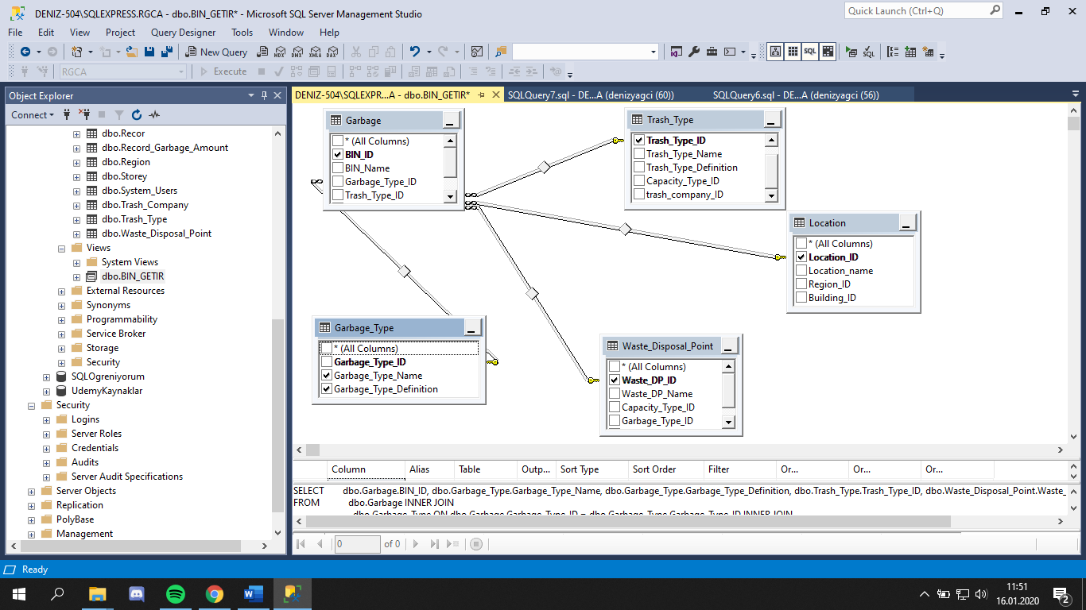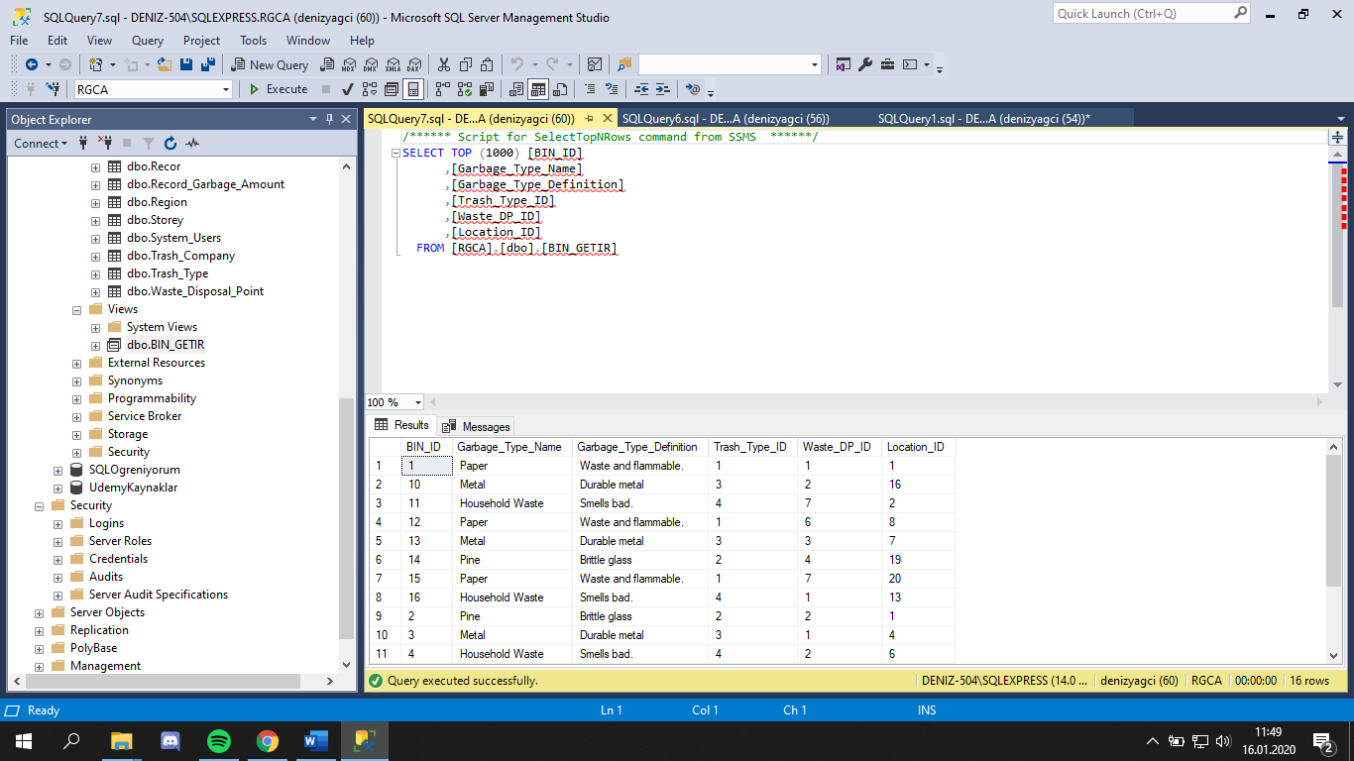

ALTER VIEW [dbo].[BIN_GETIR]

AS

select BIN_ID,Garbage_Type_Name,Garbage_Type_Definition,

Trash_Type.Trash_Type_ID,Location.Location_ID from Garbage

inner join Garbage_Type on Garbage.Garbage_Type_ID=Garbage_Type.Garbage_Type_ID

inner join Trash_Type on Garbage.Trash_Type_ID=Trash_Type.Trash_Type_ID

inner join Location on Garbage.Location_ID=Location.Location_ID

GO

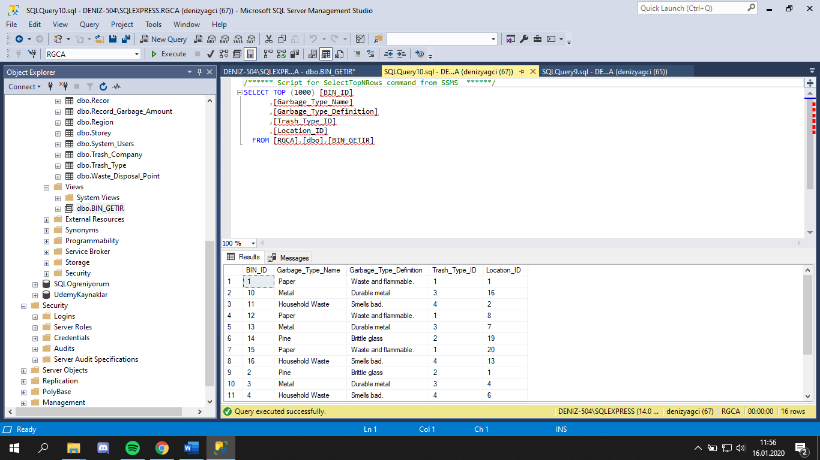

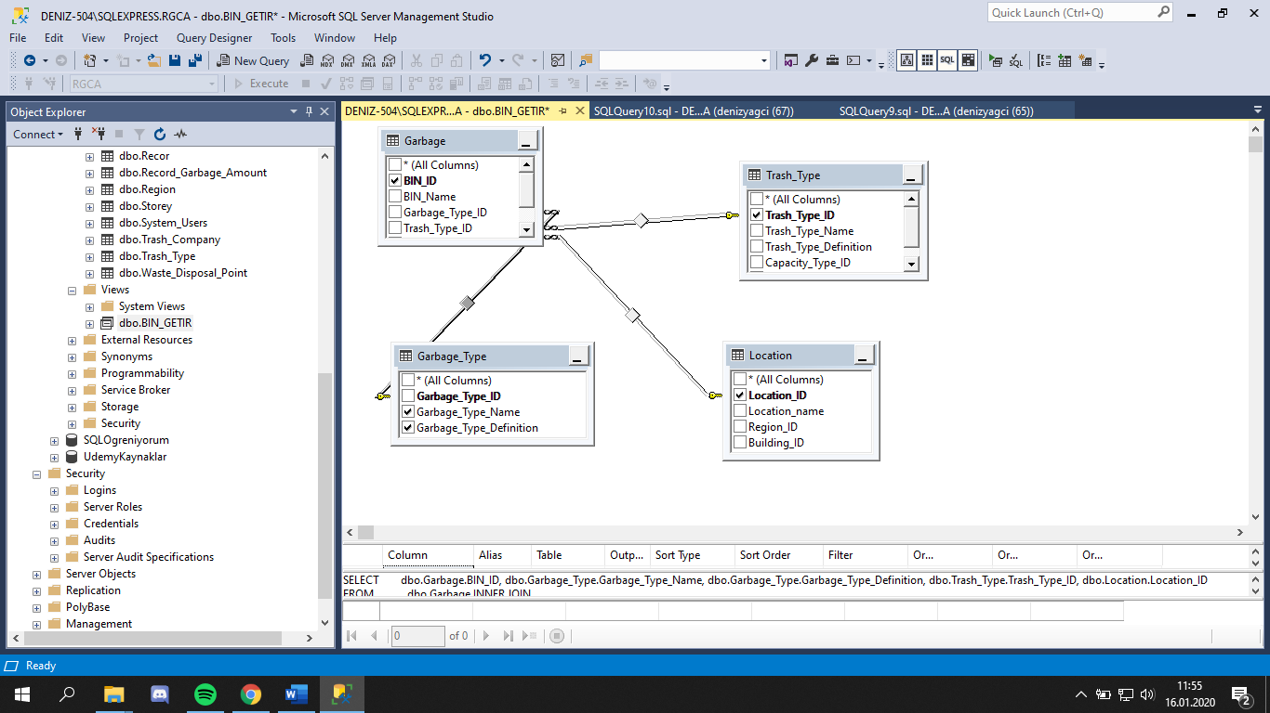

### **A.2)CREATE/ALTER INDEX EXAMPLES**

set statistics io on

set statistics time on

select*from Employee where Employee_Name='Deniz'

create nonclustered index Employee on Employee (Employee_Name)

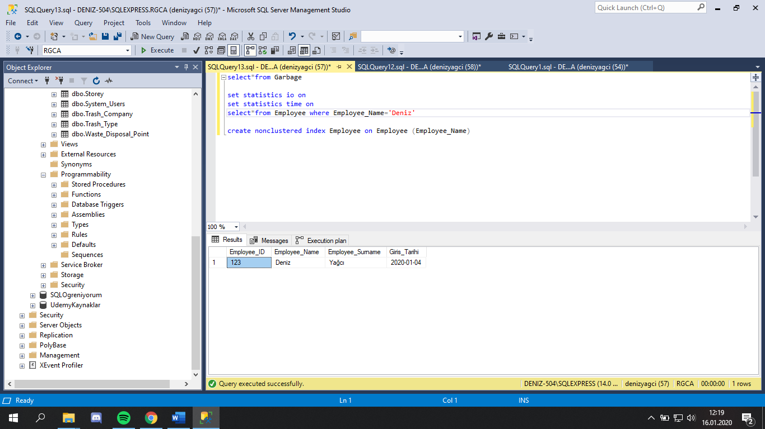 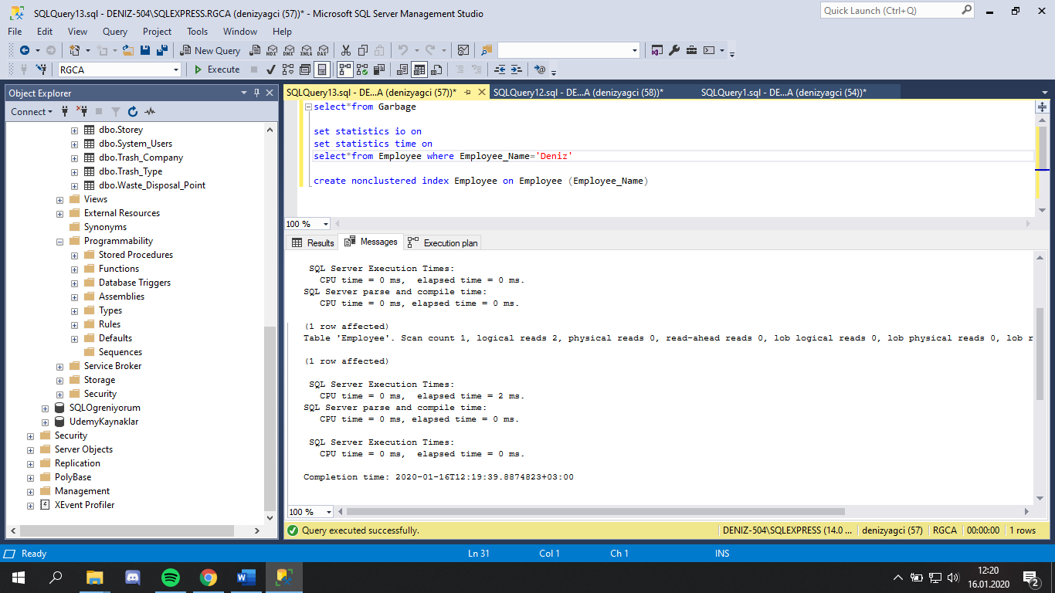

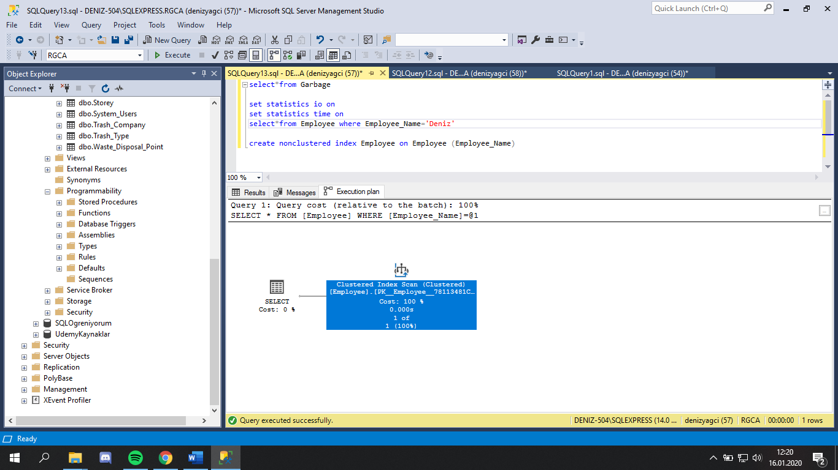

statistics io on

set statistics time on

select*from Employee where Giris_Tarihi='2020-01-04'

alter index IND_Employee_Getir

on Employee(Giris_Tarihi)

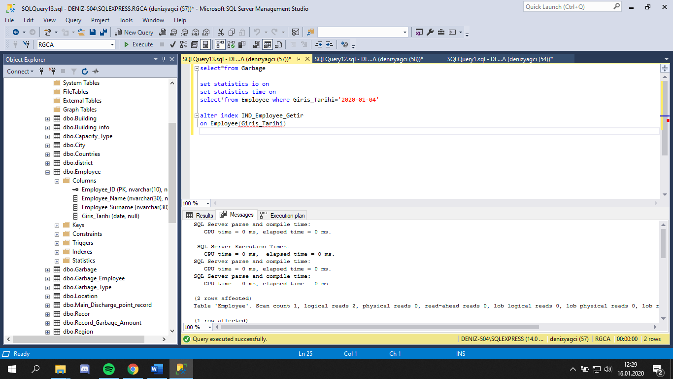

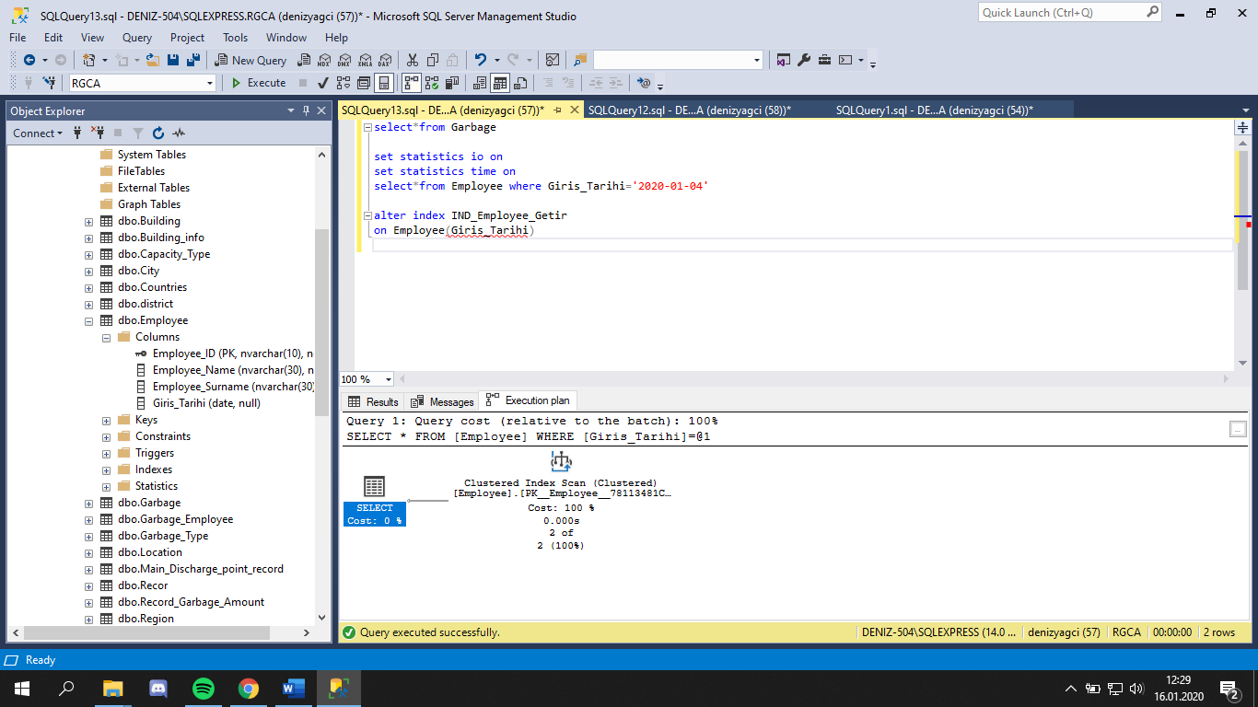

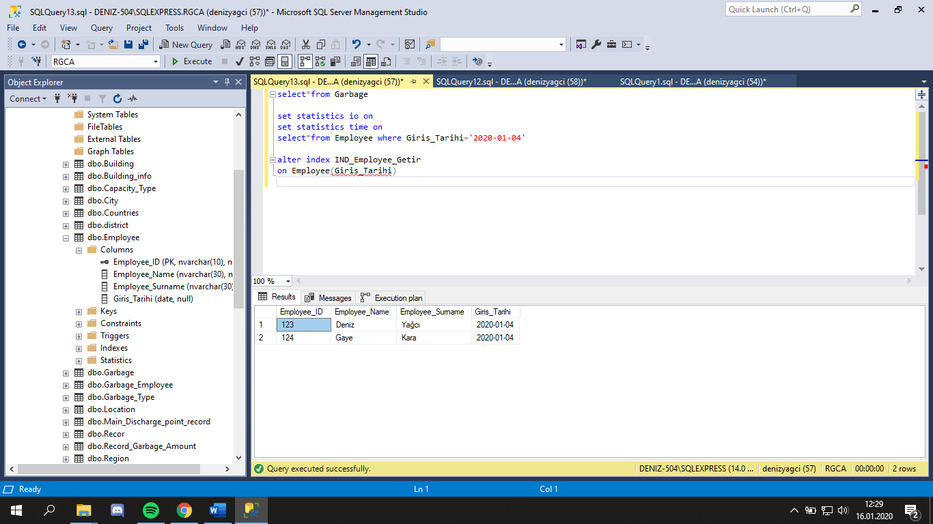

## **B)DML STATEMENTS-DATA MANIPULATION LANGUAGE**

### **B.1)INSERT INTO**

INSERT INTO [dbo].[Garbage]

([BIN_ID]

,[BIN_Name]

,[Garbage_Type_ID]

,[Trash_Type_ID]

,[Location_ID]

,[Waste_DP_ID])

VALUES

(

'17',

'BIN Paper',

'1',

'1',

'15',

'2'

)

GO

## 

### **B.2)UPDATE STATEMENTS**

UPDATE [dbo].[Garbage]

SET [BIN_ID] = '18'

,[BIN_Name] = 'BIN Metal'

,[Garbage_Type_ID] = '3'

,[Trash_Type_ID] = '3'

,[Location_ID] = '8'

,[Waste_DP_ID] = '4'

WHERE BIN_ID='17'

GO

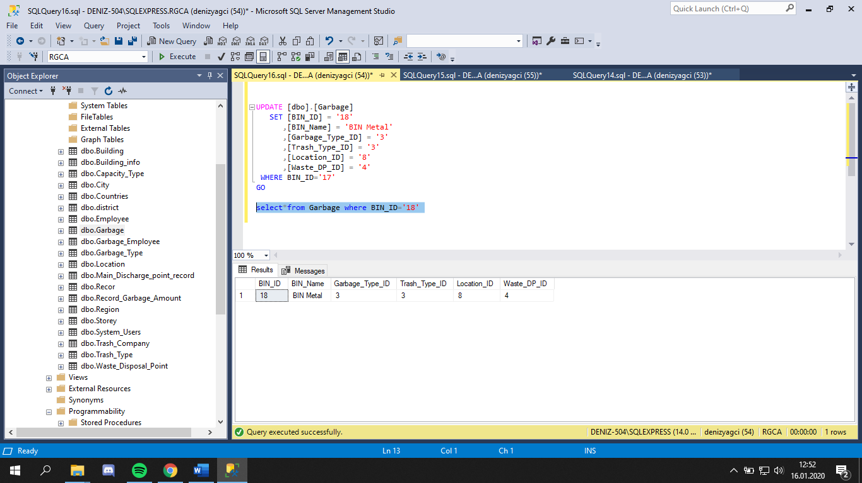

### **B.3)DELETE STATEMENTS**

DELETE FROM [dbo].[Garbage]

WHERE BIN_ID='18'

GO

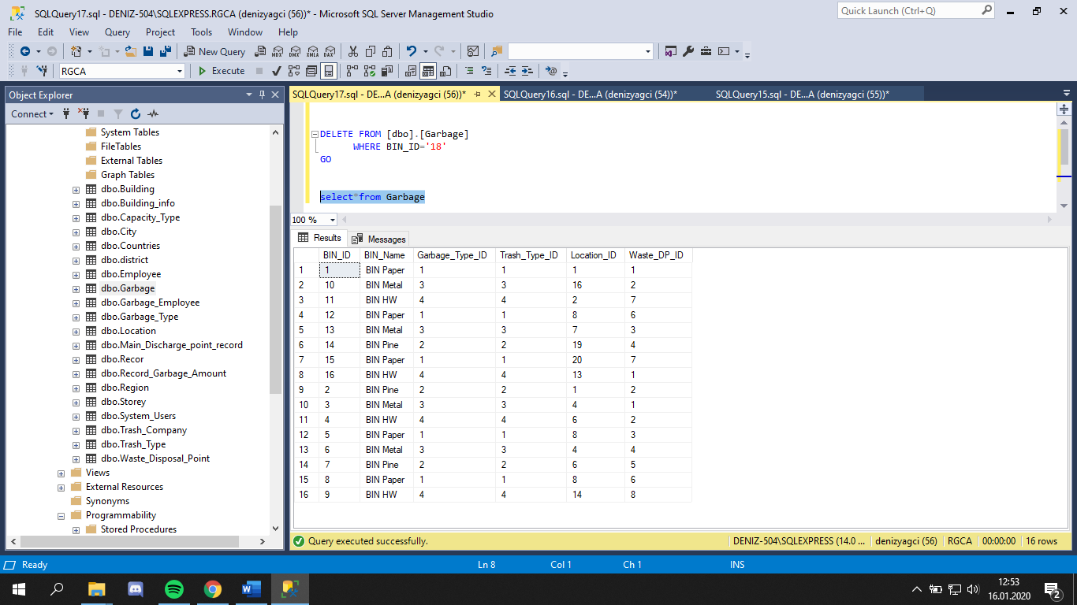

### **B.4)STORE PROCEDURE**

create proc [dbo].[SP_Location_Getir]

as

begin

select Location.Location_ID, Location_name,Region_Name,Building_Name, Storey_Name from Location

inner join Building on Location.Building_ID=Building.Building_ID

inner join Region on Location.Region_ID= Region.Region_ID

inner join Storey on Building.Storey_ID=Storey.Storey_ID

end

execute SP_Location_Getir

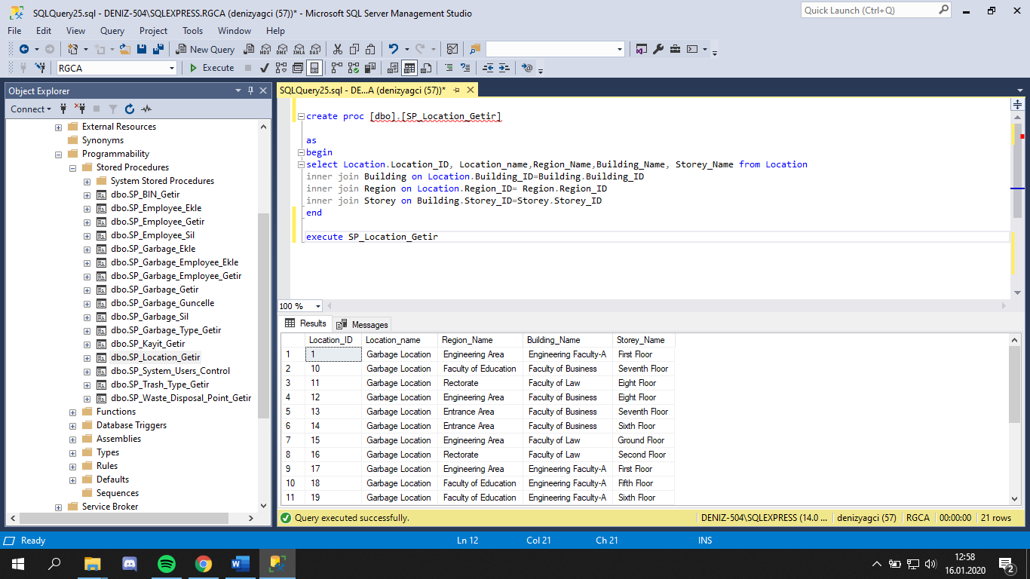

## **C)DQL STATEMENTS-DATA QUERY LANGUAGE**

### **C.1)SIMPLE JOINS-JOINING TWO TABLES**

select Location.Location_ID, Location_name,Region_Name,Building_Name, Storey_Name from Location

join Building on Location.Building_ID=Building.Building_ID

join Region on Location.Region_ID= Region.Region_ID

join Storey on Building.Storey_ID=Storey.Storey_ID

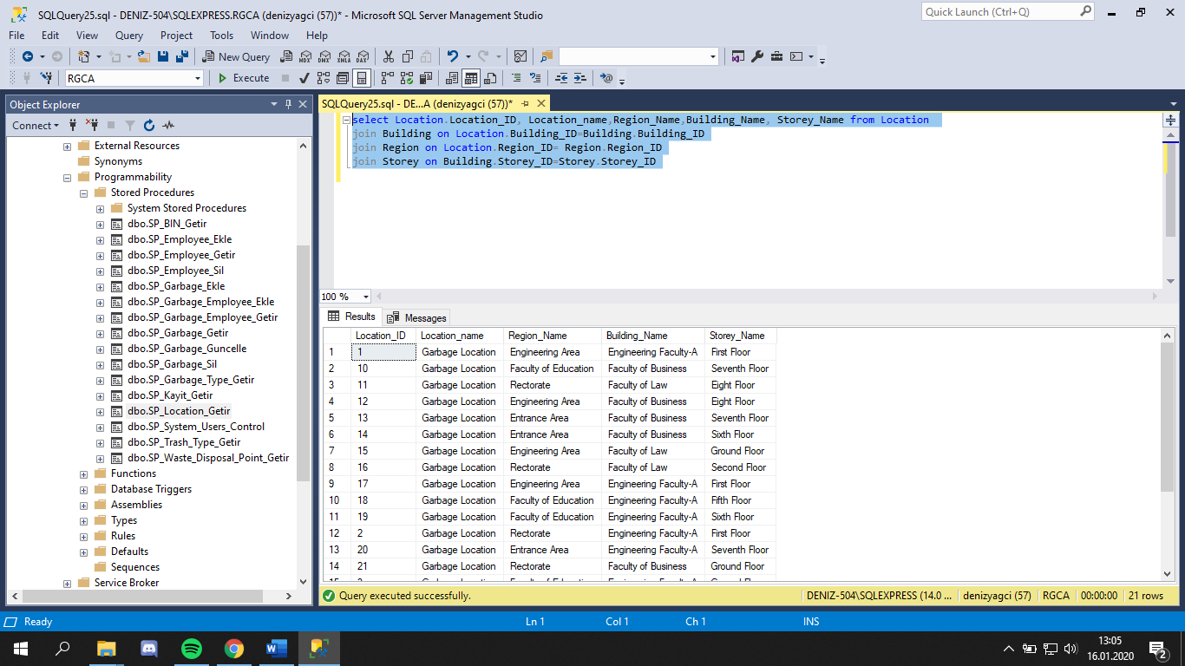

### **C.2)INNER/OUTER JOINS**

select Location.Location_ID, Location_name,Region_Name,Building_Name, Storey_Name from Location

inner join Building on Location.Building_ID=Building.Building_ID

inner join Region on Location.Region_ID= Region.Region_ID

inner join Storey on Building.Storey_ID=Storey.Storey_ID 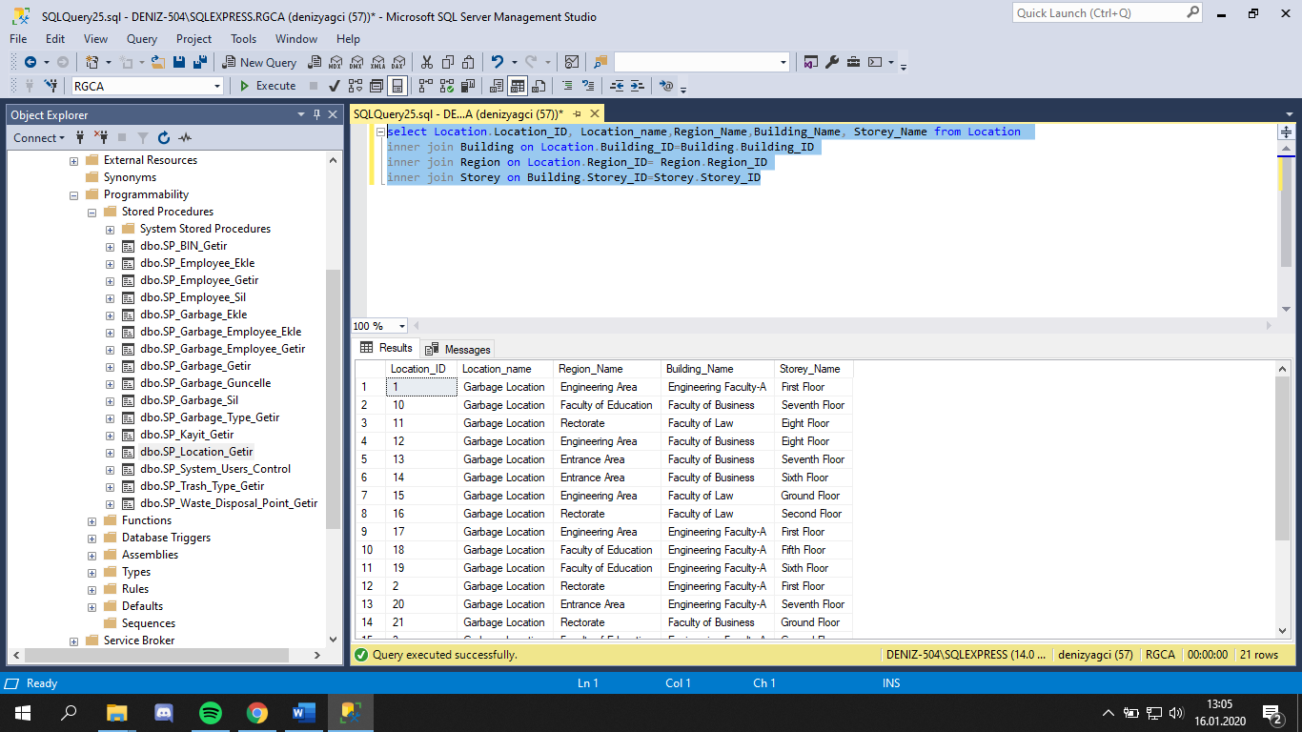

### **C.3)NESTED QUERIES**

SELECT *FROM Garbage

WHERE Location_ID=(SELECT Garbage_Type_ID FROM Garbage WHERE BIN_ID='14')

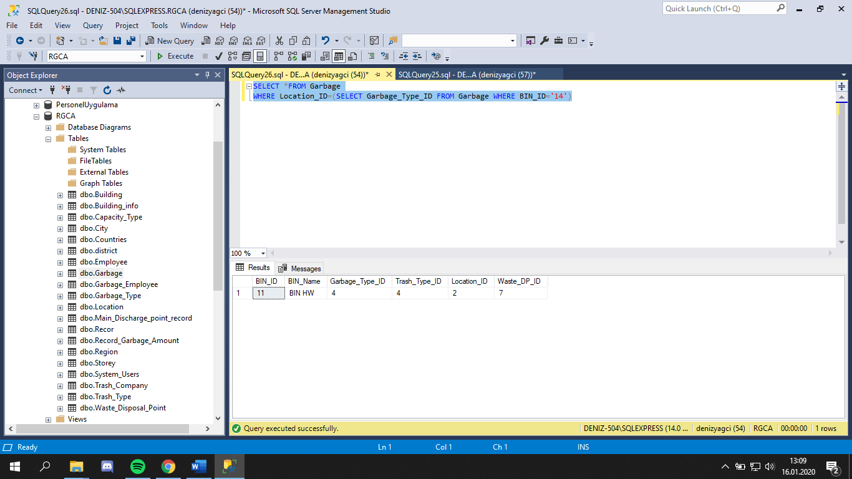

### **C.4)SORTING**

SELECT *FROM Garbage

ORDER BY BIN_Name DESC 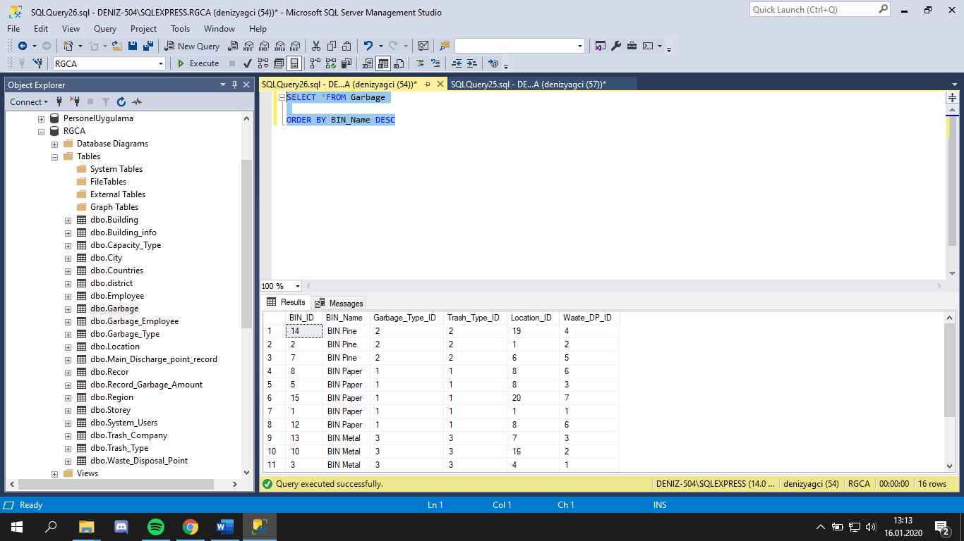

### **C.5)GROUP BY**

SELECT BIN_name, COUNT(BIN_Name) FROM

Garbage

GROUP BY BIN_Name 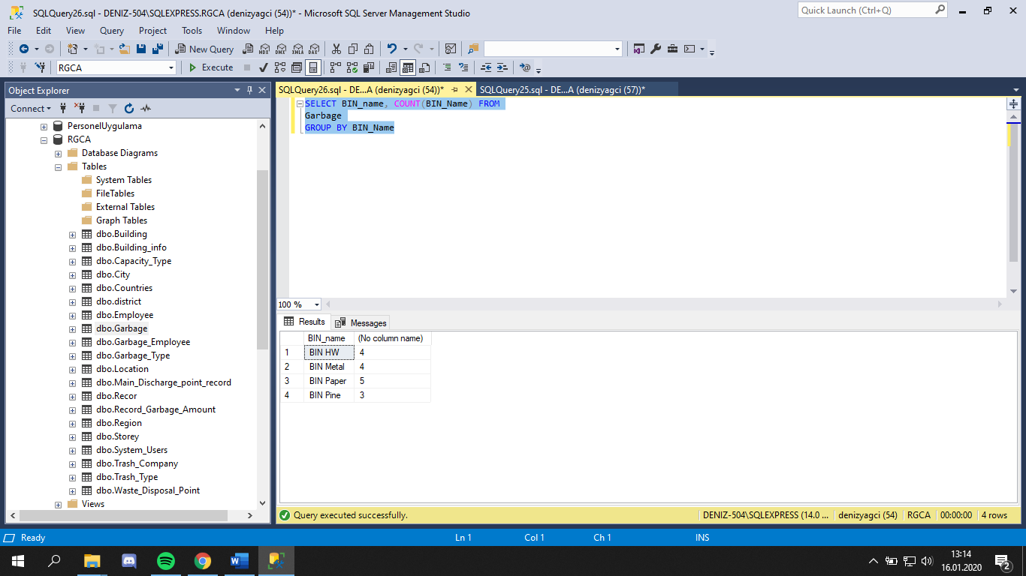

### **C.6)USING SELECT STATEMENTS WITH STORED PROCEDURE**

CREATE proc [dbo].[SP_BIN_Getir]

as

begin

select BIN_ID,Garbage_Type_Name,Garbage_Type_Definition,

Trash_Type.Trash_Type_ID,Waste_Disposal_Point.Waste_DP_ID,Location.Location_ID from Garbage

inner join Garbage_Type on Garbage.Garbage_Type_ID=Garbage_Type.Garbage_Type_ID

inner join Trash_Type on Garbage.Trash_Type_ID=Trash_Type.Trash_Type_ID

inner join Location on Garbage.Location_ID=Location.Location_ID

inner join Waste_Disposal_Point on Garbage.Waste_DP_ID=Waste_Disposal_Point.Waste_DP_ID

end

EXECUTE SP_BIN_Getir 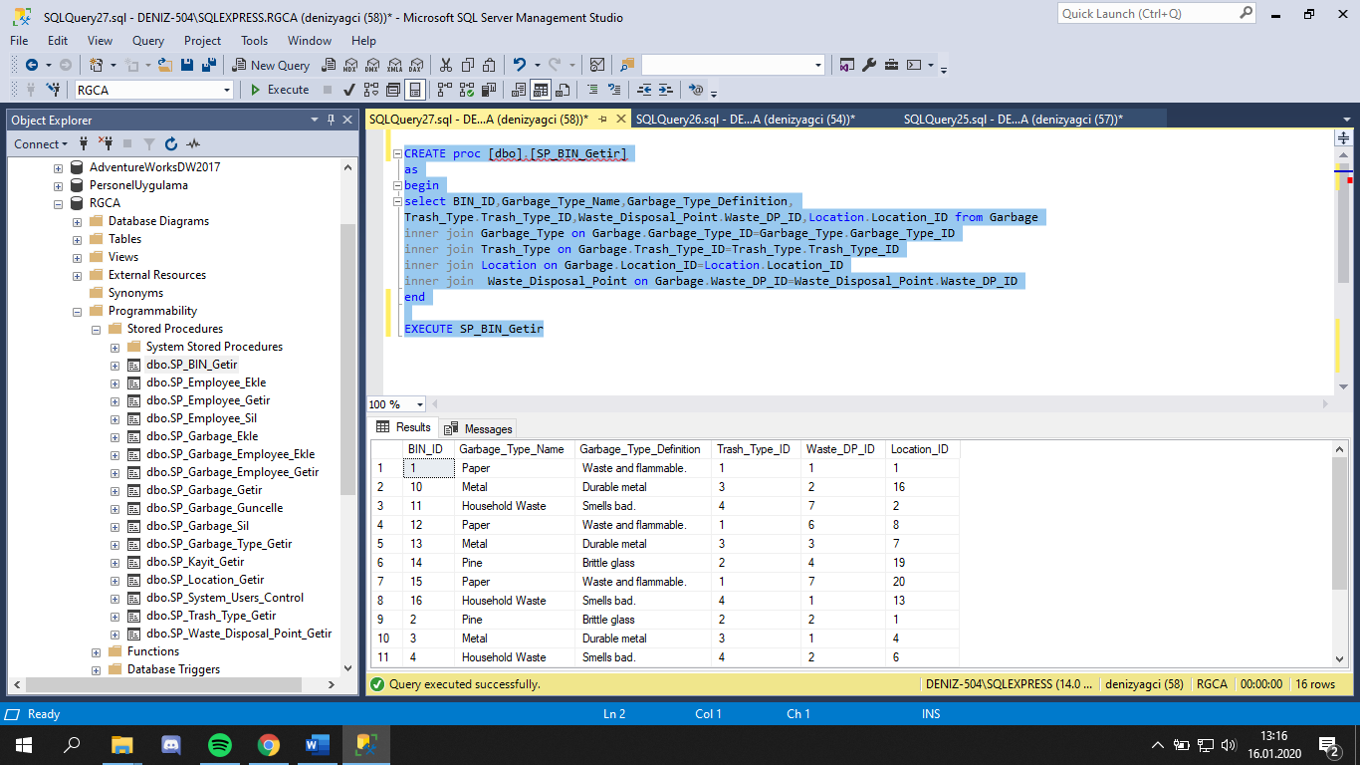

## **D)DCL STATEMENTS-DATA CONTROL LANGUAGE**

CREATE TRANSACTION

UPDATE System_Users SET User_Sifre='2'

WHERE User_ID='1'

COMMIT

BEGIN CATCH

ROLLBACK

END CATCH

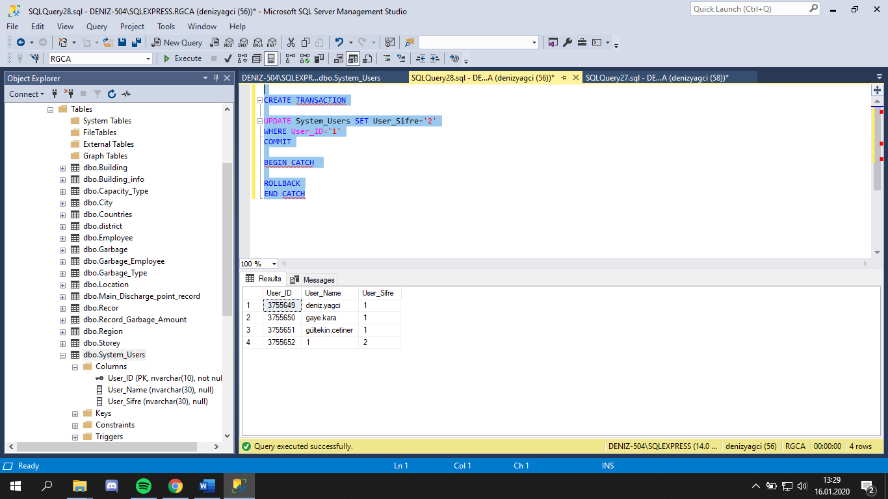

# **INTEGRETY TEST**

## **1)TEST 1**

CREATE TABLE [dbo].[Garbage_Employee](

[Garbage_Employee_ID] [nvarchar](10) NOT NULL,

[BIN_ID] [nvarchar](10) NULL,

[Employee_ID] [nvarchar](10) NULL,

PRIMARY KEY CLUSTERED

(

[Garbage_Employee_ID] ASC

)WITH (PAD_INDEX = OFF, STATISTICS_NORECOMPUTE = OFF, IGNORE_DUP_KEY = OFF, ALLOW_ROW_LOCKS = ON, ALLOW_PAGE_LOCKS = ON) ON [PRIMARY]

) ON [PRIMARY]

GO

ALTER TABLE [dbo].[Garbage_Employee] WITH CHECK ADD FOREIGN KEY([Employee_ID])

REFERENCES [dbo].[Employee] ([Employee_ID])

GO

ALTER TABLE [dbo].[Garbage_Employee] WITH CHECK ADD FOREIGN KEY([BIN_ID])

REFERENCES [dbo].[Garbage] ([BIN_ID])

GO

INSERT INTO [dbo].[Garbage_Employee]

([Garbage_Employee_ID]

,[BIN_ID]

,[Employee_ID])

VALUES

('1041','3','123')

GO

**It run because, Garbage and Employee tables(Master tables) have this data BIN_ID=’3’ and Employee_ID=’123’**

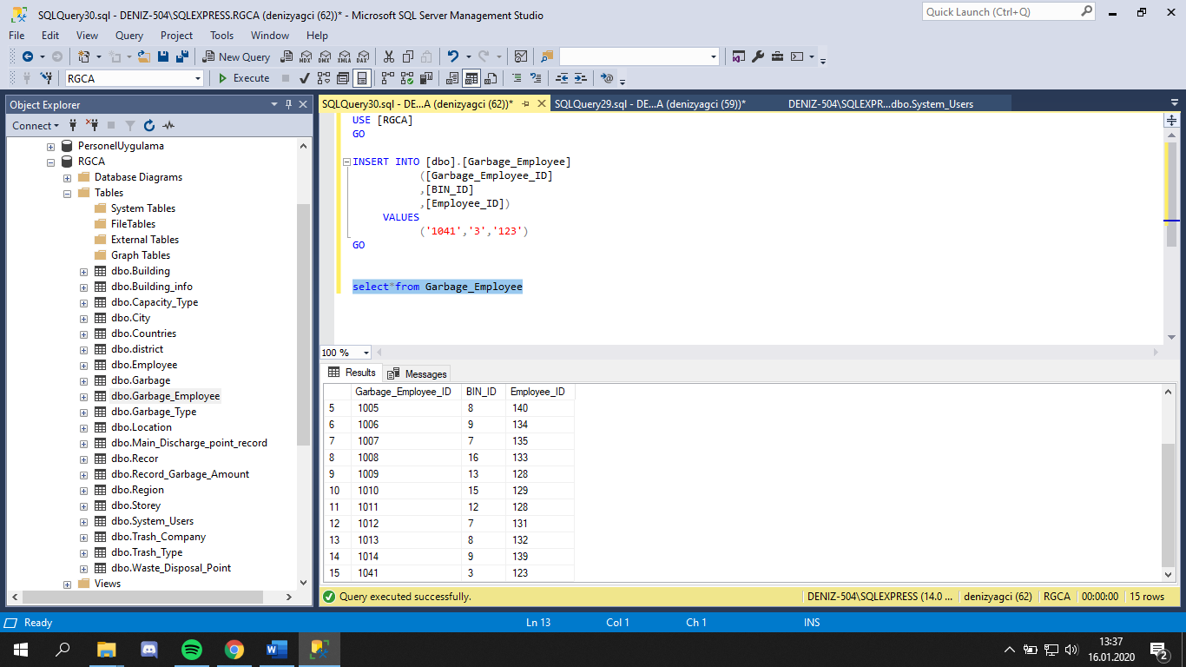

## **2)TEST 2**

UPDATE [dbo].[Building]

SET [Building_ID] = '23'

,[Building_Name] = 'xxxxxx'

,[Storey_ID] = '10'

WHERE Building='10'

GO

**It doesn’t run because Storey table(Child table) don’t contain data is storey_ıd=’10’**

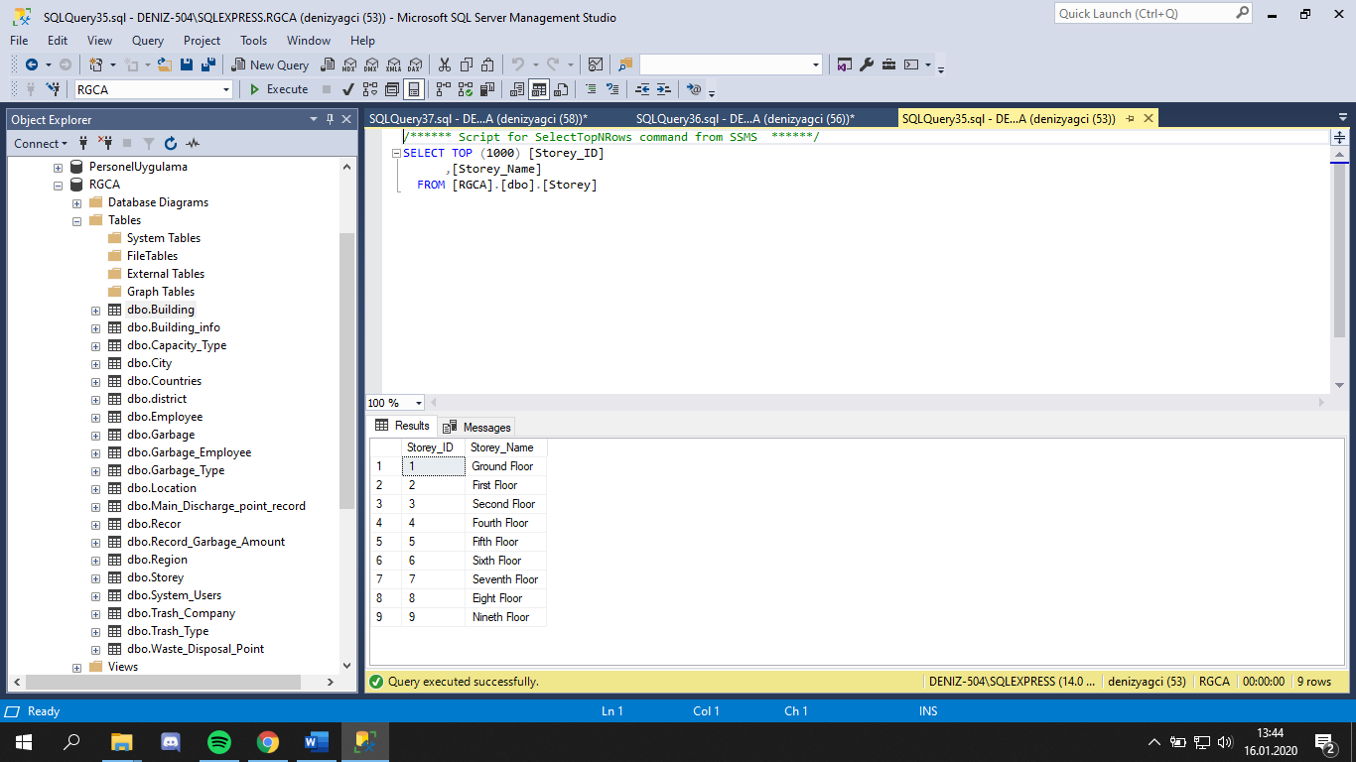

**3)TEST 3**

DELETE FROM [dbo].[Storey]

WHERE Storey_Name='First Floor'

GO

**It doesn’t run because this data is used by Building table(master table).**

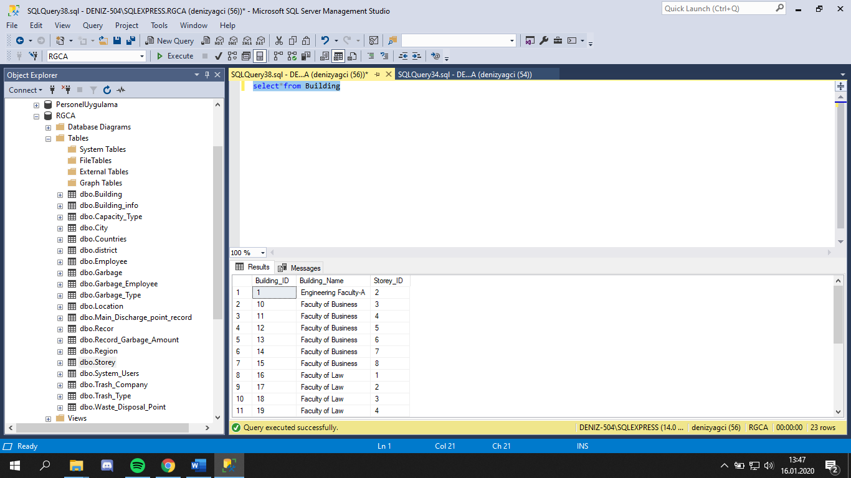

## **4)TEST 4**

select BIN_ID,Garbage_Type_Name,Garbage_Type_Definition,

Trash_Type.Trash_Type_ID,Waste_Disposal_Point.Waste_DP_ID,Location.Location_ID from Garbage

inner join Garbage_Type on Garbage.Garbage_Type_ID=Garbage_Type.Garbage_Type_ID

inner join Trash_Type on Garbage.Trash_Type_ID=Trash_Type.Trash_Type_ID

inner join Location on Garbage.Location_ID=Location.Location_ID

inner join Waste_Disposal_Point on Garbage.Waste_DP_ID=Waste_Disposal_Point.Waste_DP_ID

**It run because these tables have relations with PK and FK consraints.**

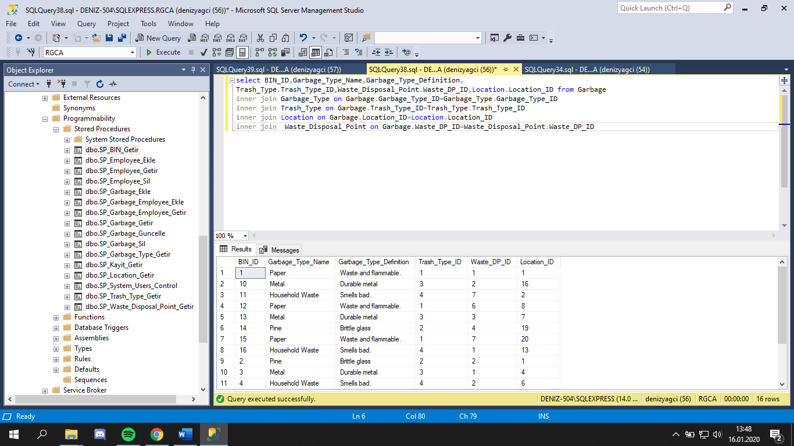

## **5)TEST 5**

INSERT INTO [dbo].[System_Users]

([User_ID]

,[User_Name]

,[User_Sifre])

VALUES

('1223456'

,'ddedededededededeedddddddddddedededede'

,'dededededededededededededdddddddddd')

GO

**It doesn’t run because, User([User_ID] ,[User_Name] ,[User_Sifre])**

**Data type is different.**

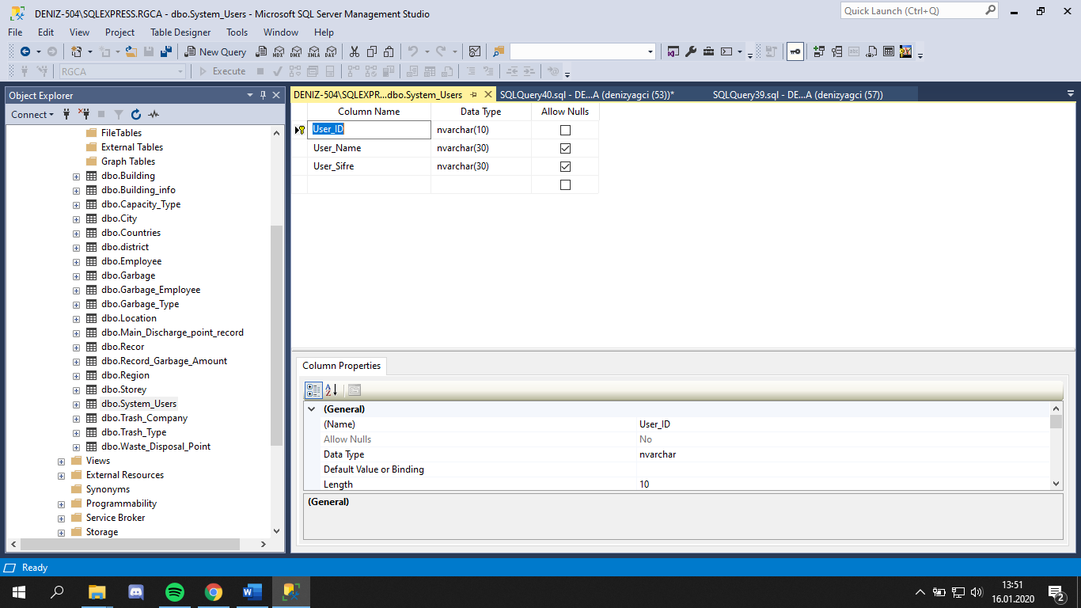

**6)TEST 6**

INSERT INTO [dbo].[Garbage]

([BIN_ID]

,[BIN_Name]

,[Garbage_Type_ID]

,[Trash_Type_ID]

,[Location_ID]

,[Waste_DP_ID])

VALUES

('1'

,'BIN paper'

,'1'

,'2'

,'4'

,'5')

GO

**It doesn’t run because, BIN_ID=’1’ data already been in Garbage table.**

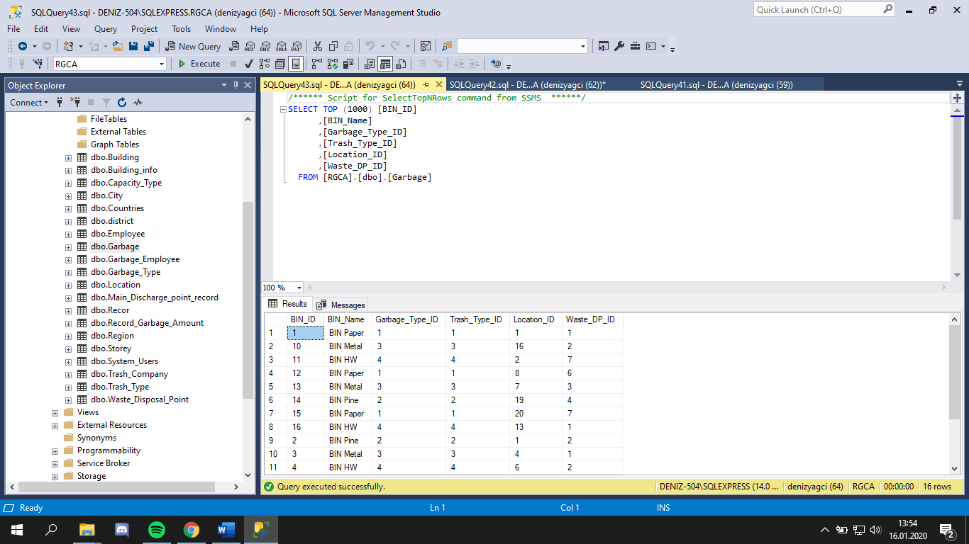

## **7)TEST 7**

DELETE FROM [dbo].[Trash_Type]

WHERE Trash_Type_ID='1'

GO

**It doesn’t run because this data is used by Garbage table(master table).**

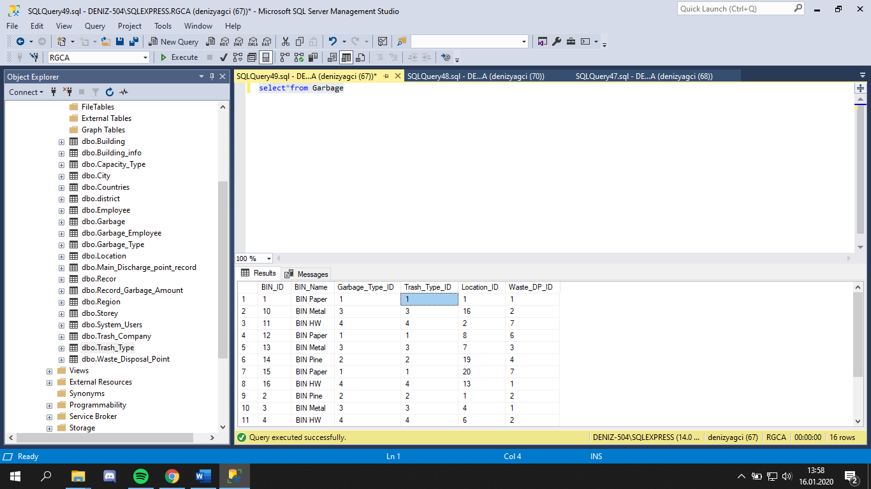

## **8)TEST 8**

select BIN_ID,Garbage_Employee_ID,Employee_Name,Employee_Surname, Employee.Giris_Tarihi from Garbage_Employee

inner join Employee on Garbage_Employee.Employee_ID=Employee.Employee_ID

**It run because, Employee table(master) and Garbage_Employee table(child) have a relation with Employee_ID** .

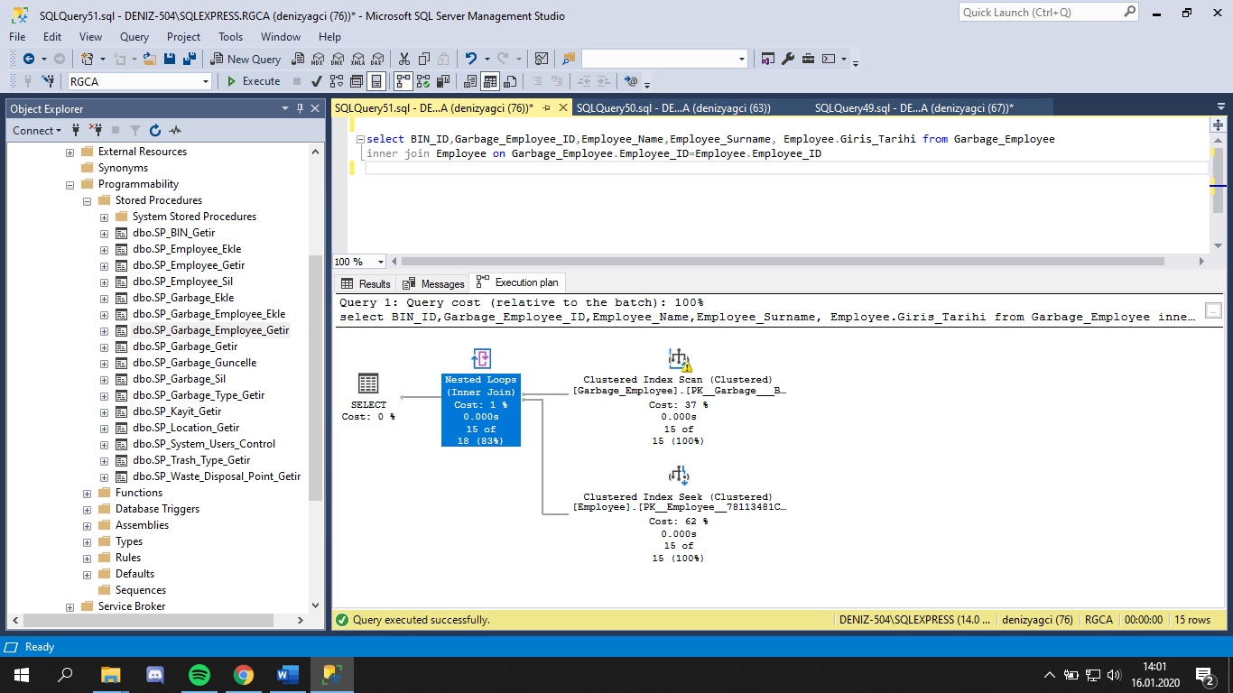

## **9)TEST 9**

select Location.Location_ID, Location_name,Region_Name,Building_Name, Storey_Name from Location

inner join Building on Location.Building_ID=Building.Building_ID

inner join Region on Location.Region_ID= Region.Region_ID

inner join Storey on Building.Storey_ID=Storey.Storey_ID

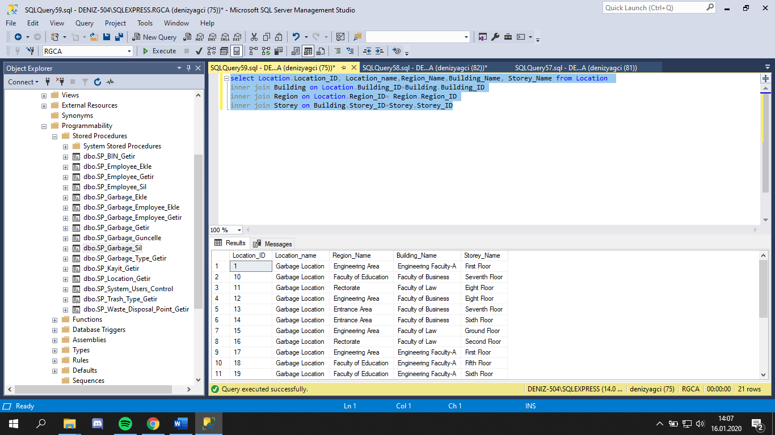

# **RGC Application(Visual Studio/C#)**

N-tier architecture was used to create this application.

* DataAccessLayer
* BusinessLogicLayer
* UserInterFace

Object-oriented programming is done in a certain order and order when dealing with the database. applications; how to access the data, what applications will be made on it and how to present it to the user side are the most important problems for a programmer. The three-tier architecture helps programmers at this point. Three-tier architecture is an important programming technique that has gained importance with object-oriented programming and is used by many programmers today. It is easier and faster to manage programs that are prepared using three-tier architecture. Because in programs prepared according to three separate layers, each action is designed separately and it is clear what is where; thus, in cases where intervention is required, this process is performed easily and without wasting time.

Layered architecture consists of 3 separate layers. These are: Data Layer, Business Layer and Presentation Layer.

In the three-tier architecture, the lowest layer is the data layer (Data Layer) where the data is withdrawn from the database and the incoming data is added to the database. With the data layer, the existing data in the database is drawn to the application. In the same way, the data layer required for the user-entered data to be saved in the application environment is saved in the existing database.

The data extracted via the data layer cannot be directly integrated into the created application. Because with the data layer, only the data is drawn to the application environment, but the operations to be performed on it are still unclear. For this purpose, adaptation of the extracted data to the application must be performed. This is provided by the Business Layer. Data adapted to the program created with the work layer is now ready.

The last one is the Presentation Layer, where the user interface of the application is configured. With the presentation layer, the view of the data that we have made available in the business layer, which will now go to the user, is determined and the application we have created is now complete.

As described above, the three-tier architecture is implemented interactively. First, the data layer (Data Layer) is drawn from the database, the business layer (Business Layer) to ensure the compatibility of this data and the presentation layer (Presentation Layer) to create an interface with the user data is shown. This can be done in the opposite direction, ie the user enters the data via the user interface (presentation layer), the entered data is adapted to the database (business layer) and finally transferred to the database (data layer). As can be seen, the three-tier architecture is implemented interactively. Below is an application for a clear understanding of this structure.

## **A)Photos of App**

* The system user is the login page.

You can login using your username and password. 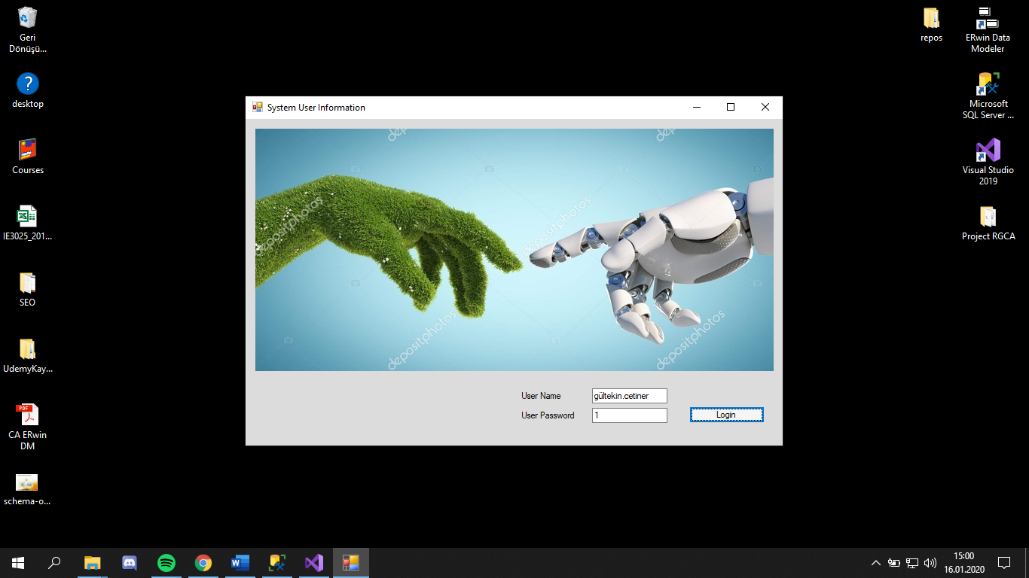

* 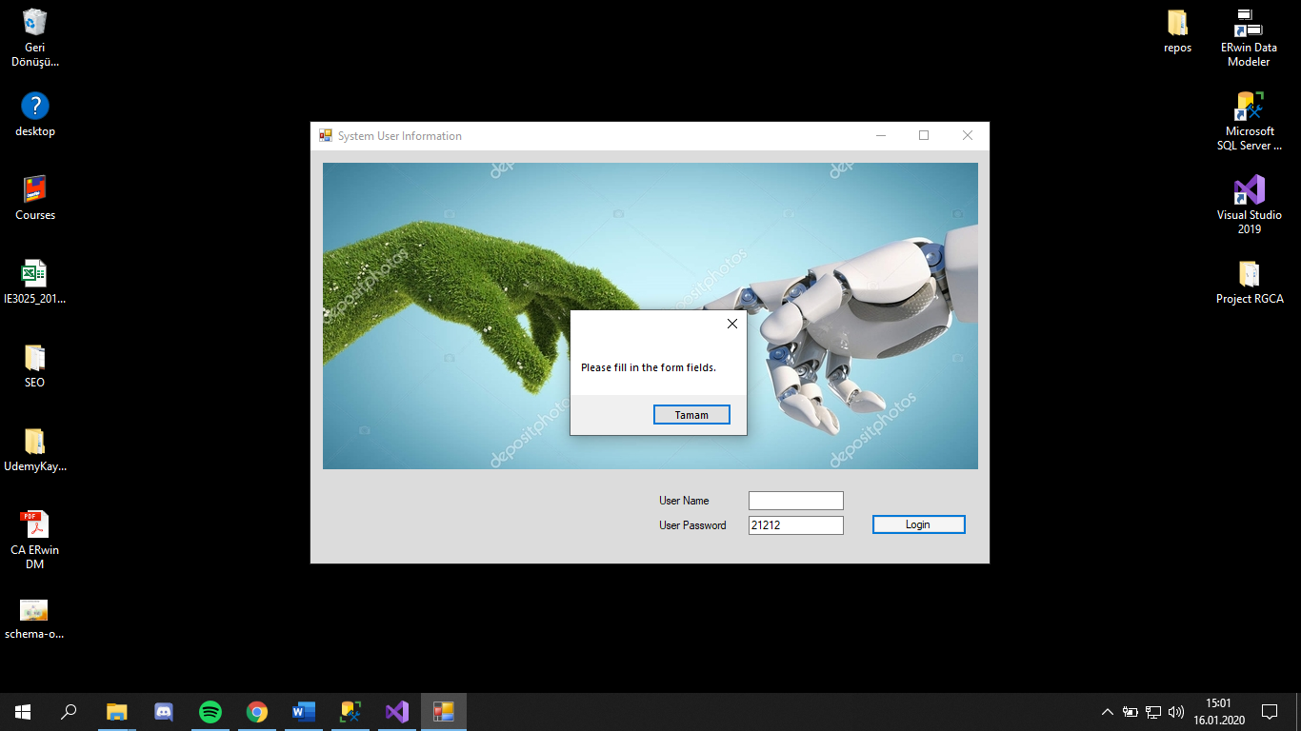It will give warning when missing information is entered.
* It will give warning when wrong information is entered.

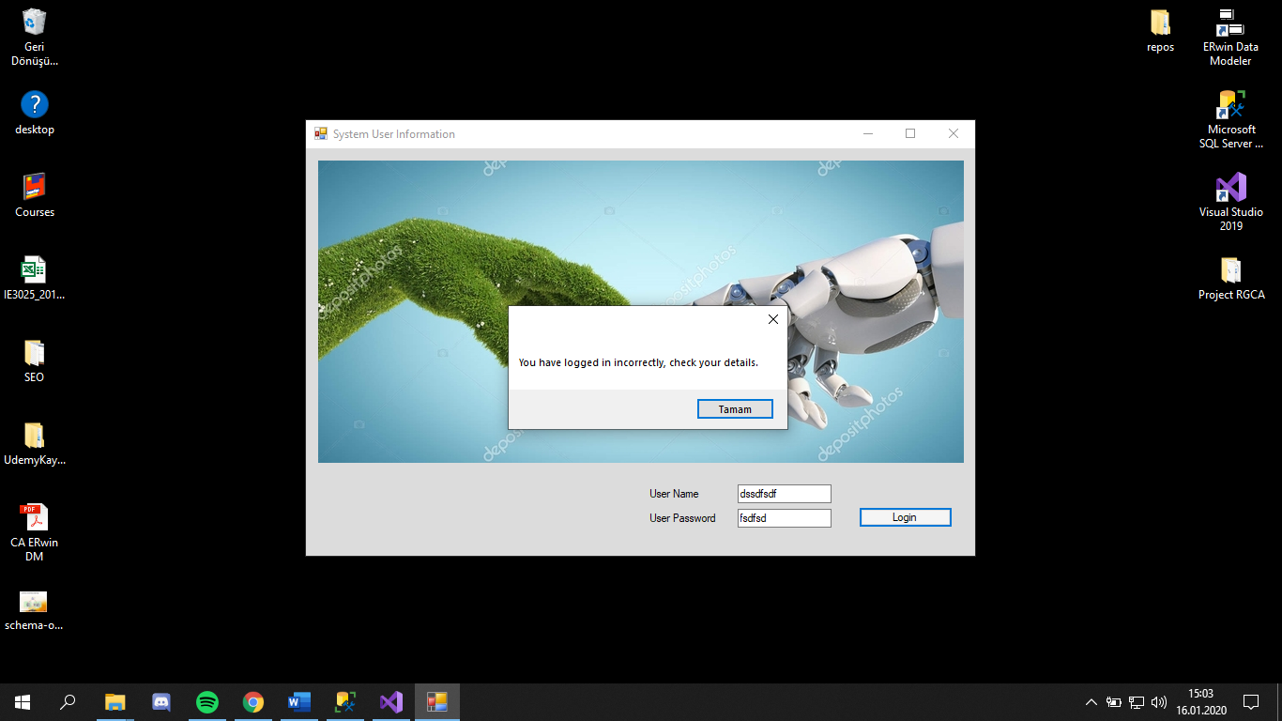

* By clicking on the buttons, the data of the relevant button will appear at the bottom. According to the information 'add' button you can add records.

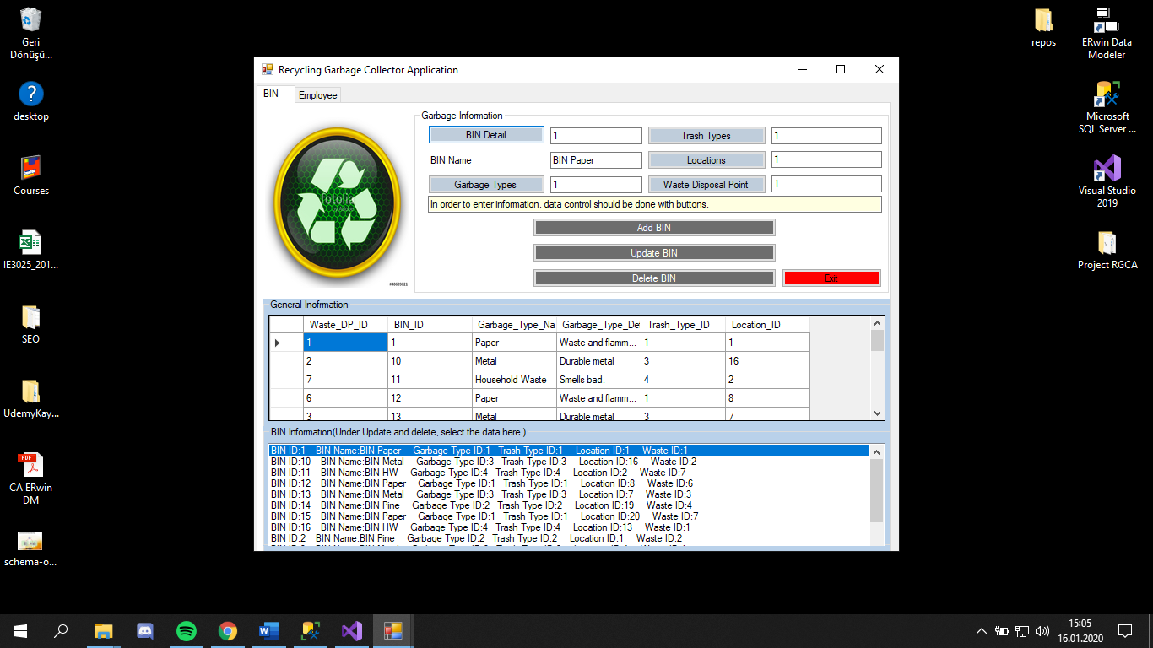

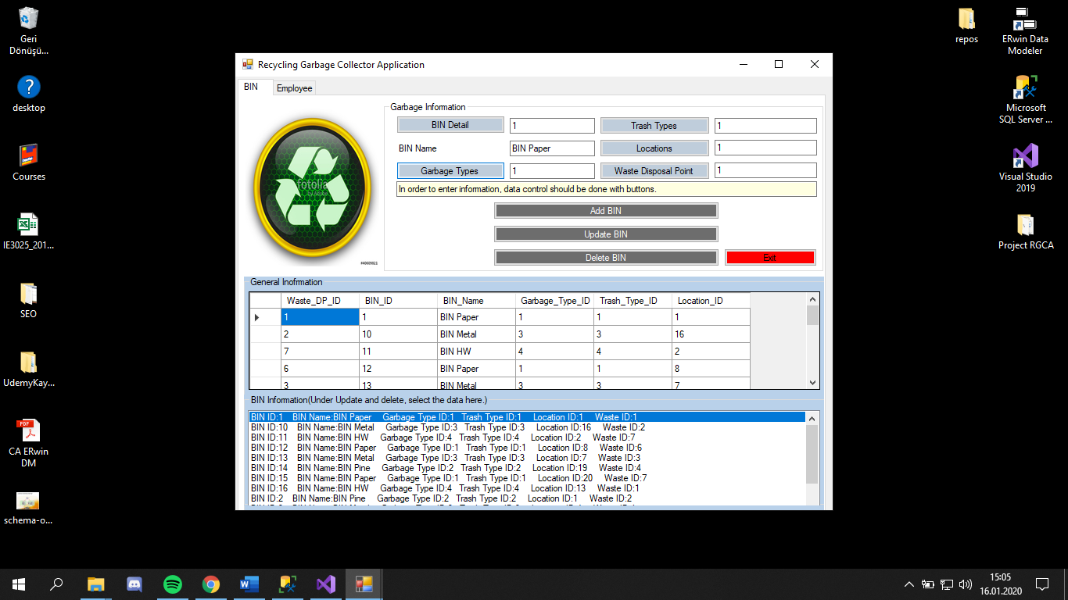

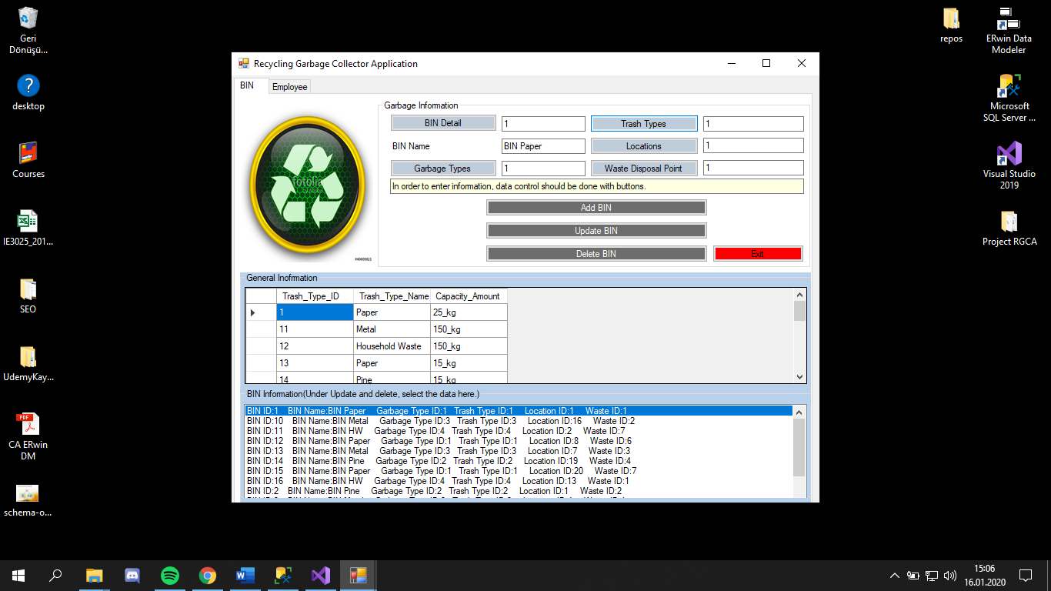

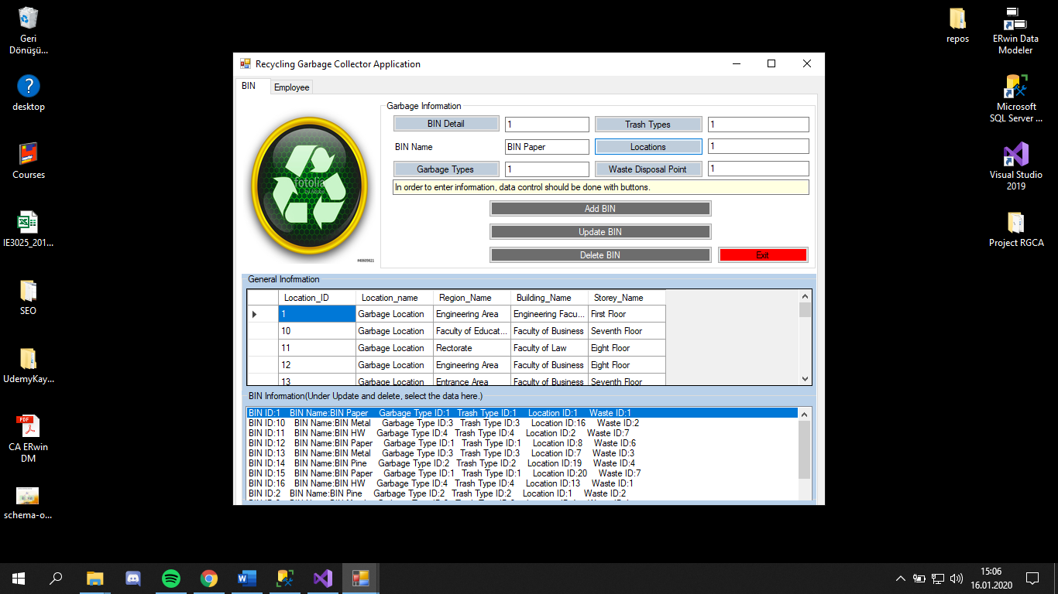

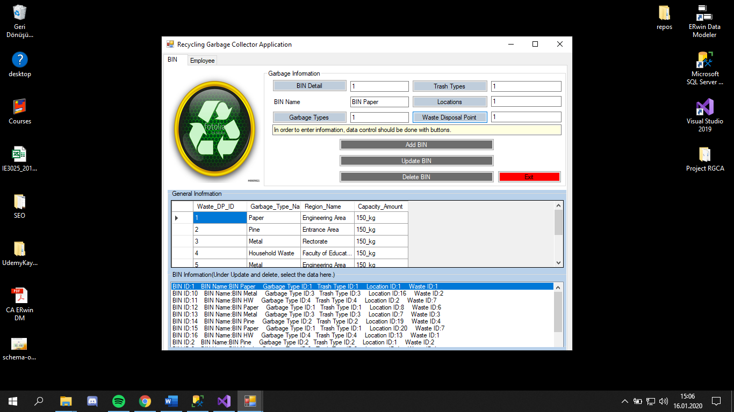

* Clicking the 'add' button will ask you if you are sure to register.

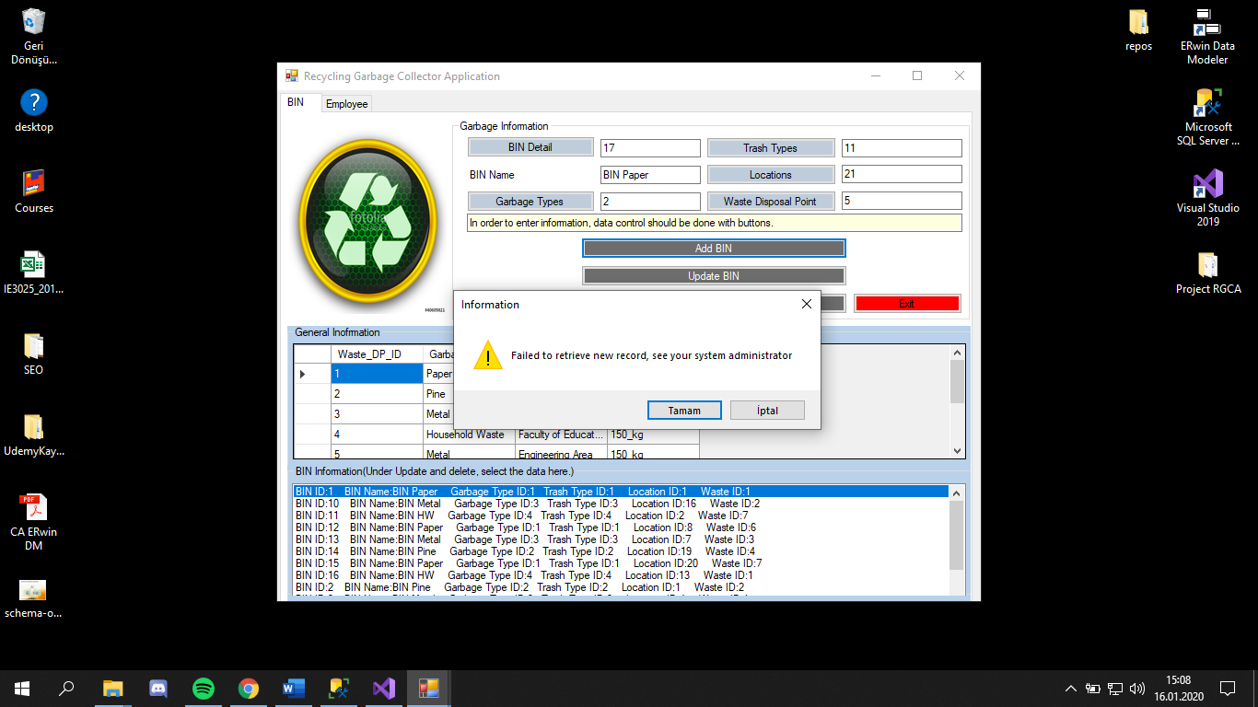

* By selecting the data from the 'text_file' section, the boxes match the data. As a result of pairing, 'delete' and 'update' button is done with the necessary actions.

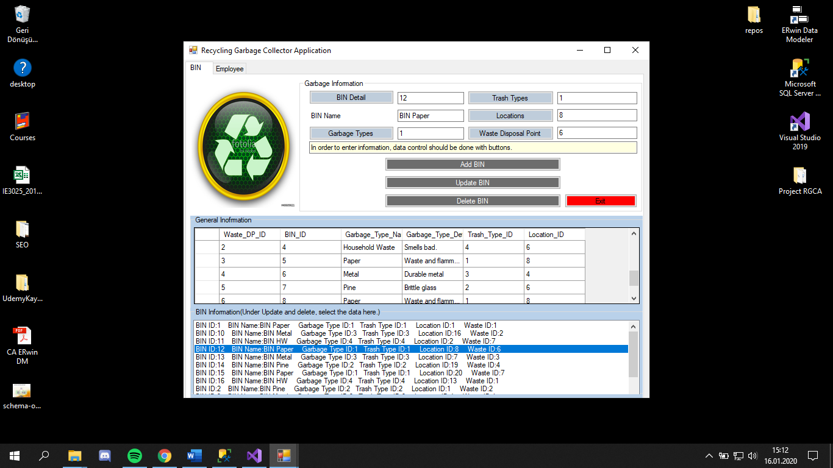

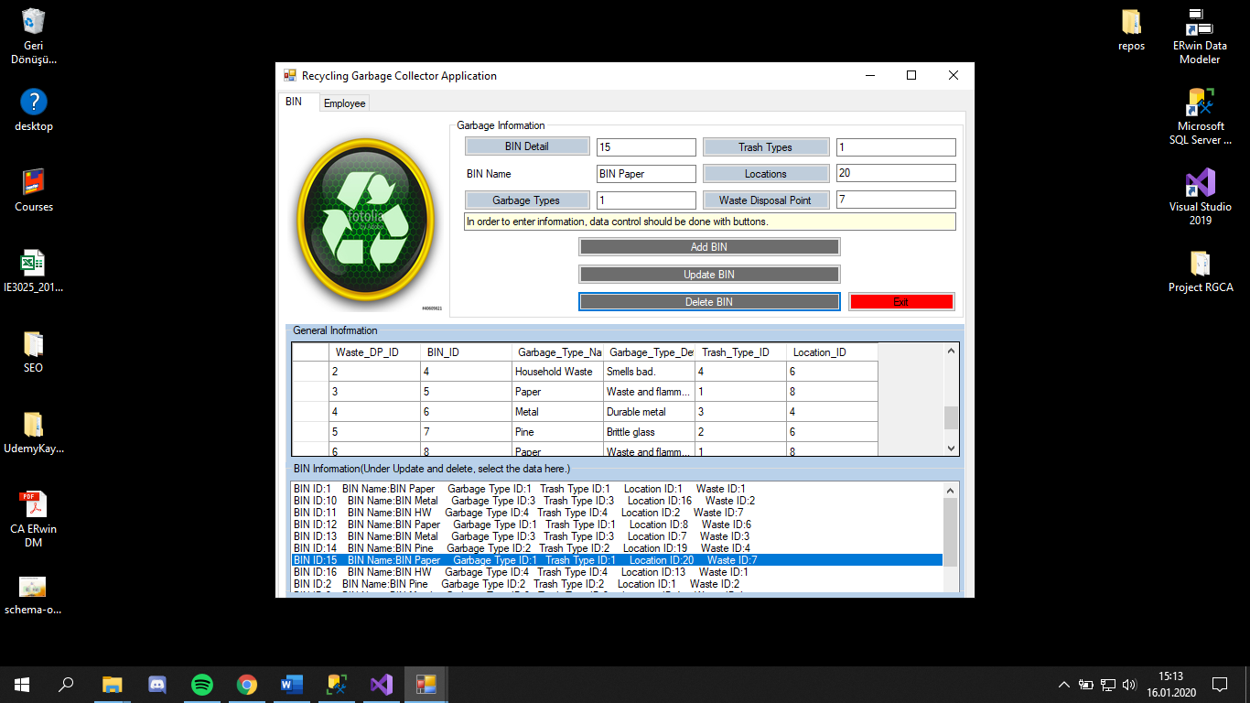

* Deletion can be dispensed with.

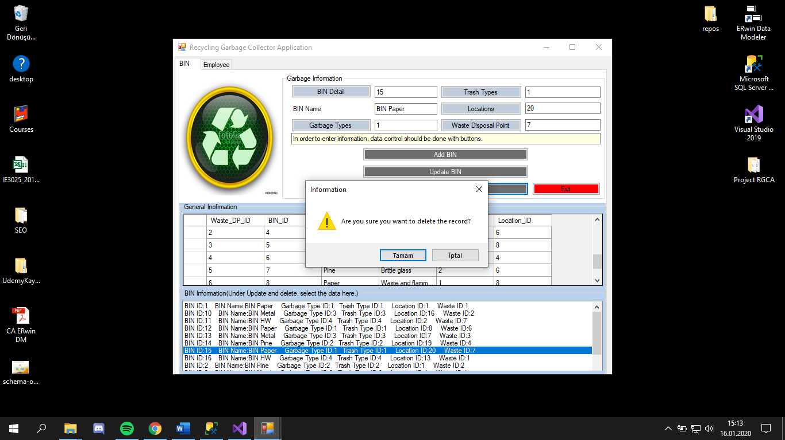

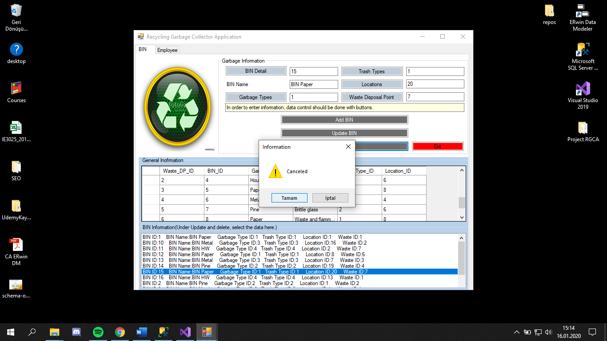

* 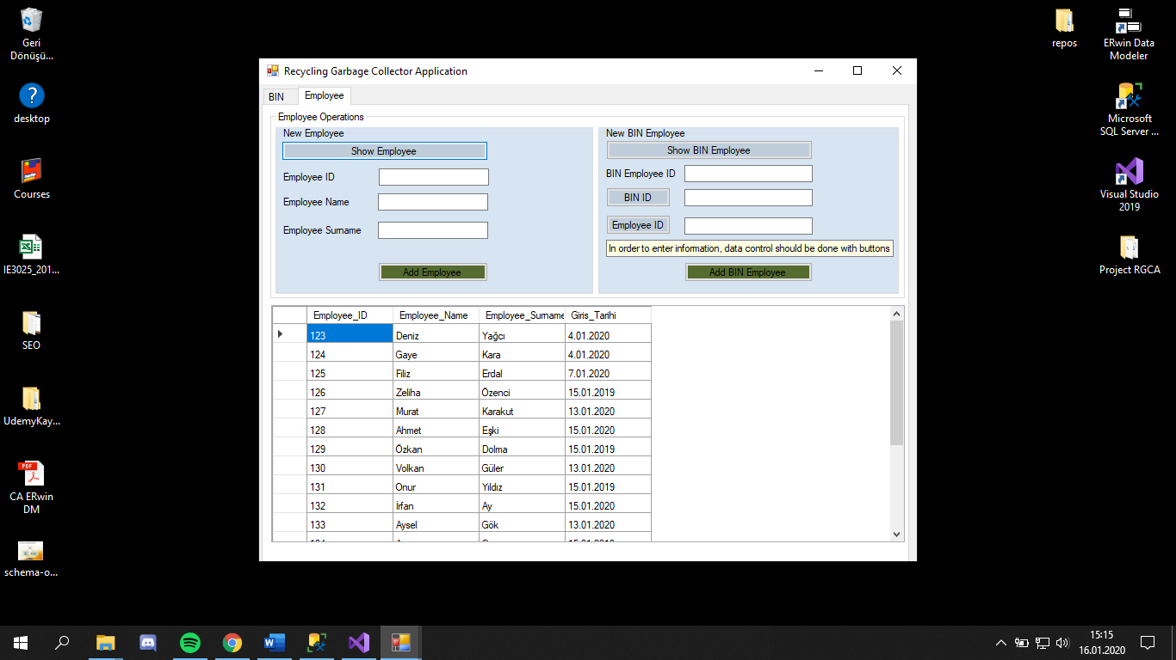In the 'Employee' section, general workers can be checked and added.

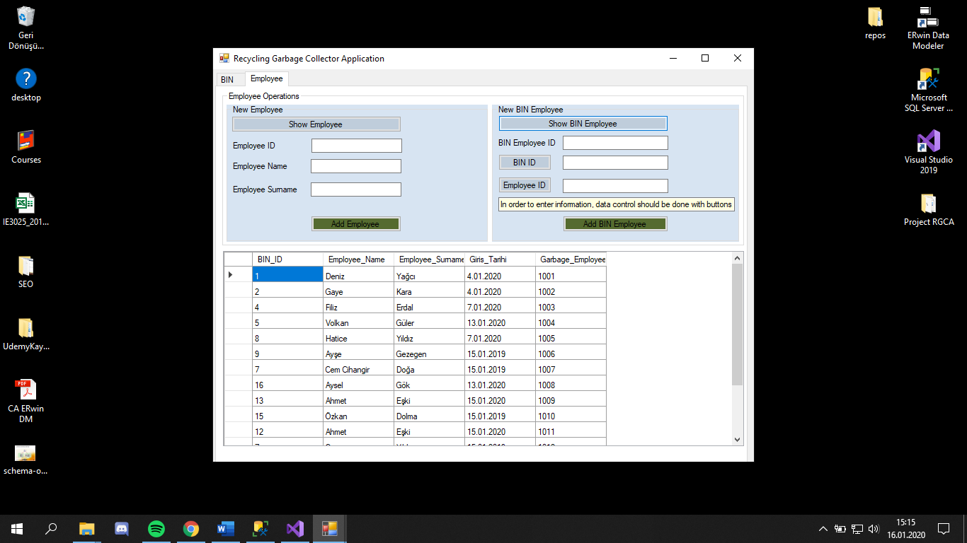

* After the required data is checked and entered, add can be done with 'add' buttons.

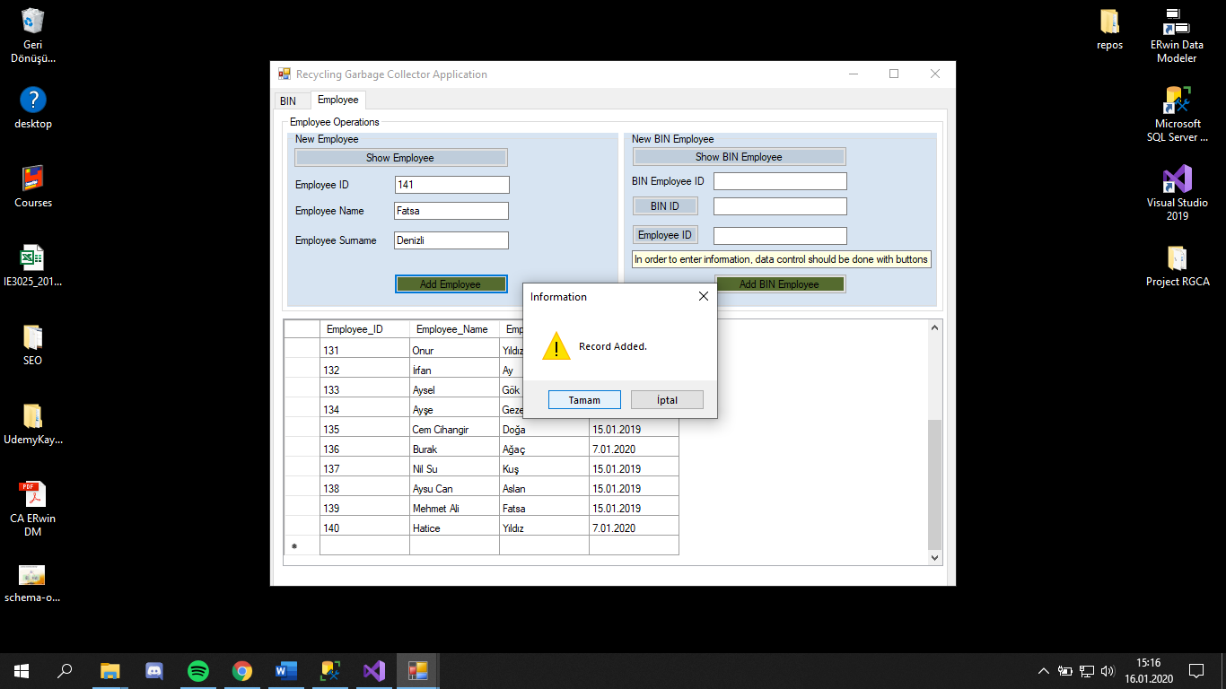

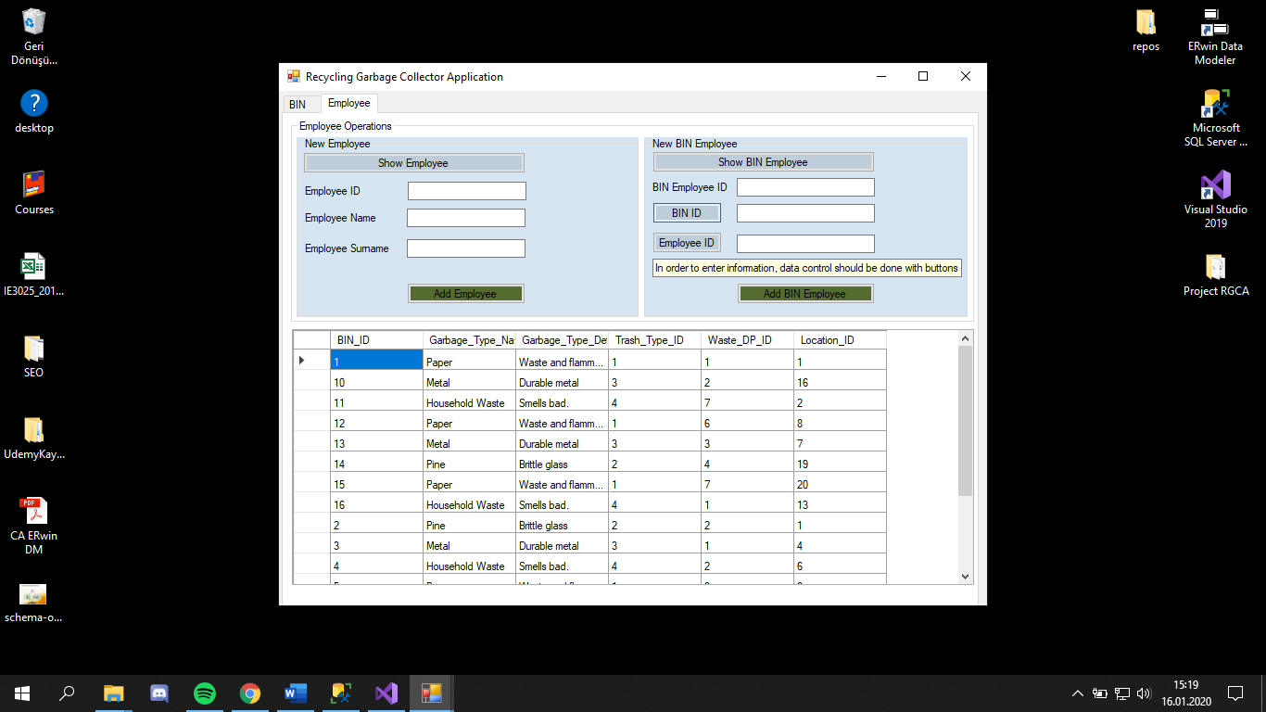

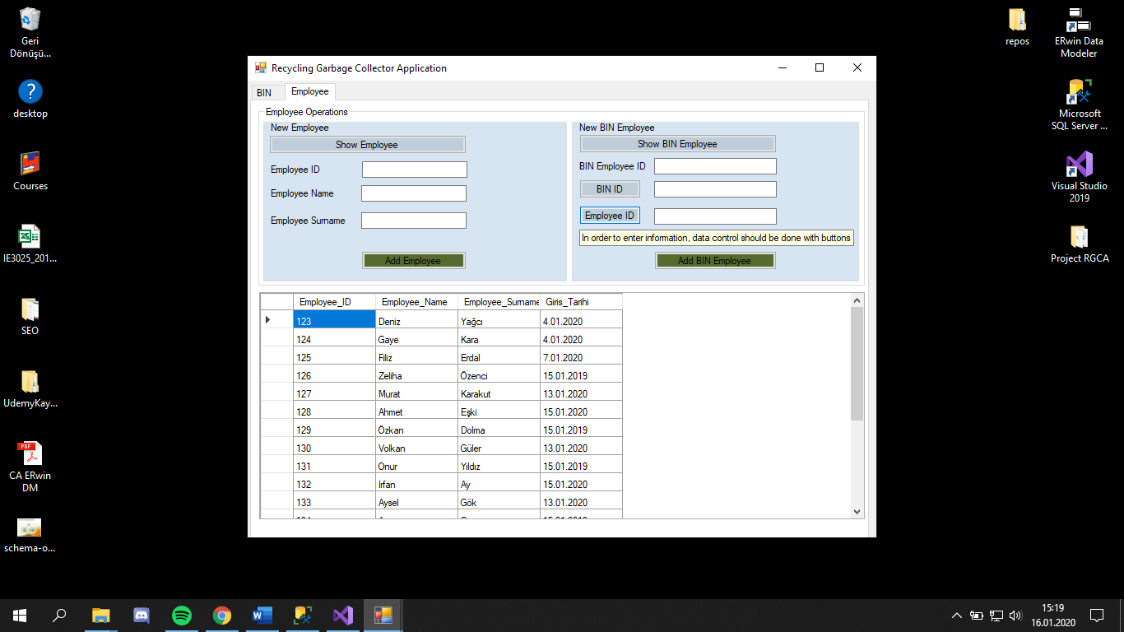

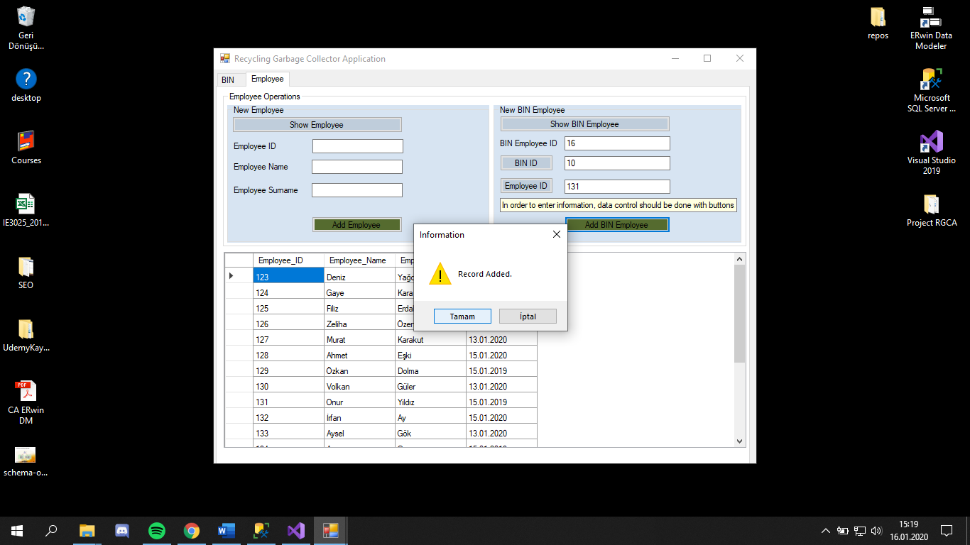

## **B)Codes of App**

using System;

using System.Collections.Generic;

using System.Linq;

using System.Text;

using System.Threading.Tasks;

using System.Data.SqlClient;

using System.Data;

using System.Configuration;

namespace RGCA

{

internal class DataAccessLayer

{

SqlConnection connect;

SqlCommand command;

SqlDataReader reader;

int sonuc = 0;

public DataAccessLayer()

{

connect = new SqlConnection();

connect.ConnectionString = ConfigurationManager.ConnectionStrings["SQL"].ConnectionString;

}

internal void BaglantiAyarla()

{

if (connect.State == System.Data.ConnectionState.Closed)

{

connect.Open();

}

else

{

connect.Close();

}

}

internal int SystemEntryControl(SystemUsers S)

{

try

{

command = new SqlCommand("SP_System_Users_Control", connect);

command.CommandType = CommandType.StoredProcedure;

command.Parameters.Add("@User_Name", SqlDbType.NVarChar).Value = S.User_Name;

command.Parameters.Add("@User_Sifre", SqlDbType.NVarChar).Value = S.User_Sifre;

BaglantiAyarla();

sonuc = (int)command.ExecuteScalar();

}

catch (Exception ex)

{

}

finally

{

BaglantiAyarla();

}

return sonuc;

}

internal SqlDataReader Garbage_Type_Getir()

{

command = new SqlCommand("SP_Garbage_Type_Getir", connect);

command.CommandType = CommandType.StoredProcedure;

BaglantiAyarla();

return command.ExecuteReader();

}

internal SqlDataReader Garbage_Getir()

{

command = new SqlCommand("SP_Garbage_Getir", connect);

command.CommandType = CommandType.StoredProcedure;

BaglantiAyarla();

return command.ExecuteReader();

}

internal SqlDataReader Trash_Type_Getir()

{

command = new SqlCommand("SP_Trash_Type_Getir", connect);

command.CommandType = CommandType.StoredProcedure;

BaglantiAyarla();

return command.ExecuteReader();

}

internal SqlDataReader Locations_Getir()

{

command = new SqlCommand("SP_Location_Getir", connect);

command.CommandType = CommandType.StoredProcedure;

BaglantiAyarla();

return command.ExecuteReader();

}

internal SqlDataReader Waste_Disposal_Point_Getir()

{

command = new SqlCommand("SP_Waste_Disposal_Point_Getir", connect);

command.CommandType = CommandType.StoredProcedure;

BaglantiAyarla();

return command.ExecuteReader();

}

internal SqlDataReader BIN_Getir()

{

command = new SqlCommand("SP_BIN_Getir", connect);

command.CommandType = CommandType.StoredProcedure;

BaglantiAyarla();

return command.ExecuteReader();

}

internal int New_Bin(Garbage G)

{

try

{

command = new SqlCommand("SP_Garbage_Ekle", connect);

command.CommandType = CommandType.StoredProcedure;

command.Parameters.Add("@BIN_ID", SqlDbType.NVarChar).Value = G.BIN_ID;

command.Parameters.Add("@BIN_Name", SqlDbType.NVarChar).Value = G.BIN_Name;

command.Parameters.Add("@Garbage_Type_ID", SqlDbType.NVarChar).Value = G.Garbage_Type_ID;

command.Parameters.Add("@Trash_Type_ID", SqlDbType.NVarChar).Value = G.Trash_Type_ID;

command.Parameters.Add("@Location_ID", SqlDbType.NVarChar).Value = G.Location_ID;

command.Parameters.Add("@Waste_DP_ID", SqlDbType.NVarChar).Value = G.Waste_DP_ID;

BaglantiAyarla();

sonuc = (int)command.ExecuteNonQuery();

}

catch (Exception ex)

{

}

finally

{

BaglantiAyarla();

}

return sonuc;

}

internal SqlDataReader Garbage_Employee_Getir()

{

command = new SqlCommand("SP_Garbage_Employee_Getir", connect);

command.CommandType = CommandType.StoredProcedure;

BaglantiAyarla();

return command.ExecuteReader();

}

internal SqlDataReader Employee_Getir()

{

command = new SqlCommand("SP_Employee_Getir", connect);

command.CommandType = CommandType.StoredProcedure;

BaglantiAyarla();

return command.ExecuteReader();

}

internal int New_Employee(Employee E)

{

try

{

command = new SqlCommand("SP_Employee_Ekle", connect);

command.CommandType = CommandType.StoredProcedure;

command.Parameters.Add("@Employee_ID", SqlDbType.NVarChar).Value = E.Employee_ID;

command.Parameters.Add("@Employee_Name", SqlDbType.NVarChar).Value = E.Employee_Name;

command.Parameters.Add("@Employee_Surname", SqlDbType.NVarChar).Value = E.Employee_Surname;

command.Parameters.Add("@Giris_Tarihi", SqlDbType.Date).Value = E.Giris_Tarihi;

BaglantiAyarla();

sonuc = (int)command.ExecuteNonQuery();

}

catch (Exception ex)

{

}

finally

{

BaglantiAyarla();

}

return sonuc;

}

internal int New_Bin_Employee(BINEmployee BE)

{

try

{

command = new SqlCommand("SP_Garbage_Employee_Ekle", connect);

command.CommandType = CommandType.StoredProcedure;

command.Parameters.Add("@Garbage_Employee_ID", SqlDbType.NVarChar).Value = BE.Garbage_Employee_ID;

command.Parameters.Add("@BIN_ID", SqlDbType.NVarChar).Value = BE.BIN_ID;

command.Parameters.Add("@Employee_ID", SqlDbType.NVarChar).Value = BE.Employee_ID;

BaglantiAyarla();

sonuc = (int)command.ExecuteNonQuery();

}

catch (Exception ex)

{

}

finally

{

BaglantiAyarla();

}

return sonuc;

}

internal int Kayit_Guncelle(Garbage G)

{

try

{

command = new SqlCommand("SP_Garbage_Guncelle", connect);

command.CommandType = CommandType.StoredProcedure;

command.Parameters.Add("@BIN_ID", SqlDbType.NVarChar).Value = G.BIN_ID;

command.Parameters.Add("@BIN_Name", SqlDbType.NVarChar).Value = G.BIN_Name;

command.Parameters.Add("@Garbage_Type_ID", SqlDbType.NVarChar).Value = G.Garbage_Type_ID;

command.Parameters.Add("@Trash_Type_ID", SqlDbType.NVarChar).Value = G.Trash_Type_ID;

command.Parameters.Add("@Location_ID", SqlDbType.NVarChar).Value = G.Location_ID;

command.Parameters.Add("@Waste_DP_ID", SqlDbType.NVarChar).Value = G.Waste_DP_ID;

BaglantiAyarla();

sonuc = (int)command.ExecuteNonQuery();

}

catch (Exception ex)

{

}

finally

{

BaglantiAyarla();

}

return sonuc;

}

internal SqlDataReader Kayit_Getir(string ID)

{

command = new SqlCommand("SP_Kayit_Getir", connect);

command.CommandType = CommandType.StoredProcedure;

command.Parameters.Add("@BIN_ID", SqlDbType.NVarChar).Value = ID;

BaglantiAyarla();

return command.ExecuteReader();

}

internal int Delete_BIN(string ID)

{

try

{

command = new SqlCommand("SP_Garbage_Sil", connect);

command.CommandType = CommandType.StoredProcedure;

command.Parameters.Add("@BIN_ID", SqlDbType.NVarChar).Value = ID;

BaglantiAyarla();

sonuc = command.ExecuteNonQuery();

}

catch

{

}

finally

{

BaglantiAyarla();

}

return sonuc;

}

}

}

using System;

using System.Collections.Generic;

using System.Linq;

using System.Text;

using System.Threading.Tasks;

using System.Data;

using System.Data.SqlClient;

namespace RGCA

{

internal class BusinessLogicLayer

{

DataAccessLayer DAL;

SqlDataReader reader;

public BusinessLogicLayer()

{

DAL = new DataAccessLayer();

}

internal int SystemUserSystemEntryControl(string user_name, string user_sifre)

{

if (!string.IsNullOrEmpty(user_name) && !string.IsNullOrEmpty(user_sifre))

{

SystemUsers S = new SystemUsers();

S.User_Name = user_name;

S.User_Sifre = user_sifre;

return DAL.SystemEntryControl(S);

}

else

return -100;

}

internal List<GarbageType> Garbage_Type_Getir()

{

List<GarbageType> garbageType = new List<GarbageType>();

try

{

reader = DAL.Garbage_Type_Getir();

while (reader.Read())

{

garbageType.Add(new GarbageType()

{

Garbage_Type_ID = reader.IsDBNull(0) ? string.Empty : reader.GetString(0),

Garbage_Type_Name = reader.IsDBNull(1) ? string.Empty : reader.GetString(1),

Garbage_Type_Definition = reader.IsDBNull(2) ? string.Empty : reader.GetString(2),

});

}

reader.Close();

}

catch (Exception ex)

{

}

finally

{

DAL.BaglantiAyarla();

}

return garbageType;

}

internal List<Garbage> Garbage_Getir()

{

List<Garbage> garbage1 = new List<Garbage>();

try

{

reader = DAL.Garbage_Getir();

while (reader.Read())

{

garbage1.Add(new Garbage()

{

BIN_ID = reader.IsDBNull(0) ? string.Empty : reader.GetString(0),

BIN_Name=reader.IsDBNull(1)? string.Empty: reader.GetString(1),

Garbage_Type_ID= reader.IsDBNull(2) ? string.Empty : reader.GetString(2),

Trash_Type_ID = reader.IsDBNull(3) ? string.Empty : reader.GetString(3),

Location_ID = reader.IsDBNull(4) ? string.Empty : reader.GetString(4),

Waste_DP_ID = reader.IsDBNull(5) ? string.Empty : reader.GetString(5)

});

}

reader.Close();

}

catch (Exception ex)

{

}

finally

{

DAL.BaglantiAyarla();

}

return garbage1;

}

internal List<TrashType> Trash_Type_Getir()

{

List<TrashType> trashType = new List<TrashType>();

try

{

reader = DAL.Trash_Type_Getir();

while (reader.Read())

{

trashType.Add(new TrashType()

{

Trash_Type_ID = reader.IsDBNull(0) ? string.Empty : reader.GetString(0),

Trash_Type_Name = reader.IsDBNull(1) ? string.Empty : reader.GetString(1),

Capacity_Amount = reader.IsDBNull(2) ? string.Empty : reader.GetString(2),

});

}

reader.Close();

}

catch (Exception ex)

{

}

finally

{

DAL.BaglantiAyarla();

}

return trashType;

}

internal List<Locations> Locations_Getir()

{

List<Locations> locationType = new List<Locations>();

try

{

reader = DAL.Locations_Getir();

while (reader.Read())

{

locationType.Add(new Locations()

{

Location_ID = reader.IsDBNull(0) ? string.Empty : reader.GetString(0),

Location_name = reader.IsDBNull(1) ? string.Empty : reader.GetString(1),

Region_Name = reader.IsDBNull(2) ? string.Empty : reader.GetString(2),

Building_Name = reader.IsDBNull(3) ? string.Empty : reader.GetString(3),

Storey_Name = reader.IsDBNull(4) ? string.Empty : reader.GetString(4)

});

}

reader.Close();

}

catch (Exception ex)

{

}

finally

{

DAL.BaglantiAyarla();

}

return locationType;

}

internal List<WasteDisposalPointType> Waste_Disposal_Point_Getir()

{

List<WasteDisposalPointType> wasteType = new List<WasteDisposalPointType>();

try

{

reader = DAL.Waste_Disposal_Point_Getir();

while (reader.Read())

{

wasteType.Add(new WasteDisposalPointType()

{

Waste_DP_ID = reader.IsDBNull(0) ? string.Empty : reader.GetString(0),

Garbage_Type_Name = reader.IsDBNull(1) ? string.Empty : reader.GetString(1),

Capacity_Amount = reader.IsDBNull(2) ? string.Empty : reader.GetString(2),

Region_Name = reader.IsDBNull(3) ? string.Empty : reader.GetString(3),

});

}

reader.Close();

}

catch (Exception ex)

{

}

finally

{

DAL.BaglantiAyarla();

}

return wasteType;

}

internal List<BINGetir> BIN_Getir()

{

List<BINGetir> binType = new List<BINGetir>();

try

{

reader = DAL.BIN_Getir();

while (reader.Read())

{

binType.Add(new BINGetir()

{

BIN_ID = reader.IsDBNull(0) ? string.Empty : reader.GetString(0),

Garbage_Type_Name = reader.IsDBNull(1) ? string.Empty : reader.GetString(1),

Garbage_Type_Definition = reader.IsDBNull(2) ? string.Empty : reader.GetString(2),

Trash_Type_ID = reader.IsDBNull(3) ? string.Empty : reader.GetString(3),

Waste_DP_ID = reader.IsDBNull(4) ? string.Empty : reader.GetString(4),

Location_ID = reader.IsDBNull(5) ? string.Empty : reader.GetString(5)

});

}

reader.Close();

}

catch (Exception ex)

{

}

finally

{

DAL.BaglantiAyarla();

}

return binType;

}

internal int New_Bin(string binId, string binName, string garbageTypeId, string

trashTypeId, string locationId, string wasteDPId)

{

if (!string.IsNullOrEmpty(binId) && !string.IsNullOrEmpty(binName) &&

!string.IsNullOrEmpty(garbageTypeId)

&& !string.IsNullOrEmpty(trashTypeId) && !string.IsNullOrEmpty(locationId) &&

!string.IsNullOrEmpty(wasteDPId))

{

Garbage G1 = new Garbage();

G1.BIN_ID = binId;

G1.BIN_Name = binName;

G1.Garbage_Type_ID = garbageTypeId;

G1.Trash_Type_ID = trashTypeId;

G1.Location_ID = locationId;

G1.Waste_DP_ID = wasteDPId;

return DAL.New_Bin(G1);

}

else

{

return -100;

}

}

internal List<Employee> Employee_Getir()

{

List<Employee> employeType = new List<Employee>();

try

{

reader = DAL.Employee_Getir();

while (reader.Read())

{

employeType.Add(new Employee()

{

Employee_ID = reader.IsDBNull(0) ? string.Empty : reader.GetString(0),

Employee_Name = reader.IsDBNull(1) ? string.Empty : reader.GetString(1),

Employee_Surname = reader.IsDBNull(2) ? string.Empty : reader.GetString(2),

Giris_Tarihi = reader.GetDateTime(3)

});

}

reader.Close();

}

catch (Exception ex)

{

}

finally

{

DAL.BaglantiAyarla();

}

return employeType;

}

internal List<BIMemployeGetir> Garbage_Employee_Getir()

{

List<BIMemployeGetir> binEmployeeType = new List<BIMemployeGetir>();

try

{

reader = DAL.Garbage_Employee_Getir();

while (reader.Read())

{

binEmployeeType.Add(new BIMemployeGetir()

{

BIN_ID = reader.IsDBNull(0) ? string.Empty : reader.GetString(0),

Garbage_Employee_ID = reader.IsDBNull(1) ? string.Empty : reader.GetString(1),

Employee_Name = reader.IsDBNull(2) ? string.Empty : reader.GetString(2),

Employee_Surname = reader.IsDBNull(3) ? string.Empty : reader.GetString(3),

});

}

reader.Close();

}

catch (Exception ex)

{

}

finally

{

DAL.BaglantiAyarla();

}

return binEmployeeType;

}

internal int New_Employee(string employeeID, string employeeName, string employeeSurname, DateTime giristarihi)

{

if (!string.IsNullOrEmpty(employeeID) && !string.IsNullOrEmpty(employeeID) &&

!string.IsNullOrEmpty(employeeSurname))

{

Employee E1 = new Employee();

E1.Employee_ID = employeeID;

E1.Employee_Name = employeeName;

E1.Employee_Surname = employeeSurname;

E1.Giris_Tarihi = giristarihi;

return DAL.New_Employee(E1);

}

else

{

return -100;

}

}

internal int New_Bin_Employee(string binEmployeeId, string binID, string employeeId)

{

if (!string.IsNullOrEmpty(binEmployeeId) && !string.IsNullOrEmpty(binID) &&

!string.IsNullOrEmpty(employeeId))

{

BINEmployee BE1 = new BINEmployee();

BE1.Garbage_Employee_ID = binEmployeeId;

BE1.BIN_ID = binID;

BE1.Employee_ID= employeeId;

return DAL.New_Bin_Employee(BE1);

}

else

{

return -100;

}

}

internal int Kayit_Guncelle(string binId, string binName, string garbageTypeId, string

trashTypeId, string locationId, string wasteDPId)

{

Garbage G2 = new Garbage()

{ BIN_ID = binId,

BIN_Name = binName,

Garbage_Type_ID = garbageTypeId,

Trash_Type_ID = trashTypeId,

Location_ID = locationId,

Waste_DP_ID = wasteDPId

};

return DAL.Kayit_Guncelle(G2);

}

internal Garbage Kayit_Getir(string ID)

{

Garbage G = new Garbage();

try

{

reader = DAL.Kayit_Getir(ID);

while (reader.Read())

{

G.BIN_ID = reader.IsDBNull(0) ? string.Empty : reader.GetString(0);

G.BIN_Name = reader.IsDBNull(1) ? string.Empty : reader.GetString(1);

G.Garbage_Type_ID = reader.IsDBNull(2) ? string.Empty : reader.GetString(2);

G.Trash_Type_ID = reader.IsDBNull(3) ? string.Empty : reader.GetString(3);

G.Location_ID = reader.IsDBNull(4) ? string.Empty : reader.GetString(4);

G.Waste_DP_ID = reader.IsDBNull(5) ? string.Empty : reader.GetString(5);

}

}

catch

{

}

finally

{

DAL.BaglantiAyarla();

}

return G;

}

internal int Delete_BIN(String ID)

{

return DAL.Delete_BIN(ID);

}

}

}

using System;

using System.Collections.Generic;

using System.ComponentModel;

using System.Data;

using System.Drawing;

using System.Linq;

using System.Text;

using System.Threading.Tasks;

using System.Windows.Forms;

using System.Data.SqlClient;

using System.Configuration;

namespace RGCA

{

public partial class AnaForm : Form

{

BusinessLogicLayer BLL;

SqlConnection connect = new SqlConnection();

public AnaForm()

{

InitializeComponent();

BLL = new BusinessLogicLayer();

GarbageDoldur();

datagridviewgöster11("execute SP_BIN_Getir");

datagridviewgöster("execute SP_Employee_Getir");

SqlConnection connect = new SqlConnection();

connect.ConnectionString = ConfigurationManager.ConnectionStrings["SQL"].ConnectionString;

}

private void GarbageTypeDoldur()

{

List<GarbageType> garbageTypeList = BLL.Garbage_Type_Getir();

lst_display.DataSource = garbageTypeList;

}

private void GarbageDoldur()

{

List<Garbage> garbageTypeList = BLL.Garbage_Getir();

lst_displayBın.DataSource = garbageTypeList;

}

private void TrashTypeDoldur()

{

List<TrashType> trashTypeList = BLL.Trash_Type_Getir();

lst_display.DataSource = trashTypeList;

}

private void LocationTypeDoldur()

{

List<Locations> locationTypeList = BLL.Locations_Getir();

lst_display.DataSource = locationTypeList;

}

private void WasteTypeDoldur()

{

List<WasteDisposalPointType> wasteTypeList = BLL.Waste_Disposal_Point_Getir();

lst_display.DataSource = wasteTypeList;

}

public void BinTypeDoldur()

{

List<BINGetir> binTypeList = BLL.BIN_Getir();

lst_display.DataSource = binTypeList;

}

private void button3_Click(object sender, EventArgs e)

{

GarbageTypeDoldur();

datagridviewgöster11("Execute SP_Garbage_Getir");

}

private void button4_Click(object sender, EventArgs e)

{

TrashTypeDoldur();

datagridviewgöster11("Execute SP_Trash_Type_Getir");

}

private void button5_Click(object sender, EventArgs e)

{

LocationTypeDoldur();

datagridviewgöster11("Execute SP_Location_Getir");

}

private void button6_Click(object sender, EventArgs e)

{

WasteTypeDoldur();

datagridviewgöster11("Execute SP_Waste_Disposal_Point_Getir");

}

private void tabPage2_Click(object sender, EventArgs e)

{

}

private void button1_Click(object sender, EventArgs e)

{

GarbageDoldur();

}

private void button7_Click(object sender, EventArgs e)

{

int EtkilenenKayitSayisi = BLL.New_Bin(txt_binId11.Text,txt_binName11.Text,

txt_garbageType11.Text,txt_location11.Text,txt_trashType11.Text,txt_wasteDPId11.Text);

if (EtkilenenKayitSayisi > 0)

{

MessageBox.Show("Record Added.", "Information",

MessageBoxButtons.OKCancel,

MessageBoxIcon.Warning);

}

else if (EtkilenenKayitSayisi == -100)

{

MessageBox.Show("All Gaps are required fields.", "Information",

MessageBoxButtons.OKCancel,

MessageBoxIcon.Warning);

}

else

{

MessageBox.Show("Failed to retrieve new record, see your system administrator", "Information",

MessageBoxButtons.OKCancel,

MessageBoxIcon.Warning);

}

}

private void groupBox4_Enter(object sender, EventArgs e)

{

}

private void EmployeeGetir()

{

List<Employee> employeeList = BLL.Employee_Getir();

lst_display.DataSource = employeeList;

}

private void BinEmployeeGetir()

{

List<BIMemployeGetir> binEmployeeList = BLL.Garbage_Employee_Getir();

lst_display.DataSource = binEmployeeList;

}

private void button13_Click(object sender, EventArgs e)

{

EmployeeGetir();

datagridviewgöster("execute SP_Employee_Getir");

}

private void button14_Click(object sender, EventArgs e)

{

BinEmployeeGetir();

datagridviewgöster("execute SP_Garbage_Employee_Getir");

}

private void button2_Click(object sender, EventArgs e)

{

int EtkilenenKayitSayisi = BLL.New_Employee(txt_employeeId11.Text, txt_empName11.Text, txt_empSurname11.Text, DateTime.Now);

if (EtkilenenKayitSayisi > 0)

{

MessageBox.Show("Record Added.", "Information",

MessageBoxButtons.OKCancel,

MessageBoxIcon.Warning);

}

else if (EtkilenenKayitSayisi == -100)

{

MessageBox.Show("All Gaps are required fields.", "Information",

MessageBoxButtons.OKCancel,

MessageBoxIcon.Warning);

}

else

{

MessageBox.Show("Failed to retrieve new record, see your system administrator", "Information",

MessageBoxButtons.OKCancel,

MessageBoxIcon.Warning);

}

}

private void button10_Click(object sender, EventArgs e)

{

int EtkilenenKayitSayisi = BLL.New_Bin_Employee(txt_Bin_emp_ID.Text, txt_binID_employee.Text, txt_binEmpId.Text);

if (EtkilenenKayitSayisi > 0)

{

MessageBox.Show("Record Added.", "Information",

MessageBoxButtons.OKCancel,

MessageBoxIcon.Warning);

}

else if (EtkilenenKayitSayisi == -100)

{

MessageBox.Show("All Gaps are required fields.", "Information",

MessageBoxButtons.OKCancel,

MessageBoxIcon.Warning);

}

else

{

MessageBox.Show("Failed to retrieve new record, see your system administrator", "Information",

MessageBoxButtons.OKCancel,

MessageBoxIcon.Warning);

}

}

private void button11_Click(object sender, EventArgs e)

{

BinTypeDoldur();

}

private void button12_Click(object sender, EventArgs e)

{

EmployeeGetir();

}

private void AnaForm_Load_1(object sender, EventArgs e)

{

}

private void button8_Click(object sender, EventArgs e)

{

string ID = ((Garbage)lst_displayBın.SelectedItem).BIN_ID;

int etiklenSayi = BLL.Kayit_Guncelle

(txt_binId11.Text,

txt_binName11.Text,

txt_garbageType11.Text,

txt_trashType11.Text,

txt_location11.Text,

txt_wasteDPId11.Text);

if (etiklenSayi >0)

{

GarbageDoldur();

}

else

{

MessageBox.Show("Please try again");

}

}

private void lst_display_SelectedIndexChanged_1(object sender, EventArgs e)

{

}

private void groupBox1_Enter(object sender, EventArgs e)

{

}

private void button15_Click(object sender, EventArgs e)

{

BinTypeDoldur();

datagridviewgöster11("execute SP_BIN_Getir");

}

private void button16_Click(object sender, EventArgs e)

{

Application.Exit();

}

private void lst_displayBın_SelectedIndexChanged(object sender, EventArgs e)

{

ListBox lst = (ListBox)sender;

Garbage lstgarbage = (Garbage)lst.SelectedItem;

Garbage dbgarbage = BLL.Kayit_Getir(lstgarbage.BIN_ID);

if (dbgarbage != null)

{

txt_binId11.Text = dbgarbage.BIN_ID;

txt_binName11.Text = dbgarbage.BIN_Name;

txt_garbageType11.Text = dbgarbage.Garbage_Type_ID;

txt_trashType11.Text = dbgarbage.Trash_Type_ID;

txt_location11.Text = dbgarbage.Location_ID;

txt_wasteDPId11.Text = dbgarbage.Waste_DP_ID;

}

}

private void button9_Click(object sender, EventArgs e)

{

DialogResult result= MessageBox.Show("Are you sure you want to delete the record?", "Information",

MessageBoxButtons.OKCancel,

MessageBoxIcon.Warning);

if (result== DialogResult.OK)

{

Garbage garbage2 = (Garbage)lst_displayBın.SelectedItem;

int etkilenenSayi = BLL.Delete_BIN(garbage2.BIN_ID);

if (etkilenenSayi > 0)

{

GarbageDoldur();

}

}

else

{

MessageBox.Show("Canceled", "Information",

MessageBoxButtons.OKCancel,

MessageBoxIcon.Warning);

}

}

private void maskedTextBox1_MaskInputRejected(object sender, MaskInputRejectedEventArgs e)

{

}

public void datagridviewgöster(string veriler)

{

SqlConnection connect = new SqlConnection();

connect.ConnectionString = ConfigurationManager.ConnectionStrings["SQL"].ConnectionString;

SqlDataAdapter da = new SqlDataAdapter(veriler,connect);

DataSet ds = new DataSet();

da.Fill(ds);

dataGridView2.DataSource = ds.Tables[0];

}

public void datagridviewgöster11(string veriler)

{

connect.ConnectionString = ConfigurationManager.ConnectionStrings["SQL"].ConnectionString;

SqlDataAdapter da = new SqlDataAdapter(veriler, connect);

DataSet ds = new DataSet();

da.Fill(ds);

dataGridView1.DataSource = ds.Tables[0];

}

private void button1_Click_1(object sender, EventArgs e)

{

datagridviewgöster("Select*from Employee");

}

private void dataGridView1_CellContentClick(object sender, DataGridViewCellEventArgs e)

{

}

private void button1_Click_2(object sender, EventArgs e)

{

}

private void dataGridView2_CellContentClick(object sender, DataGridViewCellEventArgs e)

{

}

private void dataGridView1_CellContentClick_1(object sender, DataGridViewCellEventArgs e)

{

}

}

}

using System;

using System.Collections.Generic;

using System.Linq;

using System.Text;

using System.Threading.Tasks;

namespace RGCA

{

class BIMemployeGetir

{

public string BIN_ID{ get; set; }

public string Garbage_Employee_ID { get; set; }

public string Employee_Name { get; set; }

public string Employee_Surname { get; set; }

public override string ToString()

{

return $"BIN ID:{BIN_ID} " +

$"BIN Employee ID:{Garbage_Employee_ID} " +

$"Employee Name:{Employee_Name} " +

$"Employee Surname:{ Employee_Surname}";

}

}

}

using System;

using System.Collections.Generic;

using System.Linq;

using System.Text;

using System.Threading.Tasks;

namespace RGCA

{

class BINEmployee

{

public string Garbage_Employee_ID { get; set; }

public string BIN_ID { get; set; }

public string Employee_ID { get; set; }

public DateTime Star_date { get; set; }

public override string ToString()

{

return $"BIN Employee ID:{Garbage_Employee_ID} " +

$"BIN ID:{BIN_ID} " +

$"Employee ID:{Employee_ID} " +

$"Starting Date:{Star_date}";

}

}

}

using System;

using System.Collections.Generic;

using System.Linq;

using System.Text;

using System.Threading.Tasks;

namespace RGCA

{

class BINGetir

{

public string BIN_ID { get; set; }

public string Garbage_Type_Name { get; set; }

public string Garbage_Type_Definition { get; set; }

public string Trash_Type_ID { get; set; }

public string Waste_DP_ID { get; set; }

public string Location_ID { get; set; }

public override string ToString()

{

return $"BIN ID:{BIN_ID} Garbage Type:{Garbage_Type_Name} " +

$" Definition:{Garbage_Type_Definition} Trash Type:{Trash_Type_ID} " +

$" Waste ID:{Waste_DP_ID} LOcation ID:{Location_ID} ";

}

}

}

using System;

using System.Collections.Generic;

using System.Linq;

using System.Text;

using System.Threading.Tasks;

namespace RGCA

{

class Employee

{

public string Employee_ID { get; set; }

public string Employee_Name { get; set; }

public string Employee_Surname { get; set; }

public DateTime Giris_Tarihi { get; set; }

public override string ToString()

{

return $"Employee ID:{Employee_ID} " +

$"Employee Name:{Employee_Name} " +

$"Employee_Surname:{Employee_Surname} " +

$"Employee Starting Date:{Giris_Tarihi}";

}

}

}

using System;

using System.Collections.Generic;

using System.ComponentModel;

using System.Data;

using System.Drawing;

using System.Linq;

using System.Text;

using System.Threading.Tasks;

using System.Windows.Forms;

namespace RGCA

{

public partial class Form1 : Form

{

BusinessLogicLayer BLL;

public Form1()

{

InitializeComponent();

BLL = new BusinessLogicLayer();

}

private void btn_login_Click(object sender, EventArgs e)

{

int EtkilenenKayitSayisi= BLL.SystemUserSystemEntryControl(txt_userName.Text, txt_userSifre.Text);

if (EtkilenenKayitSayisi>0)

{

AnaForm AnaForm1 = new AnaForm();

AnaForm1.Show();

}

else if (EtkilenenKayitSayisi == -100)

{

MessageBox.Show("Please fill in the form fields.");

}

else

{

MessageBox.Show("You have logged in incorrectly, check your details.");

}

}

private void Form1_Load(object sender, EventArgs e)

{

}

}

}

using System;

using System.Collections.Generic;

using System.Linq;

using System.Text;

using System.Threading.Tasks;

namespace RGCA

{

internal class Garbage

{

public string BIN_ID {get; set;}

public string BIN_Name {get; set;}

public string Garbage_Type_ID {get; set;}

public string Trash_Type_ID{get; set;}

public string Location_ID{get; set;}

public string Waste_DP_ID { get; set; }

public override string ToString()

{

return $"BIN ID:{BIN_ID} BIN Name:{BIN_Name} Garbage Type ID:{Garbage_Type_ID} " +

$"Trash Type ID:{Trash_Type_ID} Location ID:{Location_ID} Waste ID:{Waste_DP_ID} ";

}

}

}

using System;

using System.Collections.Generic;

using System.Linq;

using System.Text;

using System.Threading.Tasks;

namespace RGCA

{

internal class GarbageType

{

public string Garbage_Type_ID { get; set; }

public string Garbage_Type_Name { get; set; }

public string Garbage_Type_Definition { get; set; }

public override string ToString()

{

return $"Garbage Type:{Garbage_Type_ID} Garbage Name:{Garbage_Type_Name} Garbage Definition:{Garbage_Type_Definition}";

}

}

}

using System;

using System.Collections.Generic;

using System.Linq;

using System.Text;

using System.Threading.Tasks;

namespace RGCA

{

class Locations

{

public string Location_ID { get; set; }

public string Location_name { get; set; }

public string Region_Name { get; set; }

public string Building_Name { get; set; }

public string Storey_Name { get; set; }

public override string ToString()

{

return $"Location:{Location_ID} Location Name:{Location_name} Region Name:{Region_Name}" +

$" Building Name:{Building_Name} Storey:{Storey_Name}";

}

}

}

using System;

using System.Collections.Generic;

using System.Linq;

using System.Threading.Tasks;

using System.Windows.Forms;

namespace RGCA

{

static class Program

{

/// <summary>

/// The main entry point for the application.

/// </summary>

[STAThread]

static void Main()

{

Application.EnableVisualStyles();

Application.SetCompatibleTextRenderingDefault(false);

Application.Run(new Form1());

}

}

}

using System;

using System.Collections.Generic;

using System.Linq;

using System.Text;

using System.Threading.Tasks;

namespace RGCA

{

internal class SystemUsers

{

public string User_Name { get; set; }

public string User_Sifre { get; set; }

}

}

using System;

using System.Collections.Generic;

using System.Linq;

using System.Text;

using System.Threading.Tasks;

namespace RGCA

{

class TrashType

{

public string Trash_Type_ID { get; set; }

public string Trash_Type_Name { get; set; }

public string Capacity_Amount { get; set; }

public override string ToString()

{

return $"Trash Type:{Trash_Type_ID} Trash Type{Trash_Type_Name} Capacity:{Capacity_Amount}";

}

}

}

using System;

using System.Collections.Generic;

using System.Linq;

using System.Text;

using System.Threading.Tasks;

namespace RGCA

{

class WasteDisposalPointType

{

public string Waste_DP_ID { get; set; }

public string Garbage_Type_Name { get; set; }

public string Capacity_Amount { get; set; }

public string Region_Name { get; set; }

public override string ToString()

{

return $"Waste ID:{Waste_DP_ID} Garbage Type:{Garbage_Type_Name}" +

$" Capacity:{Capacity_Amount} Region Name:{Region_Name}";

}

}

}